Career Paper

What do you want to be when you grow up? This is the question everyone seems to ask until you finally decide what it is you are going to do with your life. All of your grueling years of school, tests, and quizzes have prepped you for the moment in your life when you officially become a working adult. Do you have dreams of becoming a teacher? A fireman? A beautician? It is hard to decide what you want your career to be. At this moment, I am very interested in going into the field of Optometry. In this paper, I am going to describe the occupation, give a little bit of background information, and tell about the benefits of a career in Optometry.

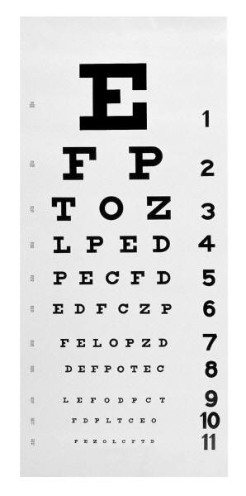 I became interested in Optometry very recently. I always knew I wanted to go into to the medical field but I was always a little unsure of the direction of my path. I don’t like blood or guts, so you can automatically count me out of anything dealing with trauma. I was always intrigued by optometry because I have had problems with my vision since I was in the fifth grade. I enjoyed going to see my Optometrist (who is also my cousin) because he made his job seem so interesting. He interacted well with all of his patients and made them feel comfortable. This summer, as I was getting ready to start college, I started thinking about my future and my mind drifted towards Optometry. That very next day, I called my cousin and he invited me to shadow him around the office. I was thrilled! I will never forget that experience and how I had really found an occupation that I loved.

What exactly is Optometry? Optometrists are members of the primary general health team who specialize in the examination, diagnosis, and treatment of conditions or impairments in the vision system. (Missouri Sate Pre-Optometry) They are not eye surgeons; they simply are the people who prescribe your glasses and contact lenses. The nurses generally do the testing of your vision and the fitting of your frames and contact lenses while the Optometrist checks your vision in that funny looking object that can magically fix your vision with only a couple of clicks. Optometrists are non-medical doctors who study for four years in a college of optometry, the first two years of which emphasize classroom and laboratory work in the basic biomedical and physical sciences while the remaining two years are composed primarily of supervised patient care in hospitals, private practices, and clinics. (Missouri State Pre-Optometry)

What does it take to become an Optometrist? To practice optometry in the U.S., you must have a license. Obtaining a license requires a Doctor of Optometry degree from an accredited program as well as passing scores on a clinical State board and written examination. Sometimes examinations taken through the National Board of Examiners in Optometry can be substituted for the written test. Every 1-3 years, licenses must be renewed. Continuing education credits are required for license renewal. (Optometry Career Overview) At Missouri State, you must complete a rigorous schedule in the biomedical field including chemistry, physics, and biomedical science courses. Many students earn their degree in Biology, Biomedical Sciences, Chemistry, Psychology, Physics, or Astronomy and Materials Science. After earning a master’s degree in one of these programs, you then go on to Optometry school for four years.

After going through all that schooling and finding a job at a clinic or perhaps starting your own practice, what is a typical schedule for an Optometrist? As an Optometrist, your days will vary on the type of work that you do but you can expect to:

* C:\Users\John Hulett\AppData\Local\Microsoft\Windows\Temporary Internet Files\Content.IE5\3JSBDEIO\MCj00900700000[1].wmfexamine people’s eyes to diagnose vision problems and eye diseases;
* test patients’ visual acuity, depth and color perception, and ability to focus and coordinate the eyes;
* prescribe [eyeglasses](http://vision.about.com/od/eyeglasses/p/Lens_options.htm) and [contact](http://vision.about.com/od/contactlenses/p/Contacts.htm) lenses;
* provide vision therapy and low-vision rehabilitation;
* analyze test results and develop a treatment plan;
* administer drugs to patients to aid in the diagnosis of vision problems and prescribe drugs to treat some eye diseases;
* provide preoperative and postoperative care to cataract patients, as well as patients who have had [laser](http://vision.about.com/od/lasikandvisionsurgery/LASIK_and_Other_Vision_Correction_Procedures.htm) vision correction or other eye surgery;
* diagnose conditions due to systemic diseases such as [diabetes](http://diabetes.about.com/) and [high](http://highbloodpressure.about.com/) blood pressure and refer patients to other health practitioners as needed. **(**Optometrist: Career Information**)**

I believe one of the best parts of my day will be the interaction with my patients. Knowing that you have helped someone is one of the best feelings you can have.

The future of Optometry is very optimistic. This is due to the aging of a growing population. The elderly have an increased risk of diseases such as diabetes, cataracts, hypertension, and glaucoma. These patients will need optometric care. Employment will also grow as employee vision care plans improve, as more people realize the importance of good vision care, and as annual incomes increase. (Optometry Career Overview) The demand for eye doctors will always be around because people will always have vision problems. An optometrist will always have a variety of patients because people of all ages suffer from different eye problems. I think this is one of the reasons I am so interested in this career - because these doctors will always be needed. Optometrists held about 33,000 jobs in 2006. Some held more than one job, sometimes having their own practices and also working in other optometrists' practices or in vision care centers. (Optometrist: Career Information) In 2008, optometrists in the U.S. earned an average annual salary of around $103,000. Those with eight or more years of experience earned as much as $124,000. (U.S. News and World Report: Best Careers 2009)

In conclusion, Optometry seems like a great occupation for me. It has a very optimistic future and great benefits. I have reviewed background information about this career, and described briefly what it takes to become an Optometrist. I have also described some of the duties of an Optometrist after obtaining a degree and starting a career. It is hard to figure out what you want to do with the rest of your life but it is helpful to have some ideas of what interests you. It is strange how you can shadow one career for a day and then the next you are scheduling classes for that career to become your own.