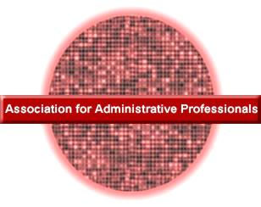
April 21, 2012

Ms. Emily Gibson
459 South Ridge View Drive
Chicago, IL 60603

Dear Emily:
On behalf of the members of the Association for Administrative Professionals, I would like to welcome you to the organization. We have many unique activities planned to focus on training and business issues, and I am confident that you will enjoy them. Here are some of the activities we have planned:
- Asking administrative professionals to be guest speakers at meetings.
- Participating in the regional and national conferences.
- Shadowing an administrative professional for a day.
- Finding internships for members of the organization.
The next meeting will feature a presentation by Erin Foster, the President of the Harrison County Chapter. Her presentation on “Annual Reviews - Getting Your 2¢ In” will be of great value in career advancement. Please call Elexis Nelson at (317) 555-0432 as soon as possible to RSVP.
Date: June 7, 2012
Time: 4:30 p.m.
Where: Community College
Business Building
Room 255
I am looking forward to seeing you at our next meeting.
Sincerely,

Michelle Hulett

