Tulip Basics
Table of Contents
Table of Figures 2
Origins 3
Planting 3
Plant at the right depth 3
After Flowering 4
Forcing Tulips. 5
Bibliography 6
Index 7

Table of Figures
Figure 1. Angelique 3
Figure 2. Beauty of Apeldoorn 3
Figure 3. Black Parrot 3
Figure 4. Candela 3
Figure 5. Plaisir 3
Figure 6 Planting Depth Guide 4
Figure 7: Dissecting a Tulip Bulb 4

Origins. Tulips originated in Turkey getting their name from the Turkish word "tulbend" which means turban. Tulips were thought to look like the turbans. (Hats that were worn in Turkey at that time.) I have always mistakenly associated the origin of Tulips with Holland. Tulips were introduced to Holland from Persia.

Tulips are classified with perennials but often need to be treated as annuals. Dig up your tulip bulbs once the foliage has died & store them in a cool dry area for replanting in the fall. There are a wide variety of tulips, some are shown in the following figures.
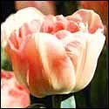  Figure 1. Angelique | 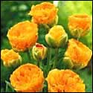  Figure 2. Beauty of Apeldoorn |  | 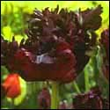  Figure 3. Black Parrot
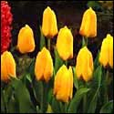  Figure 4. Candela |  | 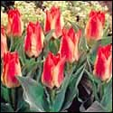  Figure 5. Plaisir

Order your bulbs early enough that they can spend anywhere from 8 to 10 weeks basking in the chill of your frig. Store them in a mesh bag so that they get good air circulation. If you are a fruit lover you may want to strongly consider getting a spare refrigerator – one of the minis so readily available. Fruit gives off ethylene gas – and ethylene gas will kill the flower inside your bulbs.

Planting. Choose your planting spot carefully. No open, sunny areas – and no Southern exposures. Find the coolest spots on your property – preferably those that are either in partial shade with only morning sun. Otherwise your poor plants will pop out and fry before you have a chance to admire them.

Tulips will thrive in almost any type of soil where there is reasonable drainage. During the growing season they like plenty of moisture but the roots must not stand in water. Be careful not to feed tulips during the growing season as this will produce 'leggy' plants. Plant from October until late December, 4 inches deep and approximately 5 to 6 inches apart.

Plant at the right depth. Follow instructions for your climate as seen in Figure 6. Space them correctly. Set tulip bulbs 2 to 4 inches apart. Exception: When planting forget-me-nots, pansies, violas, or other flowers above the bulbs, plant the tulips 8 inches apart on center and the flowers 10 inches on center. See the depth chart in Figure 6 on page 5. If you are using one of the many available bulb planters be sure that the soil in the whole planting area is well worked to prevent any sitting water at the bottom of the hole made by the planter.

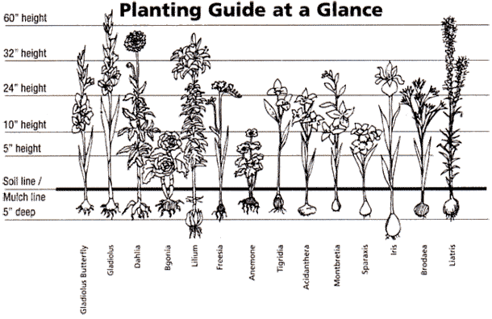
Figure 6 Planting Depth Guide

Water well after planting, and often enough to keep the soil from drying out when there is a lack of rain. When stems emerge from the soil, water to keep the soil moist.

Tulip failures are mostly due to damage by slugs and snails. Apply a slug repellant immediately after planting and repeat at monthly intervals until the plants stand well above the ground.

After Flowering. Remove flower heads (deadheading) and let the plant die back before removing. This allows the food supply in the plant to feed the main bulb that will produce next year’s flower. It is important with tulips that all the dead foliage and petals are removed and not composted. Tulip plants can leave a disease, 'tulip fire' as they die off in late spring.

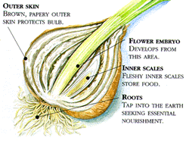
Figure 7: Dissecting a Tulip Bulb

Like other bulbs, Tulips should be stored in a cool, well ventilated area. The garage in summer is definitely not the place to keep tulip bulbs. Many an inexperienced gardener has pulled up bulbs, and kept them in the garage until fall planting, only to find, dried up bulbs a few months later.

Forcing Tulips. Tulips can be forced to bloom indoors winter months. Plant a few bulbs in a flower pot. Then chill the pot or set it in the cold for 12 to 15 weeks. After the pot is brought indoors the tulips will grow and bloom.

Bibliography
n.d. <http://tulips.blomsbulbs.com/growtulips.cfm>.
n.d. 2012 7 June <http://www.gardenersnet.com/bulbs/tulips.htm>.
http://www.americanmeadows.com/Flower-Bulb-Info/SpringBulbPlantingGuide.cfm. n.d.
Swezey, Lauren Bonar. "A Westerner's Guide to Tulips." Sunset 1999.

Index

D
Deadheading, 4
H
Holland, 3
P
Perennials, 3
S
Soil, 3, 4
Storage. See Store
Store, 3

Swezey, Lauren Bonar, A Westerner’s Guide to Tulips (Sunset, October 1999)

