Supply List
 | Item | Quantity | Price | Cost of Materials
 | Cabinet | 1 | 200.00 | $ 200.00
 | Ceramic tile | 100 | 1.00 | $ 100.00
 | Drill | 1 | 45.00 | $ 45.00
 | Drywall (Gypsum) | 3 | 7.00 | $ 21.00
 | Faucet | 1 | 75.00 | $ 75.00
 | Flashlight | 1 | 12.00 | $ 12.00
 | Grout | 1 | 20.00 | $ 20.00
 | Hammer | 3 | 10.00 | $ 30.00
 | Lumber (2x4) | 10 | 3.50 | $ 35.00
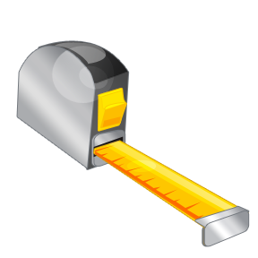 | Measuring tape | 3 | 8.50 | $ 25.50
 | Nails | 150 | .02 | $ 3.00
 | Paint | 5 | 15.00 | $ 75.00
 | Paintbrushes | 9 | 4.00 | $ 36.00
 | PVC pipe | 6 | 3.00 | $ 18.00
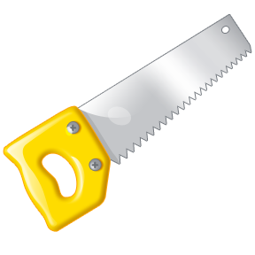 | Saw | 2 | 25.00 | $ 50.00
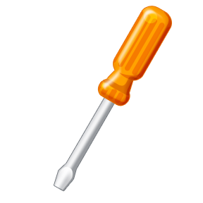 | Screwdriver | 2 | 6.00 | $ 12.00
 | Screws | 125 | .03 | $ 3.75
 | Sink | 1 | 150.00 | $ 150.00
 | Toilet | 1 | 175.00 | $ 175.00
 | Towel holder | 2 | 9.50 | $ 19.00
TOTAL COST OF MATERIALS |  |  |  | $1,105.25

