Lost Pet
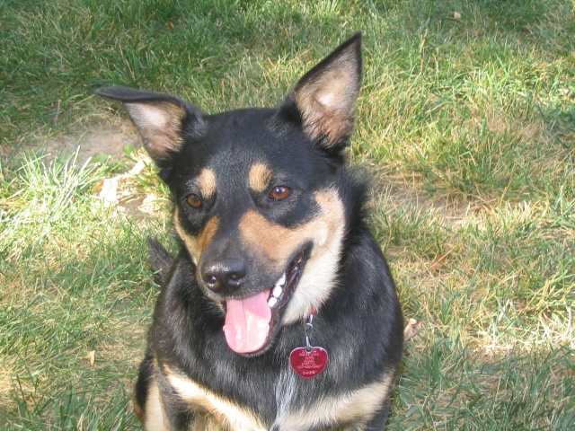
Dakota is a black and tan Heeler/Shepherd mix.
She is 5-years old and weighs about 50 pounds.
She is not aggressive and is very friendly with people.
Please call day or night (123) 456-7890.
Michelle Hulett  (123) 456-7890 | Michelle Hulett  (123) 456-7890 | Michelle Hulett  (123) 456-7890 | Michelle Hulett  (123) 456-7890 | Michelle Hulett  (123) 456-7890 | Michelle Hulett  (123) 456-7890 | Michelle Hulett  (123) 456-7890 | Michelle Hulett  (123) 456-7890 | Michelle Hulett  (123) 456-7890 | Michelle Hulett  (123) 456-7890

