Association Rule Mining
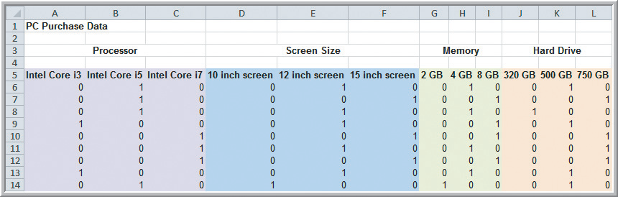
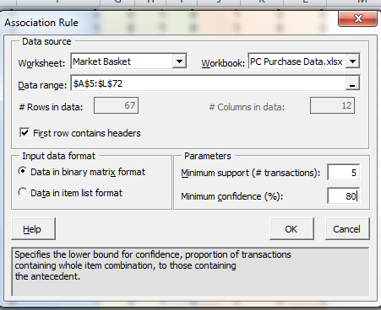 | 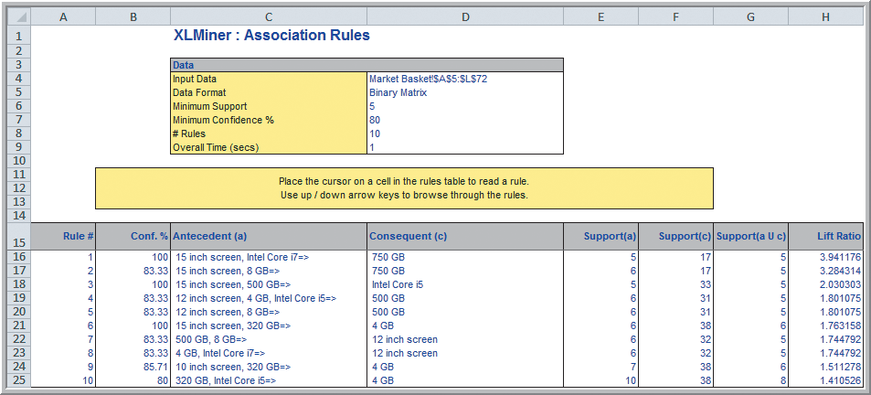

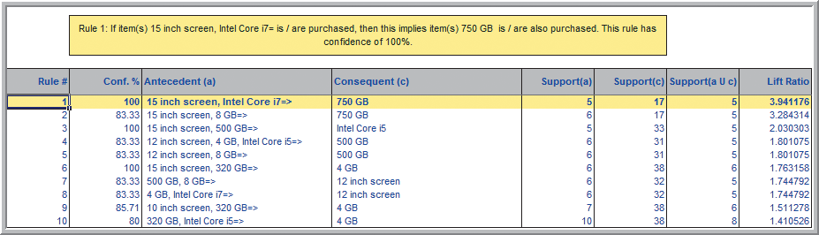
Rules are sorted by their Lift Ratio (how much more likely one is to purchase the consequent if they purchase the antecedents).

