Building a Simple Expert System for Retirement Planning

1 . |  | When employees at your company retire, they are given cash bonuses. These cash bonuses are based on the length of employment and the retiree's age. In order to receive a bonus, an employee must be at least 50 years of age and have worked for the company for 5 years. The following table summarizes the criteria for determining bonuses.  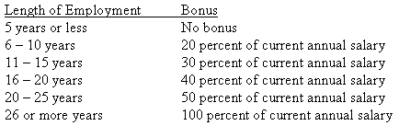  Using the information provided, build a simple expert system. Use your spreadsheet software to build the expert system.

