Functions with Criteria: sumif(), averageif(), and countif()
A simple example of the use of the =sumif() function is to compute the total of the monthly salaries for female employees as shown in Figure 1 below. Here, we want to sum the monthly salaries in column D, but only if the employee is female. The formula to use is shown in cell D17.
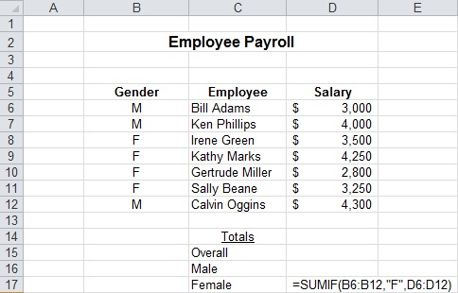
Figure 1. Example of =SUMIF function
The general format of the =sumif() function is given by
=sumif(test_range, criteria, sum_range)

The function requires three parameters
- The row or column to which the criteria is applied
- The condition that determines which entries are summed
- the column of values from which the sum is computed
Examples:
- =sumif(G5:G200, "female", K5:K200) -- the column containing the genders of the employees is G and the column containing the salaries is K in this example
- =sumif(A2:A8, ">60",C2:C8) -- sums the values in the cells C2 through C8 for which the corresponding value in A2 through A8 is greater than 60
- =sumif(B6:B12,"A",D6:D12) -- sums the sales for salespeople from area A; the criteria column is B and the sum column is D

Payroll Example Revisited
Let's exercise our knowledge of the =sumif() to complete the model in Figure 2 below.
Figure 2. Payroll model
In this model the commission rate and the base salary depend upon the area to which the salesperson is assigned. To create the formula to compute the commission for Bill Adams so that can be copied requires the use of the =if() function to determine the area to which Bill is assigned. The commission computation will be:
=if(B6="A", $C$22 * C6, $D$22 * C6)

If Bill Adams is assigned to area A, use the commission rate for area A in the commission computation. If Bill Adams is not assigned to area A, then it must be area B, use the commission rate for area B. Similarly with the gross earning calculation, the =if() function is required to determine the appropriate gross earnings:
=if(B6="A", D6 + $C$21, D6 + $D$21)

To compute the total sales for area A, use the =sumif() function:
=sumif(B6:B12,"A",D6:D12)

If we wish to copy the function for the computation of the total commissions awarded in area and the total gross earning, the criteria column range needs to be an absolute cell reference:
=sumif($B$6:$B$12, "A", D6:D12)

Closely related to the =sumif() function is the =countif() function. The countif() function counts the number of occurrences in the test range that meet the criteria. In the scenario above the average salary of a female employee could be computed using
=sumif(G5:G200, "female", K5:K200)/countif(G5:G200, "female")

The general format of the countif function is given by
=countif(test_range, criteria)

For another example of the use of the countif() let's count the number of salespeople in area B. The command would be =countif(B6:B12, "B"). The result would be 4. If you wished to apply multiple criteria you could use the =countifs() function which has the format:
-countifs(test_range1, criteria1, [test_range2, criteria2])

Note: The [] means that the entry is optional.
There can be up to 127 test range and criteria pairs specified.

There is also an =averageif() function with the same format as the =sumif() function. To compute the average salary for area A the entry would be given by
=averageif(B6:B12, "A", D6:D12)

Exercise: Download the workbook in Figure 2 and complete the payroll calculations.
How about =maxif() or =minif()?
Alas, Excel does NOT provide a =maxif() or a =minif() function. To find the maximum or minimum under some criteria requires a two-step process. The first step is to use an =if() to determine which of the entities on the worksheet satisfy the criteria. The =if() will be placed in a cell to the right of (or below) the model on the worksheet in a "scrap area". Once the rows that satisfy the criteria are available the =max() is applied to the column in the scrap area.
Suppose the sales manager for area A wished to set sales targets for next February. To do so the manager might want to know the max and min sales amounts for the current year. To accomplish this using the model above, in the column range K6:K12 in the scrap area for this model we would place the sales for each of the salespeople from area A and a zero in the cell associated with each salesperson from area B. The formula in K6 would be: =if(B6="A", D6, 0). This formula can be copied from K6 down through K12. Then in an appropriate cell on the worksheet the function = max(K6:K12) would provide the maximum sales for February by a salesperson assigned to area A. Note that in this particular problem the sales amounts are positive so the use of zero for areas other than A works. Check the example below in case you cannot guarantee the maximum value is positive.
To compute the minimum sales for area B, in cell M6, a potential entry could be:
=if(B6="B", D6, "")

When copied from M6 down through M12, for each salesperson in area B their sales will be in the associated cell in column M and a blank will be in the associated cell if the salesperson is assigned to area A. Then in an appropriate cell on the worksheet the function = min(M6:M12) would provide the minimum sales for February by a salesperson assigned to area B. NOTE: Since our sales are positive we could not use zero for the false value since it would be smaller than the other positive values so "" was used instead.
This technique is also useful when you wish to examine or otherwise process, perhaps even in multiple steps, a subset of data meeting a criteria.

