Graphs/Charts

Introduction
Graphs, or Charts as they are referred to in Excel, provide a visual presentation of data. Often people are able to better see relationships among data when presented as a graph as contrasted with viewing columns or rows of numerical values.
In Excel to create a graph use the Insert tab under the Illustrations group to access the Chart icon. Excel provides many chart types for presenting data - these include: Column, Line, Pie, Bar, Area, X Y (Scatter), Stock, Surface, Doughnut, Bubble, and Radar. It is easy to switch from one chart type to another; there exist guidelines for assisting users for making a selection, but the ease of conversion permits the user to view many different types from which to select the type that best represents the view of the data the user is attempting to provide.
Once a chart is constructed the Layout tab becomes available to add, delete, or alter features in the chart. The terminology used for the components that make up a chart is shown in Figure 1 below.
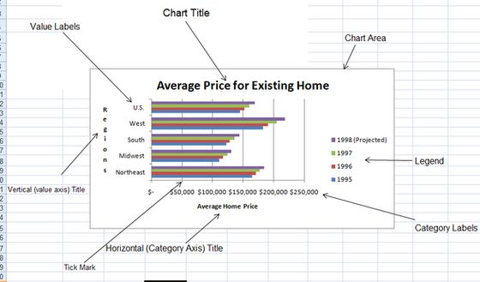
Figure 1. Terminology for components of a chart
The chart above was constructed from data in the workbook in Figure 2 below.
Figure 2. Model for Chart construction
The steps used to construct the chart above are:
- Select the data including the headings that are to appear in the chart - the range selected is A6:F10.
- Click on the Insert tab - Charts appears as its own group (see Figure 3).
- Click on the down arrow below the Bar menu item and select the first 2-D Bar option - the chart for this data appears on the worksheet - move the chart - with the crosshair showing in the chart hold the left mouse button down and drag the chart below the model.
- Notice the data on the x-axis (the category axis) overlaps slightly. Move the mouse to the middle (vertically) of the right edge of the chart area; the crosshair changes to a double-ended arrow - press the left mouse button and drag until the axis data is easy to read.
- With the chart area selected click the Layout tab (see Figure 4). Under the Labels group select Chart Title and from the menu presented select Above Chart; type the title "Average Price for Existing Home".
- From the Layout tab under the Labels group select Axis Titles, Primary Horizontal Axis Title, Title Below Axis and enter "Average House Price".
- From the Layout tab under the Labels group select Axis Titles, Primary Vertical Axis Title, Vertical Title and enter "Regions".
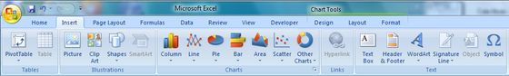
Figure 3. Insert tab groups and menu icons after chart selection
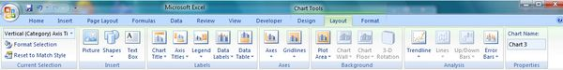
Figure 4. Layout tab groups and menu icons
Exercise: Download the workbook in Figure 2 and open it in Excel. Construct the chart in Figure 1 on the same sheet.

More Chart Features
The illustrative example for this section uses data contained in non-adjacent ranges from the model for the chart data set. The basic model is illustrated in Figure 5 below.
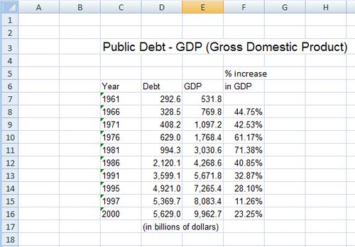
Figure 5. GDP % increase model
This illustration uses the Year column and the % increase column for the chart data set. To select this data first select the range C8:C16, click and hold the CTRL key while selecting the range F8:F16. Choose a Column chart option from the Insert tab, Charts group. The resulting chart is displayed in Figure 6. The chart was dragged slightly to the right so it would not overlap the model.
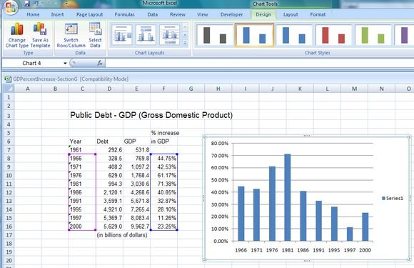
Figure 6. The column chart created from non-adjacent selection of data set from model
Notice in Figure 6 on the Ribbon the new tabs Design and Layout. Under the Design tab in the Chart Styles group select the red bars - note the bars in the chart are now red. Next, click on the Move Chart button and in the Move Chart dialog box enter Sheet2 next to the New Sheet radio button. Excel provides a dialog box to notify you that this sheet already exists - respond Yes. The chart now resides on Sheet2.

How to make simple changes to the chart
REMOVING A LEGEND: Since there is only one series, remove the legend by selecting it by clicking on legend labelled Series 1 in the chart area. Right-click and select Delete from the menu.
CHANGE CHART TYPES: Right-click in some white space in the chart area and select Change Chart Type from the menu - do this a number of times and select different types of charts.
ADDING DATA LABELS: Right-click on a bar and select Add Data Labels from the menu (see Figure 7); right-click once again on a bar and select Format Data Labels from the menu. From the Format Data Labels dialog box click the Inside End radio button. To remove these labels right-click and select the Delete option from the menu.
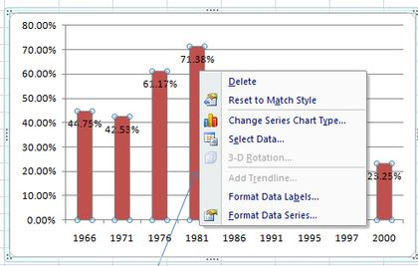
Figure 7. The menu produced by a right click on a bar
From the Layout menu as in the first example add axis titles and a chart title. To call attention to the largest % increase which occurs in the 5-year span from 1976-1981 use the Shapes menu from the Layout tab, Insert group. From the Lines section choose the one ended arrow. On the worksheet a crosshair appears. Left-click and drag to draw the arrow - click in white area to complete the drawing (see Figure 8). Add the text "largest 5-year increase" just below the arrow. Clicking on the arrow you can change its direction and/or end points or delete it (select the arrow and use Delete key).
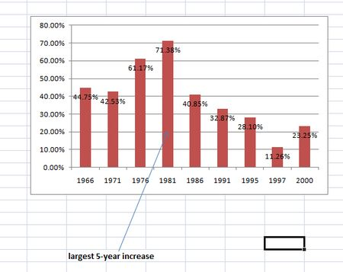
Figure 8. Chart with arrow and text added

