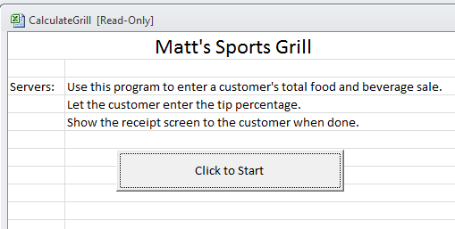

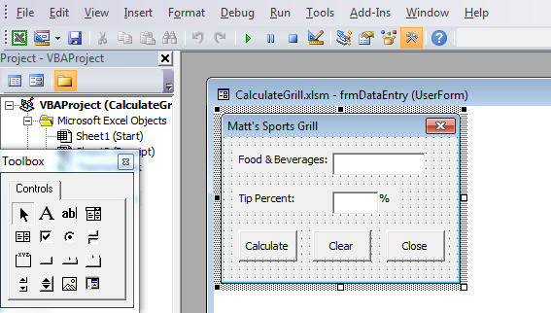

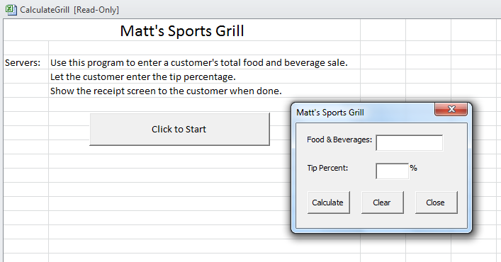
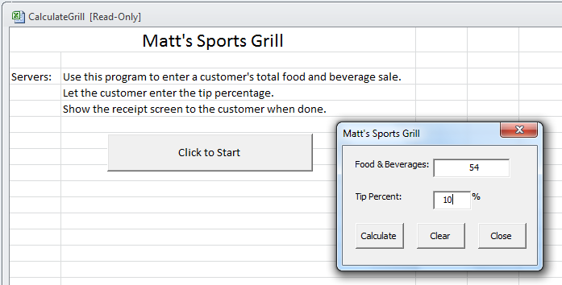 | 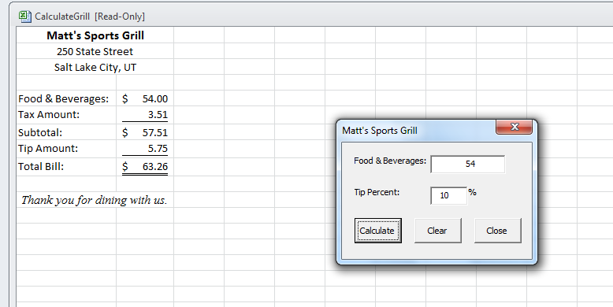

Private Sub cmdStart_Click()

frmDataEntry.Show

End Sub

Private Sub cmdCalculate_Click()

' Declare variables
Dim dblMeal As Double
Dim dblTip As Double
Dim dblTotal As Double
Dim dblTaxAmount As Double
Dim dblAmountDue As Double

' Get cost of meal from text box
dblMeal = txtMeal.Text

' Function call to perform calculations
dblAmountDue = TotalBill(dblMeal, dblTip, dblTotal, dblTaxAmount)

' Complete the receipt
Worksheets("Receipt").Unprotect
Worksheets("Receipt").Range("B5") = dblMeal
Worksheets("Receipt").Range("B6") = dblTaxAmount
Worksheets("Receipt").Range("B7") = dblTotal
Worksheets("Receipt").Range("B8") = dblTip
Worksheets("Receipt").Range("B9") = dblAmountDue

Worksheets("Receipt").Protect
Worksheets("Receipt").Activate

End Sub

Function TotalBill(dblMeal, dblTip, dblTotal, dblTax)

' Declare constant and variable
Const dblTaxRate As Double = 0.065
Dim dblTipRate As Double

' Calculate the tax and subtotal
dblTax = Round(dblMeal * dblTaxRate, 2)
dblTotal = dblMeal + dblTax

' Calculate the tip and grand total
dblTipRate = Val(txtTip.Text) / 100
dblTip = Round(dblTotal * dblTipRate, 2)
TotalBill = dblTotal + dblTip

End Function

Private Sub cmdClear_Click()

' Clear data entry form
txtMeal.Text = ""
txtTip.Text = ""
txtMeal.SetFocus

End Sub

Private Sub cmdClose_Click()

' Close the form
frmDataEntry.Hide
Worksheets("Start").Activate

End Sub

Private Sub txtMeal_Change()

End Sub

