Partitioning Data
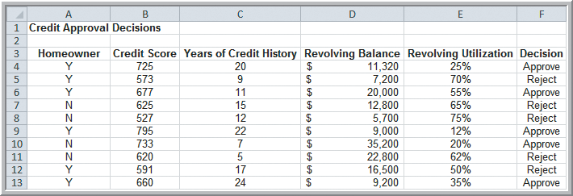
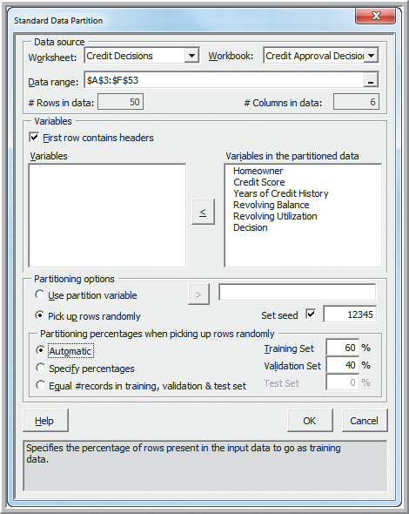 | 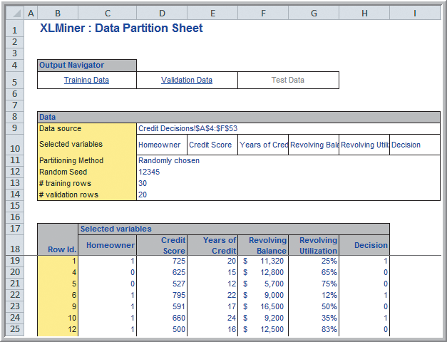
Reject if this is > 74.66
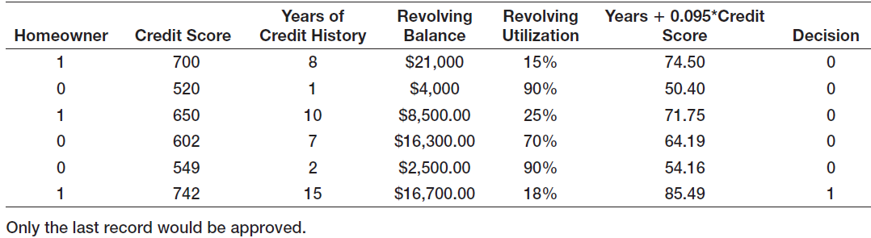

Discriminant Analysis
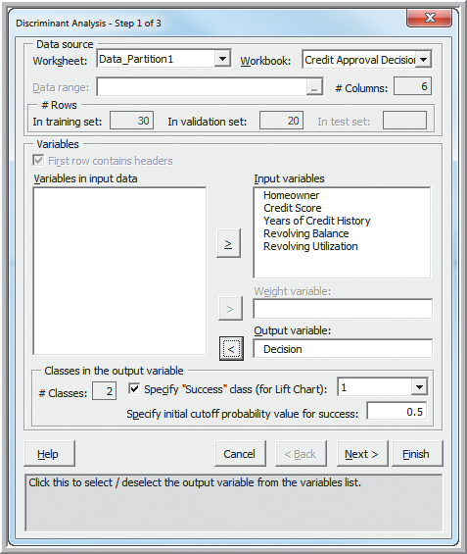
Partition the data (see above) to create the
Data_Partition1 worksheet.

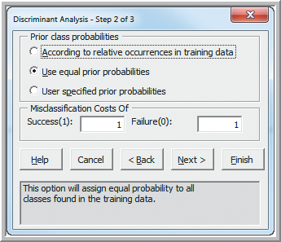 | 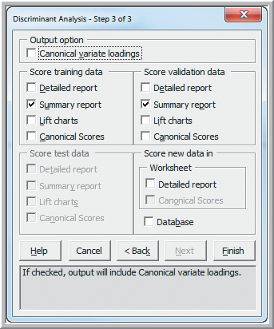
Match variables in new range:  Worksheet: Credit Decisions  Data range: A57:E63  Match variables with same names | 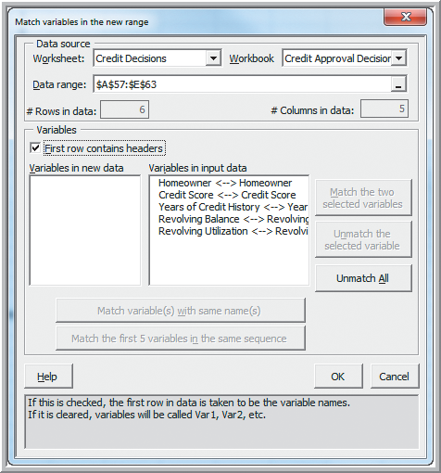

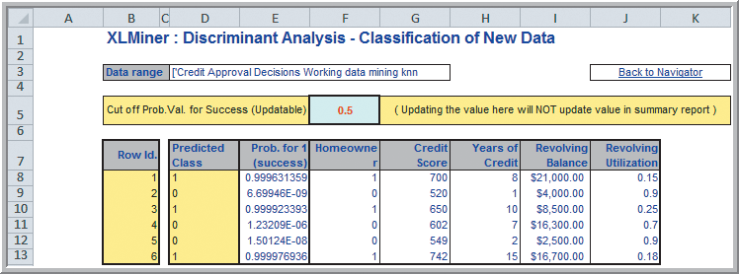
Half of the applicants are in the “Approved” class

