Random Values for Games and Simulation
Excel provides us with two functions for generating "random" numbers:
=RAND(), returns a decimal value between 0 (inclusive) and 1 (exclusive)
that is uniformly distributed between 0 and 1

=RANDBETWEEN(x, y), returns an integer value between x and y (inclusive)
that is uniformly distributed

The term uniformly distributed means that any value within the limits has an equal chance of being chosen.
For example, we can simulate the roll of a six-sided die using =randbetween(1, 6).
A computer simulation of the Chuck-a-luck die game
In this example we will simulate playing a game similar to the Chuck-a-luck gambling game (see http://en.wikipedia.org/wiki/Chuck-a-luck). In our game one die is rolled with the resulting value set as the target value. The player of the game then rolls three die. We will be interested in the number of dice rolled that match the target value. In a gambling version there are different payoffs for matching on one, two, or three die. We will simulate playing the game 100 times and calculate the following two statistics after all games are played:
- the total number of games for which there is at least one match
- the total number of matches
Click the link Chuck-a-luck to open the game simulation spreadsheet and then save it to a folder of your choice. Let's simulate game 1 by entering =randbetween(1, 6) in cell B5. Now copy the formula in cell B5 to cells C5, D5, and E5. To determine the number of target cell matches in game 1 enter the formula =countif(C5:E5, B5) in cell F5 (see section SumIf Function if you need to review the =countif() function). The formulas entered should be:
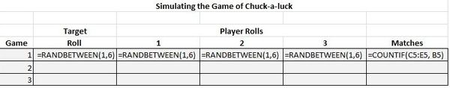
Now, to simulate all 100 games, simply copy the formulas in row 5 to rows 6 through 104. You may have noticed that the value in the cells keep changing as the spreasheet recalculates. Press function key F9 (the recalculate key) to observe this. We will "freeze" the values for the rolls of the die in the simulation using the following steps:
- Select the range of random values to freeze/fix, cells B5:E104 in our example
- Type Ctrl-C or right click in the selected range and select Copy
- Right click in the selected range again and under Paste Special choose the first icon, Values(V)
Now the underlying formulas for randbetween have been removed from the cells and only the last values are retained.
Finally, let's calculate the summary statistics. The total number of games with at least one match can be calculated in cell I4 using the formula =COUNTIF(F5:F104, ">0"). The total number of matches can be calculated in cell I5 using the formula =SUM(F5:F104).
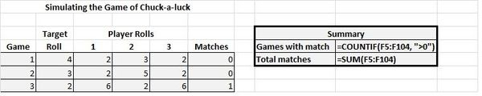
Exercise: Create a 2 player game where each player will roll two die and select their smallest roll. The player with the largest "smallest" roll wins the game. For each game you are to record the winner player 1 or 2. Your simulation should play at least 100 games and report how many wins each player achieves as well as the number of ties. Also indicate which player wins the most games, if there is one. If both players win the same number of games, then the worksheet should report that the result is a tie. This will require a somewhat interesting =if() function.

