Tableau Lab
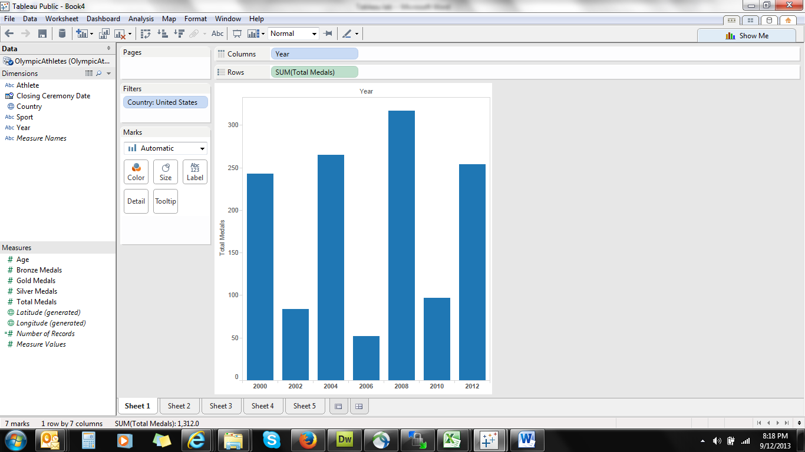
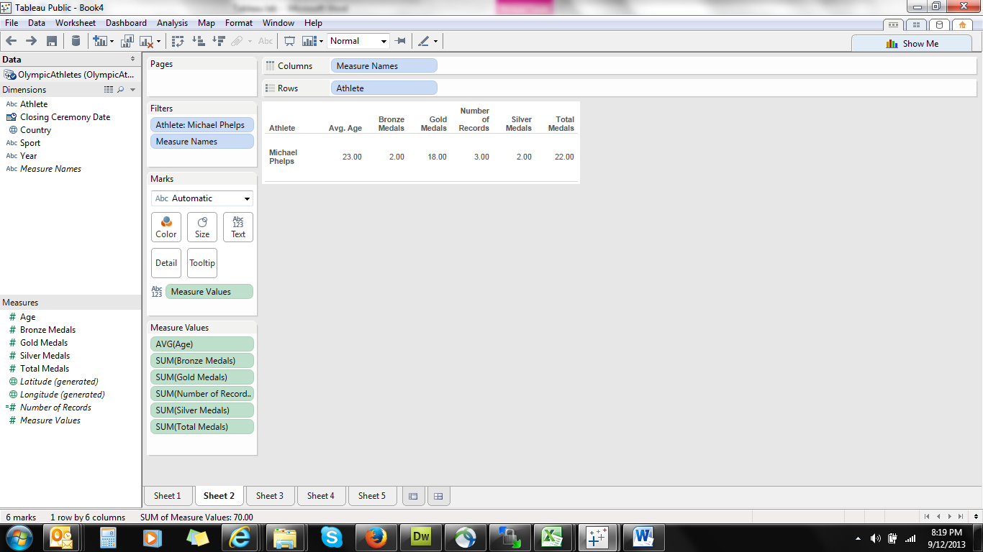
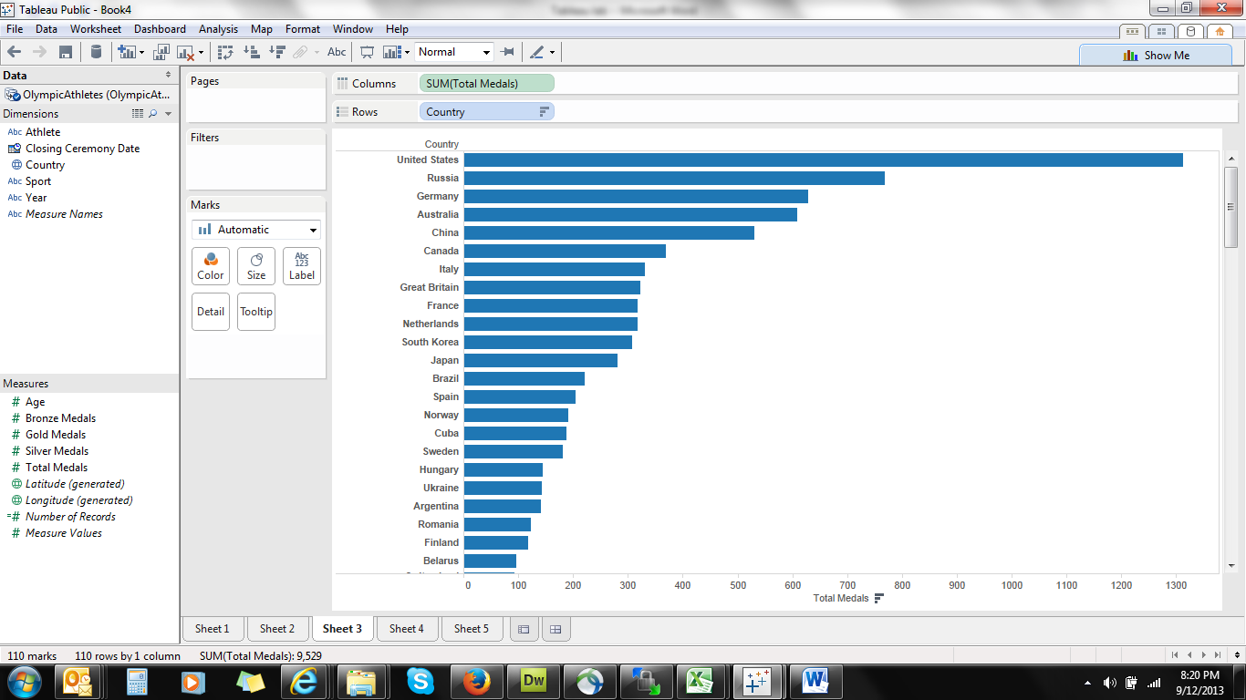
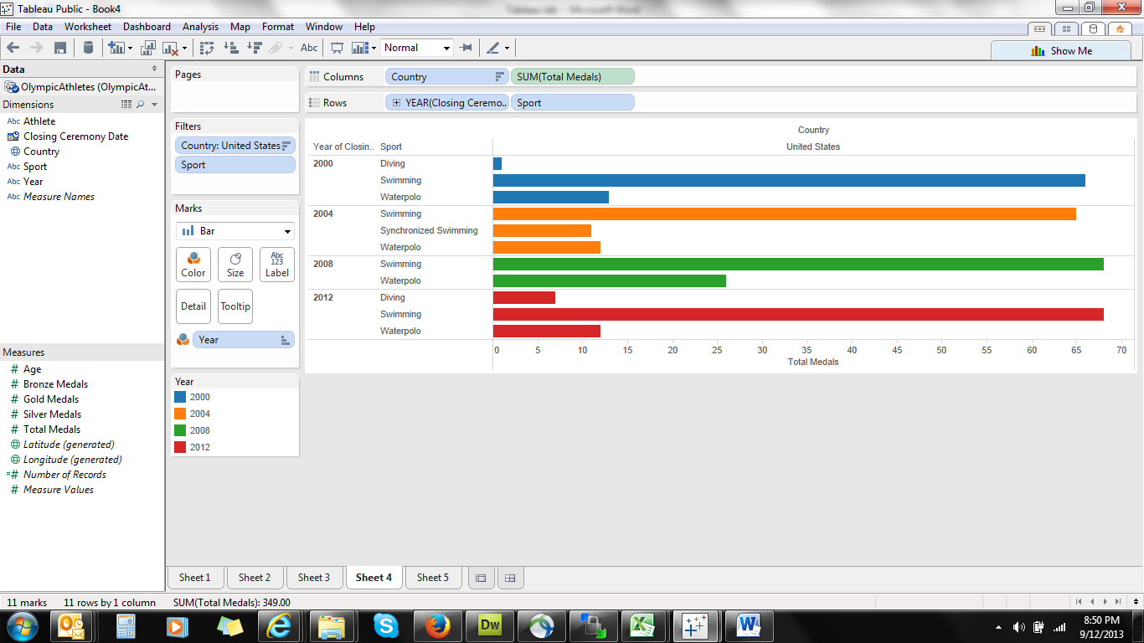
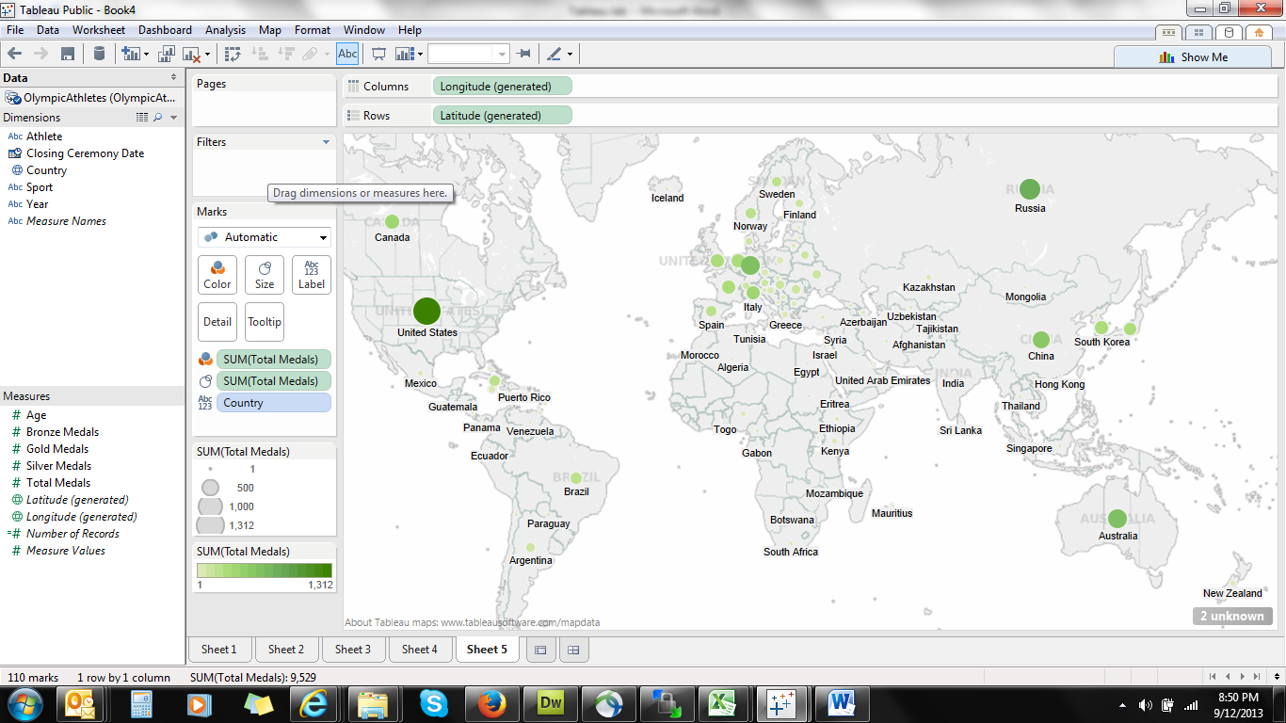

Tableau lab
- How many medals have athletes won since the 2000 Games?
- How has the number of gold medals changed over time?
- Which countries have won the most number of medals in swimming?
- How many each of gold, silver and bronze medals has Michael Phelps won?
- Create a map view of the total medals won by each country
- Design 3 different views of data of your own design.

