**Tableau Software Project Solution**

There is no single, right answer. Each of you could possibly present an analysis and set of screen captures that reflect your thinking.

My main concerns are products and profitability. These two things logically become the X and Y of my analysis with Tableau so that I can look into underperforming areas in our product portfolio.

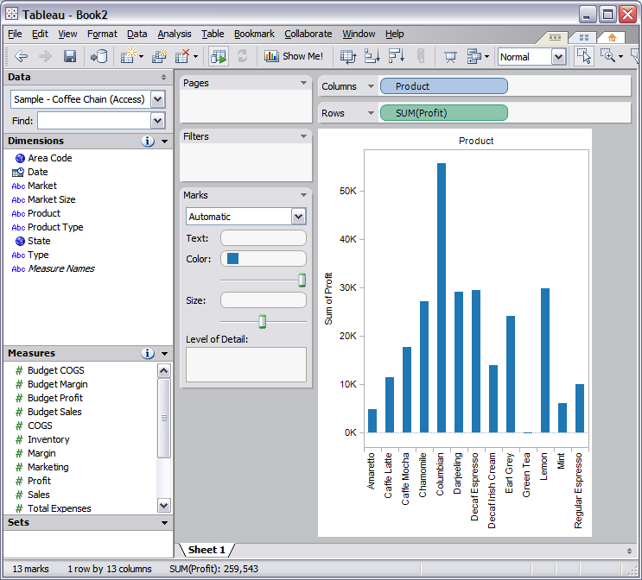

I immediately noticed that “Green Tea” had the lowest profit so I double-click on it to drill down and find out why. What I find is that Green Tea has a loss of -$231.

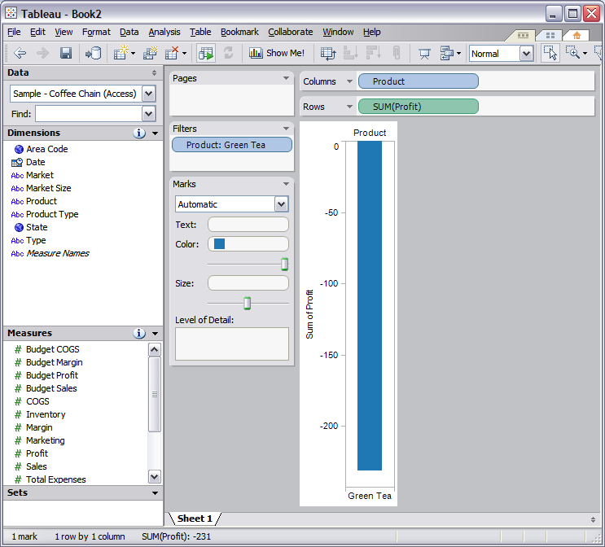

To find out if this is a regional problem, I also drag “Market” into the visualization. This reveals that the Central and East markets are generating profits but the West market is the main source of the losses in Green Tea.

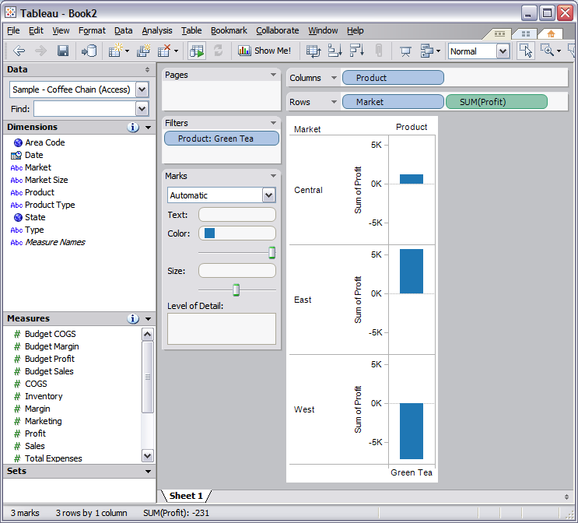

By double-clicking on the West market, it becomes the focus of the visualization and eliminates the markets that are generating profits on Green Tea. I drag “State” onto the visualization to break down the West market by state to try and find out where the problem with profit on Green Tea lies.

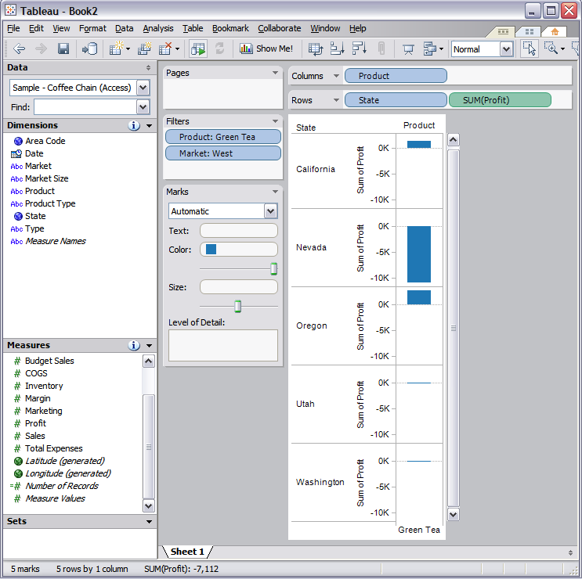

From the Visualization, it looks like Nevada is the largest source of the losses on Green Tea. Problems exist in Utah and Washington, but I’m not sure how they are performing until I get a better visualization of the data using more information.

The chart gets very long with the more data that I add so I adjust it to use dual columns in each state by clicking the “Show Me!” button at the top of Tableau. This allows me to change the chart into different formats like line, bar, or circle charts to better visualize the data. I have added Margin to this chart to see how Profit for Green Tea has matched up against Margin in the West States.

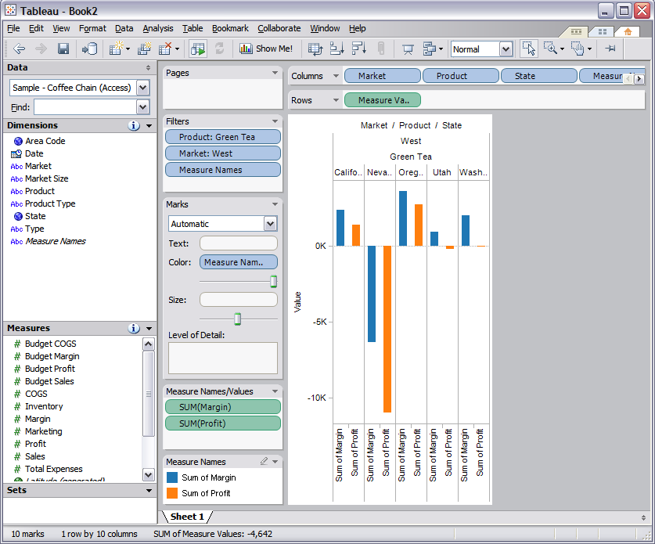

By double-clicking on the name for the state of Nevada, it becomes the focus of the visualization. We can clearly see that Green Tea is generating a loss in Nevada and operating at a negative margin (meaning that we are selling it for less than we need to break even).

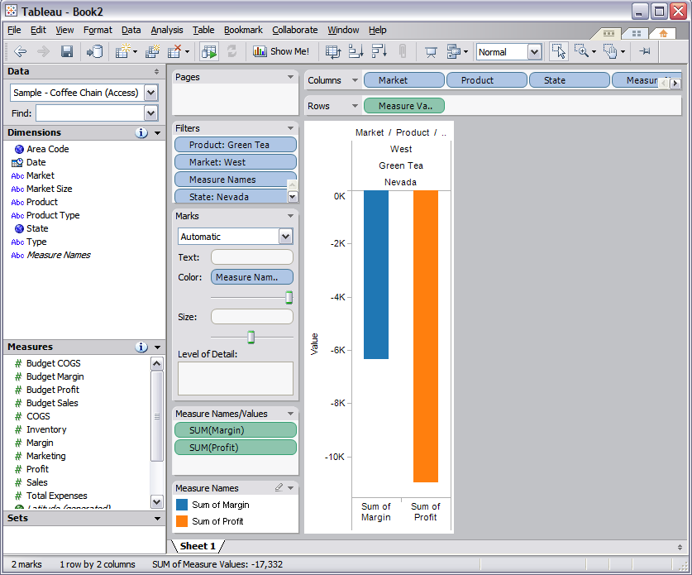

Next, I drag Sales onto the visualization to try and determine how we can have a loss of almost $11,000 on Green Tea. What I find is that we have sales of only $622 to coincide with the loss and negative margin on the Green Tea product sales in Nevada.

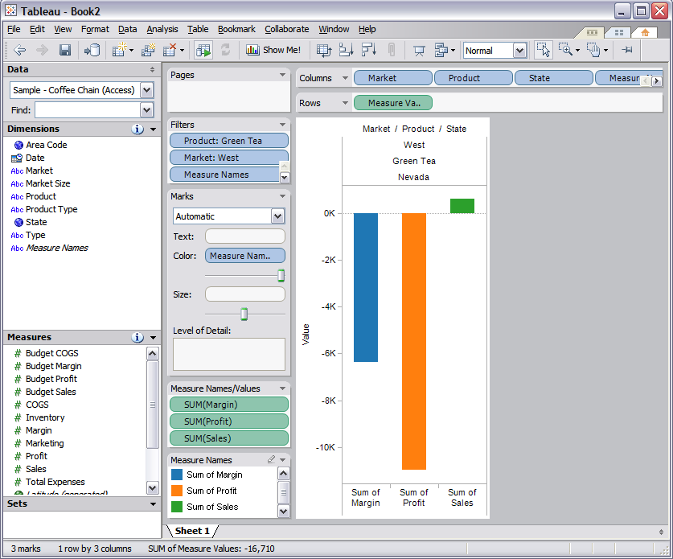By adding additional data in the way of COGS to the visualization, I find a huge problem. We have sold over $6000 worth of Green Tea for $622 in the state of Nevada. With marketing costs and overhead, the losses total almost $11,000 just for this one product in this one area. I recommend that we contact sales in this area immediately to find out why this is happening, who is responsible, and put a stop to it before we lose more money.

