The Microsoft Visual Basic Interface

Introduction
When it opens, like any regular Windows application, Microsoft Visual Basic displays a title bar in the top section. Under the title bar, the application displays a menu, followed by a Standard toolbar.
To assist you with your development, Microsoft Visual Basic can display various windows.
The Project Explorer
The Project Explorer window shows a list of the code segments that are available to your worksheet. It is usually available whenever you open Microsoft Visual Basic. It is usually positioned in the top-left section. If it is not present, to display it, on the main menu of Microsoft Visual Basic, you can click View -> Project Explorer. To close it, you can click its Close button .
You can move the Project Explorer to another section of the interface. To do this, click its title bar and drag it away it from there:
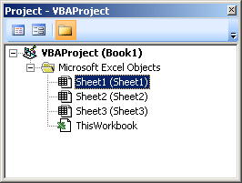
To put the window back where it was previously, you can double-click its title bar.
The Project Explorer
The Properties window is usually positioned in the bottom-left section of the screen. When it does not appear, to display it, on the main menu, click View -> Properties Window:
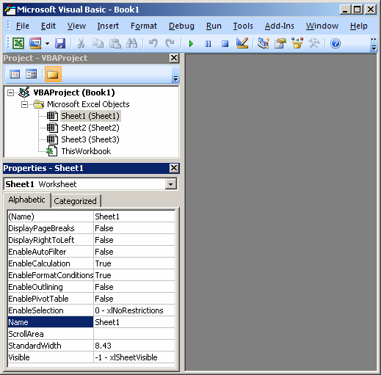
The Properties Window shows the characteristics of an object that is selected. Like any other window, to move the Properties window from its position, drag its title bar:
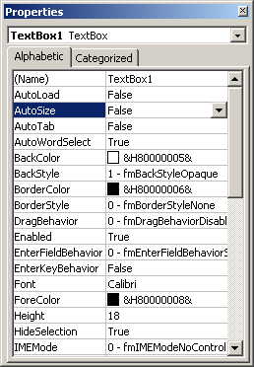
The main area of Microsoft Visual Basic uses a gray background. This area is gray because, in reality, Microsoft Visual Basic is a multiple document interface (MDI) that can be used to display various windows at the same time. At times, this gray area will be occupied with other windows.
Modules
A module is a blank window that resembles a piece of paper on which you write code. When you use Microsoft Excel and work on a document, a default module is automatically allocated for it, whether you use it or not. You can also create a module that is independent of any worksheet.
To create a module, on the main menu of Visual Basic, you can click Insert -> Module.
Practical Learning: Creating a Module
- On the main menu of Microsoft Visual Basic, click Insert -> Module
- Notice that a blank window with a blinking caret appears
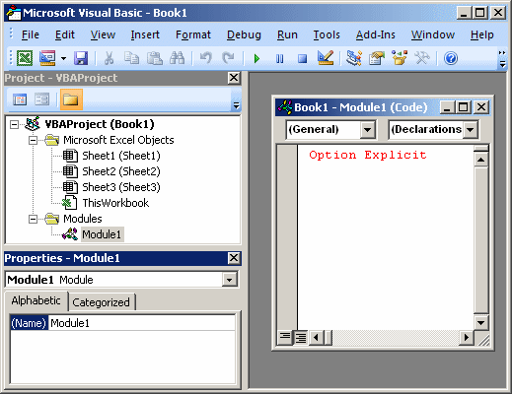
The Immediate Window
To help you test code, Microsoft Visual Basic provides a special window called the Immediate Window. To display it, on the main menu of Microsoft Visual Basic, you can click View -> Immediate Window.
Practical Learning: Displaying the Immediate Window
- To display the Immediate Window, on the main menu of Visual Basic, click View -> Immediate Window
- Notice that a window with an Immediate title bar appears at the bottom with a blinking caret
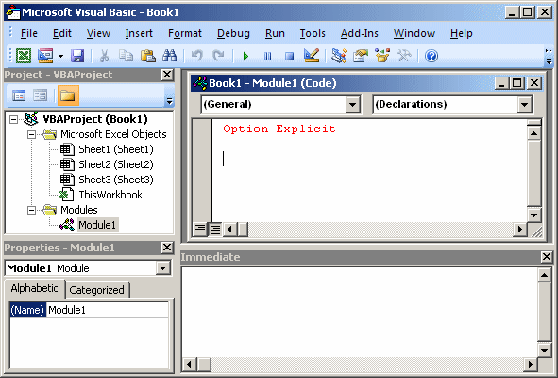
- To return to Microsoft Excel, on the Standard toolbar of Visual Basic, click the View Microsoft Excel button

