Userform
This lab teaches you how to create an Excel VBA Userform (also known as a dialog box).

Userform Example
The Userform we are going to create looks as follows.
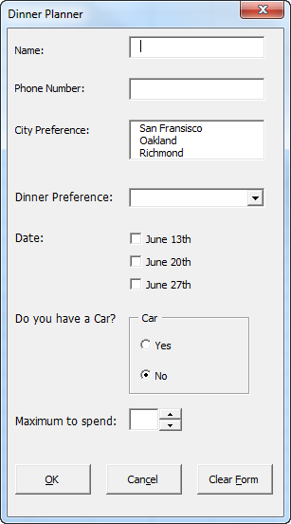

Controls
The most important Controls that can be added to an Excel VBA Userform are:
Labels
Examples of labels in our Userform are: 'Name:' , 'Phone Number:' , 'City Preference:' , 'Dinner Preference:' , etc.
Textboxes
The three boxes next to the Labels 'Name:' , 'Phone Number:' and 'Maximum to spend:' are textboxes.
Listboxes
The box next to the Label 'City Preference:' is a listbox.
Comboboxes
The dropdown-list next to the Label 'Dinner Preference:' is a combobox.
Note: a combobox is the same as a listbox except that the user can now also fill in his/her own choice if his/her choice is not included in the list.
Checkboxes and Option buttons
'June 13th', 'June 20th' and 'June 27th' are examples of Checkboxes. 'Yes' and 'No' are examples of option buttons.
Note: Checkboxes and option buttons are primarily the same except that option buttons are dependent on each other while checkboxes are not. This means that when you want to check one option button the other option button will automatically uncheck.
Frames
The field with name 'Car' including the two option buttons is a Frame control.
Note: in order for option buttons to have the dependent functionality described earlier it is best to place the option buttons in a Frame control.
Command buttons
The three command buttons at the bottom of the Userform are examples of command buttons.
Spin buttons
The spin button is placed next to the textbox at the bottom of the Userform.

Create the Userform
Now it is time to create the Userform!
1. Launch the Visual Basic Editor.
2. Click on ThisWorkbook from the Project Explorer. If the Project Explorer is not visible, click on View and then Project Explorer.
3. From the Menu click on Insert and then Userform. Your screen should be set up as below:
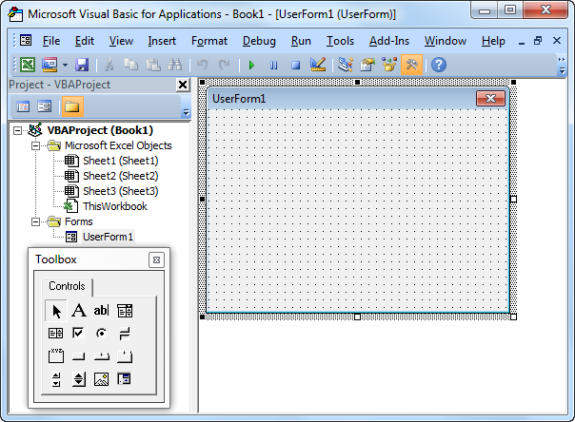
4. If the Toolbox does not appear automatically, click on View and then Toolbox.
5. Add all the controls. Once this has been completed, the result should be consistent with the picture of the Userform shown earlier. For example, create a Label by clicking on Label from the Toolbox. Next, you can drag a Label on the Userform. When you arrive at the CarFrame, remember to draw this Frame first before you place the two option buttons in it.

6. Change the names and the captions of the controls. Right mouse click on each control. Then click on Properties. Names are used in the Excel VBA code. Captions are those that appear on your screen. Change the names and captions of the controls according to the table below.
Control | Name (in VBA) | Caption
Userform | DinnerPlannerUserForm | Dinner Planner
Textbox | NameTextBox | N/A
Textbox | PhoneTextBox | N/A
Listbox | CityListBox | N/A
Combobox | DinnerComboBox | N/A
Checkbox | DateCheckBox1 | June 13th
 | DateCheckBox2 | June 20th
 | DateCheckBox3 | June 27th
Frame | CarFrame | Car
Option button | CarOptionButton1 | Yes
 | CarOptionButton2 | No
Textbox | MoneyTextBox | N/A
Spin button | MoneySpinButton | N/A
Command button | OKButton | OK
Command button | CancelButton | Cancel
Command button | ClearButton | Clear Form
9 Labels | No need to change | See Picture
Note: it is good practice to change the names of controls. This will make your code easier to read.

Show the Userform
To show the Userform, place a command button on your worksheet and add the following code line:
Private Sub CommandButton1_Click()
DinnerPlannerUserForm.Show
End Sub

UserForm_Initialize
The Sub UserForm_Initialize runs automatically whenever the Userform is loaded. Thus, when you use the Show method for the Userform, the code will automatically be executed.
Private Sub UserForm_Initialize()
'Empty NameTextBox
NameTextBox.Value = ""
'Empty PhoneTextBox
PhoneTextBox.Value = ""
'Empty CityListBox
CityListBox.Clear
'Fill CityListBox
With CityListBox
.AddItem "San Fransisco"
.AddItem "Oakland"
.AddItem "Richmond"
End With
'Empty DinnerComboBox
DinnerComboBox.Clear
'Fill DinnerComboBox
With DinnerComboBox
.AddItem "Italian"
.AddItem "Chinese"
.AddItem "Frites and Meat"
End With
'Uncheck DataCheckBoxes
DateCheckBox1.Value = False
DateCheckBox2.Value = False
DateCheckBox3.Value = False
'Set no car as default
CarOptionButton2.Value = True
'Empty MoneyTextBox
MoneyTextBox.Value = ""
'Set Focus on NameTextBox
NameTextBox.SetFocus
End Sub
Result of the code: Fields are emptied, lists are populated and checkboxes are unchecked. CarOptionButton2 is set as default, assuming that most of the people do not have a car. Finally, the last code line sets the focus on NameTextbox as this is where we want to start when the Userform is loaded. To add this code to the Userform, execute the following steps.
1. Launch the Visual Basic Editor.
2. Click on View and then Code from the Menu or right click on the Userform and then View Code.
3. The code window will appear showing you two drop-down lists. Choose Userform from the left drop-down list. Choose Initialize from the right drop-down list.
4. Add the code.

Assign a macro to the Cancel button
To close the Excel VBA Userform when you click on the Cancel button, execute the following steps.
1. Launch the Visual Basic Editor.
2. Double click on DinnerPlannerUserForm from the Project Explorer.
3. Double click on the Cancel button.
4. Add the following code line:
Private Sub CancelButton_Click()
Unload Me
End Sub

Assign a macro to the Clear button
To call the Sub UserForm_Initialize when you click on the Clear button, execute the following steps.
1. Launch the Visual Basic Editor.
2. Double click on DinnerPlannerUserForm from the Project Explorer.
3. Double click on the Clear button.
4. Add the following code line:
Private Sub ClearButton_Click()
Call UserForm_Initialize
End Sub

Assign a macro to the OK button
After clicking on the OK button, the information from the Userform will be placed on your worksheet.
Private Sub OKButton_Click()
Dim emptyRow As Long
'Make Sheet1 Active
Sheets(1).Activate
'Determine emptyRow
emptyRow = WorksheetFunction.CountA(Range("A:A")) + 1
'Export Data to worksheet
Cells(emptyRow, 1).Value = NameTextBox.Value
Cells(emptyRow, 2).Value = PhoneTextBox.Value
Cells(emptyRow, 3).Value = CityListBox.Value
Cells(emptyRow, 4).Value = DinnerComboBox.Value
If DateCheckBox1.Value = True Then Cells(emptyRow, 5).Value = DateCheckBox1.Caption
If DateCheckBox2.Value = True Then Cells(emptyRow, 5).Value = Cells(emptyRow, 5).Value & " " & DateCheckBox2.Caption
If DateCheckBox3.Value = True Then Cells(emptyRow, 5).Value = Cells(emptyRow, 5).Value & " " & DateCheckBox3.Caption
If CarOptionButton1.Value = True Then
Cells(emptyRow, 6).Value = "Yes"
Else
Cells(emptyRow, 6).Value = "No"
End If
Cells(emptyRow, 7).Value = MoneyTextBox.Value
End Sub
Explanation of the code: First, we activate Sheet1. Next, we determine emptyRow. The information from the Userform will be placed in this row. EmptyRow increases every time a record is added. Finally, we take the information from the Userform to the specific columns of emptyRow. Double click on the OK button to add the code just like we did with the Cancel and the Clear button.

Assign a macro to the Money Spin Button
By using the Money Spin Button the user can indicate how much he/she wants to spend. Execute the following steps to program this:
1. Launch the Visual Basic Editor.
2. Double click on DinnerPlannerUserForm from the Project Explorer.
3. Double click on the Money Spin Button.
4. Add the following code line:
Private Sub MoneySpinButton_Change()
MoneyTextBox.Text = MoneySpinButton.Value
End Sub

Test the Userform
Exit the Visual Basic Editor, populate row 1, and test the Userform.
Result:
