Using Solver to Find an Employee Schedule for Notting Way Patient Care
Worksheet: TutorialNottingPatientCareSchedulingSolver.xls
Pre-requisite: familiarity with the use of Solver.
In this tutorial a weekly schedule for Notting Way Patient Care is created. The schedule is required to meet state standards of staffing. To both meet the standards and keep the payroll under control, the schedule is to be developed to meet the staffing requirements as closely as possible as well as to meet the hour limits imposed by the facility.
The scheduling criteria imposed by Notting Way for scheduled hours of work is the total hours worked by a full-time employee must not exceed 40 and a part-time employee cannot exceed 24. Employees, when scheduled, work 8 hour shifts, both part-time and full-time employees.
In addition, individual employees have scheduling constraints for the week: days they cannot work, their status (full or part time), and possibly vacation time. These constraints must be indicated on the worksheet. The scheduling of individual employees is recorded in range of cells C5 through I20. The value in each of these cells will be a 1 if scheduled or a 0 if not scheduled for that day. The end objective is to make the total shortfall (cell C25) zero.
There are a number of constraints to be addressed based on the worksheet data. For example, since Michele Landry cannot work on Saturday, this constraint is recorded as H14=0 when entered in Solver.
The worksheet model is displayed in Figure 1.
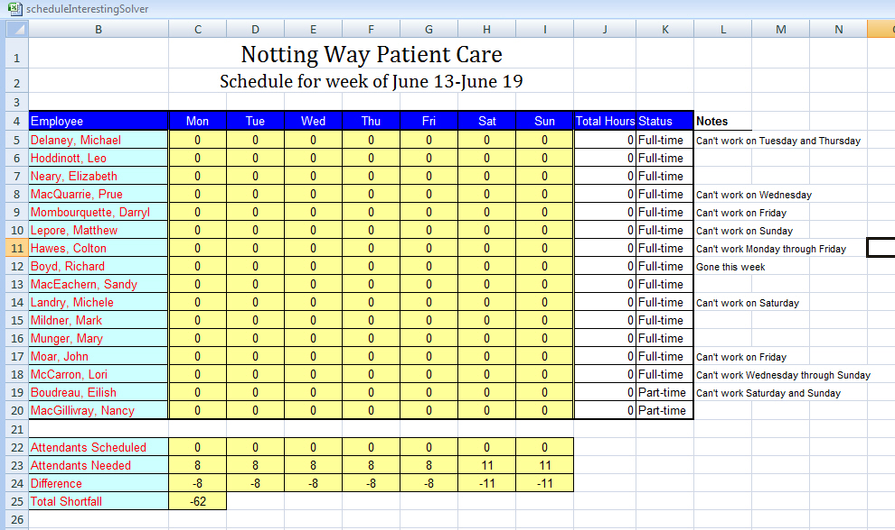
Figure 1 -- The scheduling model for Notting Way Patient Care
The basic model steps:
Step 1: In row 24 calculate the difference between the attendants scheduled and the attendants needed. The calculation is =C22-C23 for the cell C24. This formula can be copied across the row range C24:I24.
Step 2: The shortfall is the sum of the differences given by =sum(C24:I24). In our Solver model to minimize the payroll the total shortfall in cell C25 will be minimized as our objective function.
Step 3: As noted above the scheduling entries will be 1 (if scheduled) and 0 (if not scheduled). The total hours calculation for Michael Delaney will be =sum(C5:I5)*8. Copy this formula through the range J5:J20.
Step 4: The changing cells are C5:I20; Solver will enter a 1 into cells corresponding to days an employee is scheduled to work.
Constraint steps:
Step 5: Each full-time employee may work up to 40 hours per week. Michael Delaney is subject to the constraints that J5>= 0 and J5<= 40. This constraint is identical for all full-time employees -- that is, J5:J18>=0 and J5:J18 <= 40. NOTE: for Michele Landry in row 14 implementing her note as a constraint in Step 8 below will add the constraint C14:I14 = 0 which is not in conflict with the constraint here.
Step 6: Each part-time employee may work up 24 hours per week. For Eilish Boudreau (the first part-time employee) the constraints are J19>=0 and J19 <= 24. This constraint is identical for all part-time employees -- that is, J19:J20>=0 and J19:J20 <= 24.
Step 7: The constraints corresponding to the scheduling in cell C5:I20 are: C5:I20 >= 0, C5:I20 <= 1 and C5:I20 integer.
Step 8: Each note needs to be translated into a constraint. For example, Michael Delaney cannot work Tuesday or Thursday this week. This is translated into the two constraints D5 = 0 and F5 = 0.
Step 9: The number of attendants scheduled each day must be at least as large as the number of attendants needed. This yields the constraints: C24:I24 >= 0.
After completing the entry of the objective function as a minimization problem, the changing cells, and the constraints in Solver click the Solve button for the schedule.

