Visual Basic Scripting

Introduction
We’ll look at some simple examples using Visual Basic Scripting (VBScript) with Excel. VBScript is a language that can be used to program tasks in Excel. In these examples we'll create a command button which, when clicked, will execute a sequence of Visual Basic scripting commands to perform a calculation based on input entered by the user. We'll use just a few of the scripting commands that are available and these are described next.

Some Visual Basic Scripting Commands
- Sheets("Analyzer").Select
Specifies the worksheet (named "Analyzer" in this example) that contains the cell references used in the script.
- Range("c3:c5").Select
Selects a range of cells (the range c3:c5 in this example) from a worksheet (this would normally be accomplished by dragging the mouse).
- Selection.ClearContents
Clear the values (and fomulas/functions) in the selected range of cells.
- Range("c3").Value = InputBox("Enter the price of the item")
This command creates a dialog (input) box with the prompt contained within the InputBox parentheses into which the user enters the requested value. The value entered is placed in the indicated Range cell (c3 in this example).
- Range("c6").Value = Range("c3").Value * Range("c4").Value
Performs numeric calculations (the result of c3*c4 is placed in cell c6 in this example). The arithmetic operators are + (add), - (subtract), * (multiply), / (divide), and ^ (exponentiation).

Create a Command Button to Execute a Visual Basic Script
Open the AreaTriangleVB workbook. Note that the AreaTriangle worksheet contains labels for the base, height, and area of a triangle. We'll create a command button that will execute a script that prompts the user for the base and height of the triangle and then computes the area.
Create a command button using the following steps.
- Select the Developer tab and then click on the Insert button in the Controls section.
- Select the command button from the ActiveX Controls (first row and leftmost selection under ActiveX Controls as seen in Figure 1 below). Note that the Design Mode button is now selected in the Controls group.
- Left click and drag over the range b10:c11 to position the button as seen in Figure 2 below.
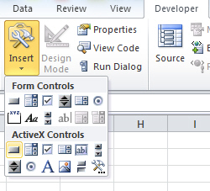
Figure 1. Inserting a command button
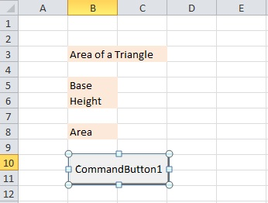
Figure 2. Spreadsheet with command button
To name the button, right click on the button for a menu (see Figure 3) and select CommandButton Object and then Edit from the submenu. Remove the current text and enter a meaningful name such as "Compute Area".
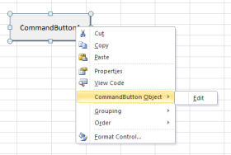
Figure 3. Editing and naming the command button

Accessing the VB Scripting window
Next we'll enter the scripting commands to prompt the user for the base and height of the triangle and then compute the area.
In Design Mode double click on the command button. This opens a window in which you enter Visual Basic commands as seen in Figure 4.
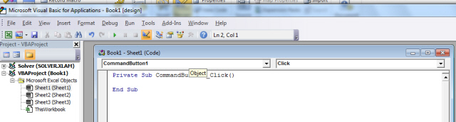
Figure 4. Visual Basic Scripting window
We'll enter the scripting commands between the two lines that indicate the subroutine (a subroutine is a named group of commands) to execute when the command button is clicked. Note that this group of commands is appropriately named CommandButton1_Click().
The area of a triangle is computed using the formula area = base * height/2. Since these operations can all be performed in a script, no Excel formula or function needs to be used in this model. The problem has two input parameters that need to be supplied by the user -- the base and the height of the triangle.
The script for this problem, with explanatory comments (lines beginning with a '), is given below.
'set the worksheet to the one containing the model
Sheets("AreaTriangle").Select
'select the cells containing the input and output values
Range("c5:c6,c8").Select
'clear these cells of the current values
Selection.ClearContents
'prompt and dialog box for user
Range("c5").Value = InputBox("Enter Base of the Triangle")
Range("c6").Value = InputBox("Enter Height of Triangle")
'compute the area from inputs
Range("c8").Value = Range("c5").Value * Range("c6").Value/2
'position the cursor on the cell with the computed value
Range("c8").Select

Copy these commands into the subroutine in the scripting window.
Close the script window by clicking on the close button X in the top right corner of the window.
Exit Design Mode by clicking on the selected button in the Controls group.
Now run the script by clicking on the Compute Area command button. If there are errors in the script you will get an error message and the cursor is placed at the likely location of the error. Once you have corrected the problems, close the window and leave the debugger.
Figure 5 below shows the results from one execution of the script.
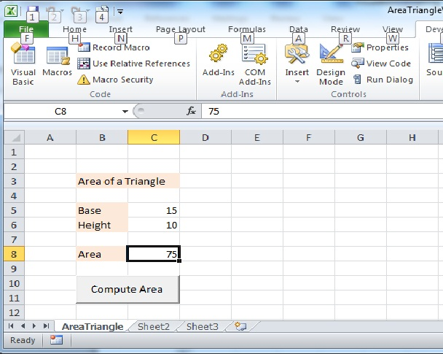
Figure 5. Results of script execution
IMPORTANT: To save the workbook use File | Save As and select the save type as Excel Macro-Enabled Workbook. Save the workbook with the name AreaTriangleVB.

Another Example: Loan Payment Model
In this model there are four input parameters: the amount of the purchase, the down payment, the annual interest rate, and the number of years for paying off the loan. There are two computations, the actual loan amount (purchase price - down payment), which can be computed in the script, and the monthly payment for the loan, for which the model uses the Excel =pmt() function. Note that when the script clears previous data it cannot clear the cell containing the formula for the monthly payment since this is computed using an Excel function and clearing this cell, c10, would remove the function from the worksheet.
Open the workbook MonthlyLoanPaymentVB. Note that the worksheet named LoanModel contains labels for the purchase amount, the down payment, the loan amount, the annual interest rate, and the number of years to pay off the loan. The corresponding values are to be entered in the cells c4, c5, c6, c7 and c8 respectively. The command button is labeled Compute Monthly Payment as seen in Figure 6 below.
In cell c10 enter the function to compute the monthly payment (adjusted for sign):
=-pmt(c7/12, c8*12, c6)

Notice in the script below that the range selected for the ClearContents action does not include c10!
A script for the model is:
Private Sub CommandButton1_Click()
Sheets("LoanModel").Select
Range("c4:c8").Select
Selection.ClearContents
Range("c4").Value = InputBox("Enter price")
Range("c5").Value = InputBox("Enter down payment")
Range("c6").Value = Range("c4").Value - Range("c5").Value
Range("c7").Value = InputBox("Enter annual interest rate as decimal (e.g. 0.05 for 5%)")
Range("c8").Value = InputBox("Enter number of years to pay off the loan")
Range("c10").Select
End Sub

Enter the script and then click on the command button to execute it and produce the results in Figure 6 below.
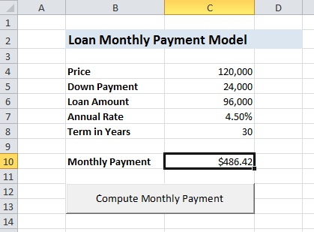
Figure 6. Results of Loan Monthly Payment Model script execution

