Why Use VBA in Excel 2010?
Microsoft Excel 2010 is an extremely powerful tool that you can use to manipulate, analyze, and present data. Sometimes though, despite the rich set of features in the standard Excel user interface (UI), you might want to find an easier way to perform a mundane, repetitive task, or to perform some task that the UI does not seem to address. Fortunately, Office applications like Excel have Visual Basic for Applications (VBA), a programming language that gives you the ability to extend those applications.
VBA works by running macros, step-by-step procedures written in Visual Basic. Learning to program might seem intimidating, but with some patience and some examples such as the ones in this paper, many users find that learning even a small amount of VBA code makes their work easier and gives them the ability to do things in Office that they did not think were possible. Once you have learned some VBA, it becomes much easier to learn a whole lot more—so the possibilities here are limitless.
By far the most common reason to use VBA in Excel is to automate repetitive tasks. For example, suppose that you have a few dozen workbooks, each of which has a few dozen worksheets, and each of those needs to have some changes made to it. The changes could be as simple as applying new formatting to some fixed range of cells or as complex as looking at some statistical characteristics of the data on each sheet, choosing the best type of chart to display data with those characteristics, and then creating and formatting the chart accordingly.
Either way, you would probably rather not have to perform those tasks manually, at least not more than a few times. Instead, you could automate the tasks by using VBA to write explicit instructions for Excel to follow.
VBA is not just for repetitive tasks though. You can also use VBA to build new capabilities into Excel (for example, you could develop new algorithms to analyze your data, then use the charting capabilities in Excel to display the results), and to perform tasks that integrate Excel with other Office applications such as Microsoft Access 2010. In fact, of all the Office applications, Excel is the one most used as something that resembles a general development platform. In addition to all the obvious tasks that involve lists and accounting, developers use Excel in a range of tasks from data visualization to software prototyping.
Despite all of the good reasons to use VBA in Excel 2010, it is important to remember that the best solution to a problem might not involve VBA at all. Excel has a large range of features even without VBA, so even a power user is unlikely to be familiar with them all. Before you settle on a VBA solution, search the Help and online resources thoroughly to make sure that there is not a simpler way.

VBA Programming 101

Using Code to Make Applications Do Things
You might think that writing code is mysterious or difficult, but the basic principles use every-day reasoning and are quite accessible. The Office 2010 applications are created in such a way that they expose things called objects that can receive instructions. You interact with applications by sending instructions to various objects in the application. These objects are many, varied, and flexible, but they have their limits. They can only do what they are designed to do, and they will only do what you instruct them to do.

Objects
Programming objects relate to each other systematically in a hierarchy called the object model of the application. The object model roughly mirrors what you see in the user interface; for example, the Excel object model contains the Application, Workbook, Sheet, and Chart objects, among many others. The object model is a conceptual map of the application and its capabilities.

Properties and Methods
You can manipulate objects by setting their Properties and calling their Methods. Setting a property changes some quality of the object. Calling a method causes the object to perform some action. For example, the Workbook object has a Close method that closes the workbook, and an ActiveSheet property that represents the sheet that is currently active in the workbook.

Macros and the Visual Basic Editor
Now that you know something about how Microsoft Excel 2010 exposes its object model, you can try calling object methods and setting object properties. To do so, you must write your code in a place and in a way that Office can understand; typically, by using the Visual Basic Editor. Although it is installed by default, many users do not know that it is even available until it is enabled on the ribbon.

Developer Tab
All Office 2010 applications use the ribbon. One tab on the ribbon is the Developer tab, where you access the Visual Basic Editor and other developer tools. Because Office 2010 does not display the Developer tab by default, you must enable it using the following procedure:

To enable the Developer tab
- On the File tab, choose Options to open the Excel Options dialog box.
- Click Customize Ribbon on the left side of the dialog box.
- Under Choose commands from on the left side of the dialog box, select Popular Commands.
- Under Customize the ribbon on the right side of the dialog box, select Main tabs, and then select the Developer check box.
- Click OK.
After Excel displays the Developer tab, note the location of the Visual Basic, Macros, and Macro Security buttons on the tab.
Figure 1. Developer tab in Excel 2010
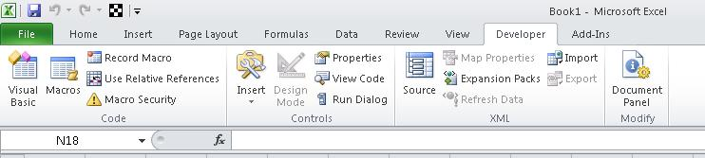

Security Issues
Click the Macro Security button to specify which macros can run and under what conditions. Although rogue macro code can seriously damage your computer, security conditions that prevent you from running helpful macros can seriously undermine your productivity. Macro security is a complex and involved topic that you should study and understand if you work with Excel macros.
For the purposes of this article, be aware that if the Security Warning: Macros have been disabled bar appears between the ribbon and the worksheet when you open a workbook that contains a macro, you can click the Enable Content button to enable the macros.
Also, as a security measure, you cannot save a macro in the default Excel file format (.xlsx); instead, you must save the macro in a file with a special extension, .xlsm.
Your First Program
There are two ways which you could program a VBA, one is to place a button on the spreadsheet and start programming by clicking the button, another one is to write Visual Basic functions inside the VB Editor. Let’s start with the button first. In order to place a button on the spreadsheet, you need to click Developer tab on the MS Excel menu bar and then click on Insert and finally select the Form Controls. Then click on the button and draw it on the spreadsheet.
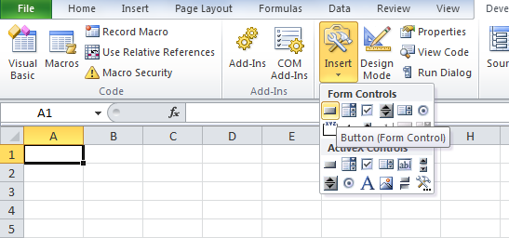 | 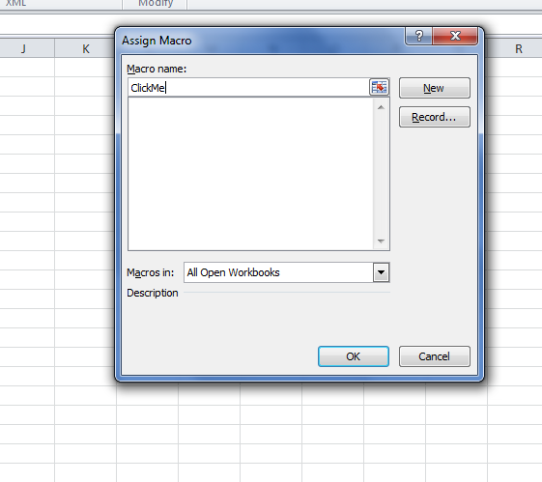
Next a dialog box will appear. Then enter name of the macro Welcome as in the figure and click OK. This will open the VBA Editor where you will enter the code below
Sub ClickMe()
Range("A1:A10").Value = "Visual Basic"
Range("A11").Value = 10
Range("B11").Value = 20

Range("C11").Value = Range("A11").Value + Range("B11").Value
End Sub
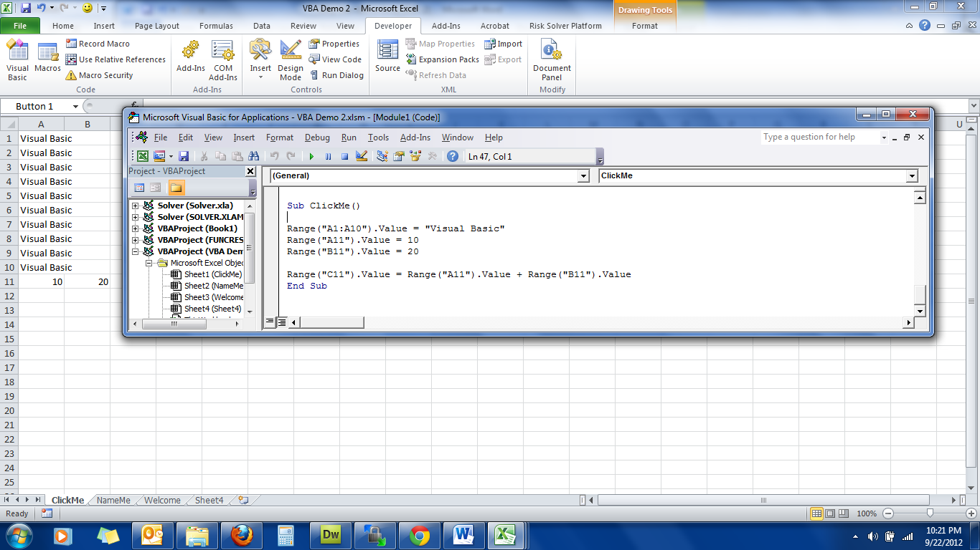

The Output
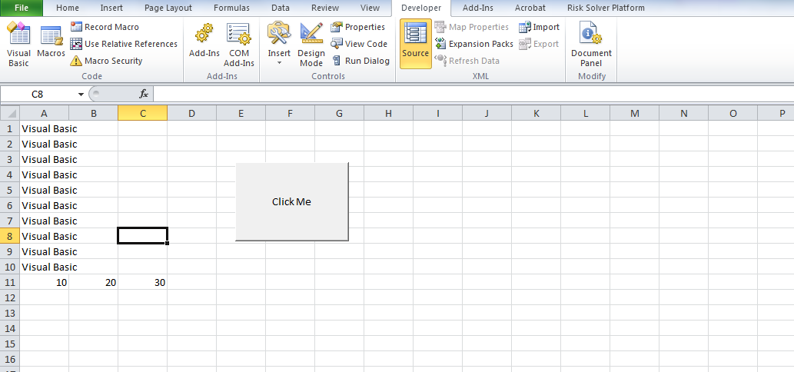

Working with Variables in Excel VBA
2.1 The Concept of Variables
Variables are like mail boxes in the post office. The contents of the variables changes every now and then, just like the mail boxes. In VBA, variables are areas allocated by the computer memory to hold data. Like the mail boxes, each variable must be given a name. To name a variable in VBA, you have to follow a set of rules, as follows:
a) Variable Names: The following are the rules when naming the variables in VBA
- It must be less than 255 characters
- No spacing is allowed
- It must not begin with a number
- Period is not permitted
Examples of valid and invalid variable names are displayed in the table below (2.1)
Valid Name | Invalid Name
My_Car | My.Car
ThisYear | 1NewBoy
Long_Name_Can_beUSE | He&HisFather *& is not acceptable
Group88 | Student ID * Spacing not allowed
Table 2.1 : Example of valid and invalid variable names

Declaring Variables
In VBA, one needs to declare the variables before using them by assigning names and data types. There are many VBA data types, which can be grossly divided into two types, namely the numeric data types and non-numeric data types

Numeric Data Types
Numeric data types are types of data that consist of numbers, which can be computed mathematically with various standard operators such as add, minus, multiply, divide and so on. In VBA, the numeric data are divided into 7 types, which are summarized in Table 2.2
Type | Storage | Range of Values
Byte | 1 byte | 0 to 255
Integer | 2 bytes | -32,768 to 32,767
Long | 4 bytes | -2,147,483,648 to 2,147,483,648
Single | 4 bytes | -3.402823E+38 to -1.401298E-45 for negative values  1.401298E-45 to 3.402823E+38 for positive values.
Double | 8 bytes | -1.79769313486232e+308 to -4.94065645841247E-324 for negative values  4.94065645841247E-324 to 1.79769313486232e+308 for positive values.
Currency | 8 bytes | -922,337,203,685,477.5808 to 922,337,203,685,477.5807
Decimal | 12 bytes | +/- 79,228,162,514,264,337,593,543,950,335 if no decimal is use  +/- 7.9228162514264337593543950335 (28 decimal places).

Table 2.2: Numeric Data Types

Non-numeric Data Types

The nonnumeric data types are summarized in Table 2.3
Data Type | Storage | Range
String(fixed length) | Length of string | 1 to 65,400 characters
String(variable length) | Length + 10 bytes | 0 to 2 billion characters
Date | 8 bytes | January 1, 100 to December 31, 9999
Boolean | 2 bytes | True or False
Object | 4 bytes | Any embedded object
Variant(numeric) | 16 bytes | Any value as large as Double
Variant(text) | Length+22 bytes | Same as variable-length string

Table 2.3: Nonnumeric Data Types

You can declare the variables implicitly or explicitly. For example, total=text1.text means that the variable total is declared implicitly and ready to receive the input in Text1 textbox. Other examples of implicit declaration are volume=8 and label=”Welcome”. On the other hand, for explicit declaration, variables are normally declared in the general section of the codes' windows using the Dim statement. The format is as follows:

Dim variableName as DataType

Example 2.1
Dim password As String
Dim yourName As String
Dim firstnum As Integer
Dim secondnum As Integer
Dim total As Integer
Dim BirthDay As Date
You may also combine them in one line, separating each variable with a comma, as follows:
Dim password As String, yourName As String, firstnum As Integer.
If the data type is not specified, VB will automatically declare the variable as a Variant. For string declaration, there are two possible formats, one for the variable-length string and another for the fixed-length string. For the variable-length string, just use the same format as Example 2.1 above. However, for the fixed-length string, you have to use the format as shown below:
Dim VariableName as String * n
where n defines the number of characters the string can hold. For example, Dim yourName as String * 10 mean yourName can hold no more than 10 Characters.
Example 2.2  In this example, we declared three types of variables, namely the string, date and currency.  Sub  NameMe()  Dim YourName As String  Dim BirthDay As Date  Dim Income As Currency  YourName = "Alex"  BirthDay = "1 April 1980"  Income = 1000  Range("A1") = YourName  Range("A2") = BirthDay  Range("A3") = Income  End Sub | The output screen of Example 2.2  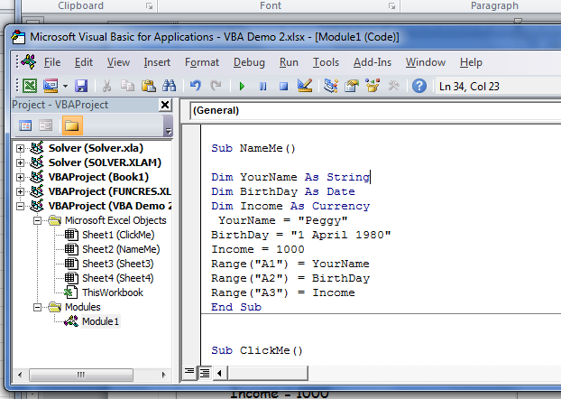

Message Box
Previously we have shown how you can display phrases in a range of cells and also perform arithmetic operations in MS Excel. Today, I shall demonstrate how we can display message boxes in a MS Excel worksheet . A message box normally acts as a dialog box where users can interact with the computer, it is able to perform certain actions in response to what the user clicks or selects. The format for a message box is as follows:
message=MsgBox(Prompt, Style Value,Title)
The first argument, Prompt, will display the message in the message box. The Style Value determines what type of command button will appear in the message box. . The Title argument will display the title of the message board. message is a variable that holds values that are returned by the MsgBox ( ) function. The values are determined by the type of buttons being clicked by the users. It has to be declared as Integer data type in the procedure or in the general declaration section. Please refer to Lesson 10 of Visual Basic Tutorial for the detail listings of the Style Value as well as the returned value.
In this example, I create three command buttons which show different Options. I put in a bit of program code in the last button which involves the use of If...Then...Elseif statements.

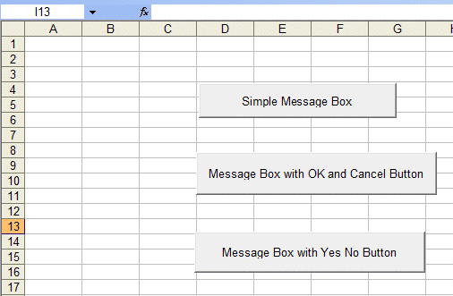 | 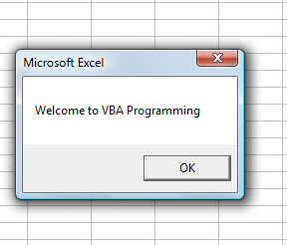  This is the message box displayed by clicking the first button  The code follows:  Sub Welcome()  MsgBox ("Welcome to VBA Programming")  End Sub
The code for the second button  Sub Message1()  Dim message As Integer  message = MsgBox("Click Yes to Proceed, No to stop", vbYesNoCancel, "Login")  If message = 6 Then  Range("A1").Value = "You may proceed"  ActiveWorkbook.Activate  ElseIf message = 7 Then  ActiveWorkbook.Close  End If  End Sub  The message box displays Yes, No and Cancel buttons.  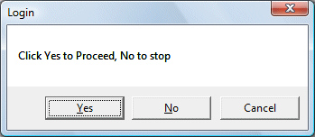 | The code for the third button:  Sub Message2()  Dim message As Integer  message = MsgBox("Click Yes to Proceed, No to stop", vbYesNo, "Login")  If message = 6 Then  Range("A1").Value = "You may proceed"  ActiveWorkbook.Activate  ElseIf message = 7 Then  ActiveWorkbook.Close  End If  End Sub  The message box displays Yes and No buttons  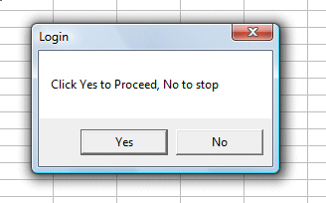
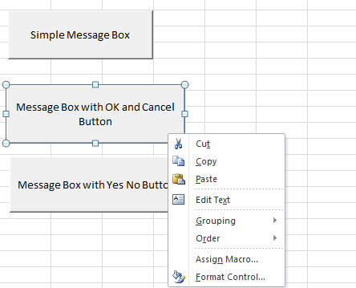
To display captions in the Command buttons, while Design Mode in the Developer tab, right click on the button. In the popup menu, click on Edit Text.

Using If.....Then....Else
Visual Basic Editor in MS Excel is just as powerful as the stand alone Visual Basic compiler in the sense that you can use the same commands in programming. For example, you can use If..Then...Else to control program flow and display certain output based on certain conditions in MS Excel. Here, I am going to demonstrate the concept using one example.
In this program, you place the button on the MS Excel spreadsheet and go into the VB editor by clicking on the button. At the VB editor, key in the program code below.
I used randomize timer and the RND function to generate random numbers. In order to generate random integers between 0 and 100, I combined the syntax Int(Rnd*100). For example, when Rnd=0.6543, then Rnd*100=65.43, and Int(65.43)=65. Using the statement cells(1,1).Value=mark will place the value of 65 into cell(1,1).
Now, based on the mark in cells(1,1), I use the If.......Then....Elseif statements to put the corresponding grade in cells(2,1). So, when you click on command button 1, it will put a random number between 1 and 100 in cells(1,1) and the corresponding grade in cells(2,1). The Interface
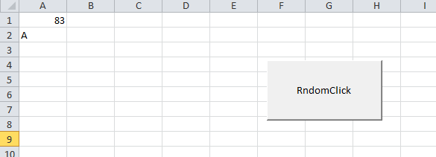
The Code
Sub RandomClick()
Dim mark As Integer
Dim grade As String
Randomize Timer
mark = Int(Rnd * 100)
Cells(1, 1).Value = mark
If mark < 20 And mark >= 0 Then
grade = "F"
Cells(2, 1).Value = grade
ElseIf mark < 30 And mark >= 20 Then
grade = "E"
Cells(2, 1).Value = grade
ElseIf mark < 40 And mark >= 30 Then
grade = "D"
Cells(2, 1).Value = grade
ElseIf mark < 50 And mark >= 40 Then
grade = "C-"
Cells(2, 1).Value = grade
ElseIf mark < 60 And mark >= 50 Then
grade = "C"
Cells(2, 1).Value = grade
ElseIf mark < 70 And mark >= 60 Then
grade = "C+"
Cells(2, 1).Value = grade
ElseIf mark < 80 And mark >= 70 Then
grade = "B"
Cells(2, 1).Value = grade
ElseIf mark <= 100 And mark >=80 Then
grade = "A"
Cells(2, 1).Value = grade
End If
End Sub

Looping
Looping is a procedure in Excel VBA that performs repetitive tasks. There are two kinds of loops in Excel VBA, the For.......Next loop and the Do...Loop . To demonstrate the For....Next loop in Excel VBA, here are two examples:
Example 1:
Sub OneLoop()
Dim i As Integer
For i = 1 To 10
Cells(i, 1).Value = i
Next
End Sub
In this VBA program, when you click on the button , the VBA program will fill cells(1,1) with the value of 1, cells(2,1) with the value of 2, cells(3,1) with the value of 3......until cells (10,1) with the value of 10. The position of each cell in the Excel spreadsheet is referenced with cells(i,j), where i represents row and j represent column.
In example 2,we use the nested loop to put the values of i+j from cells(1,1),cells(1,2),cells(1,3),cells(1,4),cells(1,5) ..........until cells(10,5). The code and output are shown below.
Example 1 | Example 2
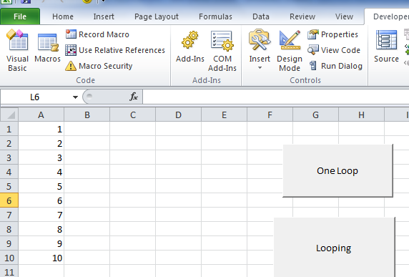 | 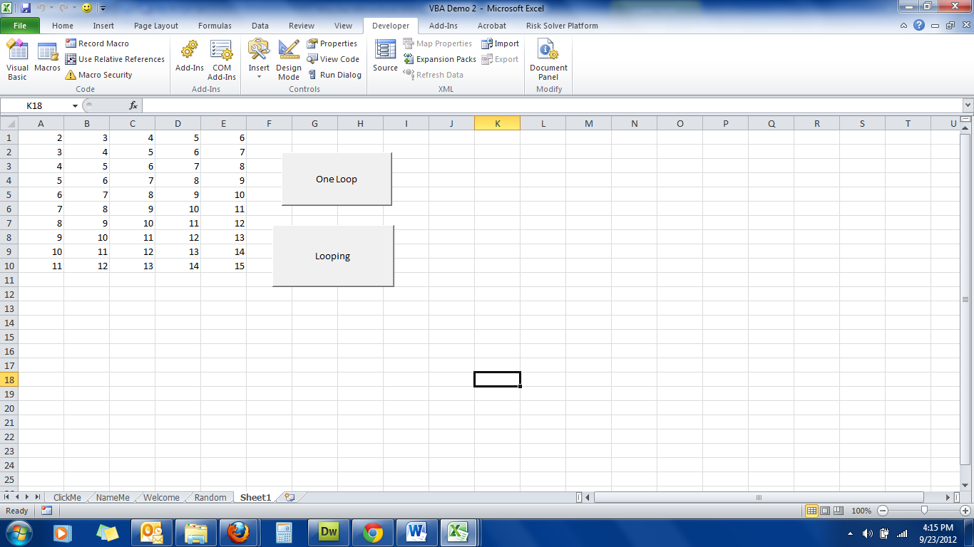
Example 2
Sub Looping()
Dim i, j As Integer
For i = 1 To 10
For j = 1 To 5
Cells(i, j).Value = i + j
Next j
Next i
End Sub

DO.........LOOP
In the previous chapter, you have learned to use the For........Next loop to execute a repetitive process. In this chapter, you will learn about another looping method know as the Do Loop. There are four ways you can use the Do Loop as show below.
i) Do...........Loop While
(ii) Do until.............Loop
(iii) Do while............Loop
(iv) Do............Loop until
 | Example 1:  Arranging numbers in ascending order  Sub DoLoop10()  Dim counter As Integer  Do  counter = counter + 1  Cells(counter, 1) = counter  Loop While counter < 10  End Sub  In this example, the program will keep on adding 1 to the preceding counter value as long as the counter value is less than 10. It displays 1 in cells(1,1), 2 in cells(2,1)…. until 10 in cells (10,1). |  | Example 2:  Arranging numbers in descending order  Sub OrderLoop()  Dim counter As Integer  Do Until counter = 10  counter = counter + 1  Cells(counter, 1) = 11 - counter  Loop  End Sub  In this example, the program will keep adding 1 to the preceding counter value until the counter value reaches 10. It displays 10 in cells(1,1), 9 in cells(2,1)….. until 1 in cells (10,1). |  | Examle 3  Sub OrderXY()  Dim counter , sum As Integer  'To set the alignment to center  Range("A1:C11").Select  With Selection  .HorizontalAlignment = xlCenter  End With  Cells(1, 1) = "X"  Cells(1, 2) = "Y"  Cells(1, 3) = "X+Y"  Do While counter < 10  counter = counter + 1  Cells(counter + 1, 1) = counter  Cells(counter + 1, 2) = counter * 2  sum = Cells(counter + 1, 1) + Cells(counter + 1, 2)  Cells(counter + 1, 3) = sum  Loop  End Sub  In this example, the program will display the values of X in cells(1,1) to cells(11,1). The value of Y is X² and the values are display in column 2, i.e. from cells(2,1) to cells(2,11). Finally, it shows the values of X+Y in column 3, i.e. from cells(3,1) to cells(3,11)
 | Example 1  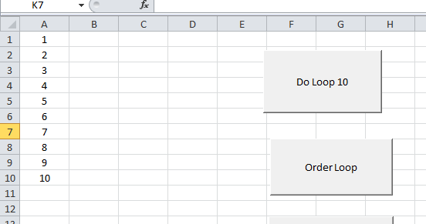 |  |  | Example 2  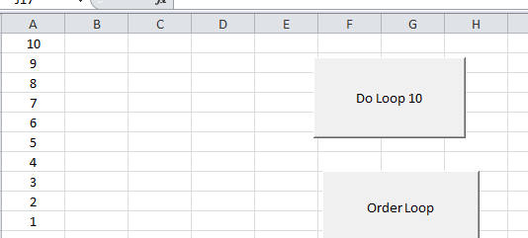
Example 3
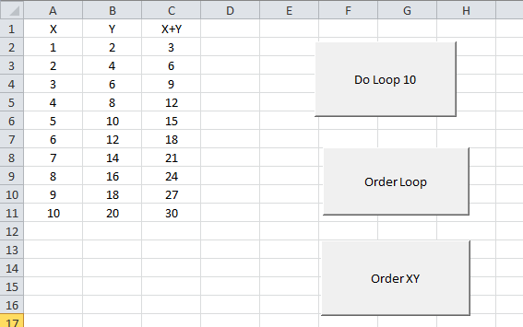

Select Case.........End Select
Normally it is sufficient to use the conditional statement If....Then....Else for multiple options or selections programs. However, if there are too many different cases, the If...Then...Else structure could become too bulky and difficult to debug if problems arise. Fortunately, Visual Basic provides another way to handle complex multiple choice cases, that is, the Select Case.....End Select decision structure. The general format of a Select Case...End Select structure is as follow:
Select Case variable
Case value 1
Statement
Case value 2
Statement
Case value 3
Statement
..
.
.
Case Else

End Select
In the following example, I will show you how to process the grades of students according to the marks given.
 | Sub CaseSelect()  Dim mark As Single  Dim grade As String  mark = Cells(1, 1).Value  'To set the alignment to center  Range("A1:B1").Select  With Selection  .HorizontalAlignment = xlCenter  End With  Select Case mark  Case 0 To 59  grade = "F"  Cells(1, 2) = grade  Case 60 To 69  grade = "D"  Cells(1, 2) = grade  Case 70 To 79  grade = "C"  Cells(1, 2) = grade  Case 80 To 89  grade = "B"  Cells(1, 2) = grade  Case 90 To 100  grade = "A"  Cells(1, 2) = grade  Case Else  grade = "Error!"  Cells(1, 2) = grade  End Select  End Sub | Explanation:  To set the cell align alignment to center, we use the following procedure:  Range("A1:B1").Select  With Selection  .HorizontalAlignment = xlCenter  End With  We can use the statement case value1 to value 2 to specify the range of values that fulfill the particular case.  You should also include the error case where the values entered are out of the range or invalid. For example, if the examination mark is from 0 to 100, then any value out of this range is invalid. In this program, I use case else to handle the error entries.  The diagram on the lower left illustrates the output of this example.  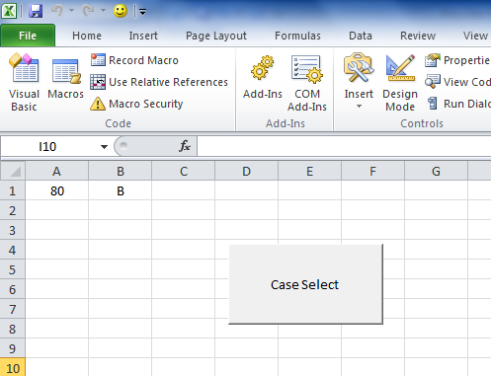

Writing Your First VBA Function in Excel

About User Defined Functions
Excel provides the user with a large collection of ready-made functions, more than enough to satisfy the average user. Many more can be added by installing the various add-ins that are available.
Most calculations can be achieved with what is provided, but it isn't long before you find yourself wishing that there was a function that did a particular job, and you can't find anything suitable in the list. You need a UDF.
A UDF (User Defined Function) is simply a function that you create yourself with VBA. UDFs are often called "Custom Functions". A UDF can remain in a code module attached to a workbook, in which case it will always be available when that workbook is open. Alternatively you can create your own add-in containing one or more functions that you can install into Excel just like a commercial add-in.
UDFs can be accessed by code modules too. Often UDFs are created by developers to work solely within the code of a VBA procedure and the user is never aware of their existence.
Like any function, the UDF can be as simple or as complex as you want. Let's start with an easy one...

A Function to Calculate the Area of a Rectangle
Yes, I know you could do this in your head! The concept is very simple so you can concentrate on the technique.
Suppose you need a function to calculate the area of a rectangle. You look through Excel's collection of functions, but there isn't one suitable. This is the calculation to be done:
AREA = LENGTH x WIDTH
Open a new workbook and then open the Visual Basic Editor (Developer Tab> Visual Basic Editor or ALT+F11).
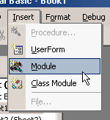 | You will need a module in which to write your function so choose Insert > Module. Into the empty module type: Function Area and press ENTER.  The Visual Basic Editor completes the line for you and adds an End Function line as if you were creating a subroutine.  So far it looks like this...
Function Area()

End Function
Place your cursor between the brackets after "Area". If you ever wondered what the brackets are for, you are about to find out! We are going to specify the "arguments" that our function will take (an argument is a piece of information needed to do the calculation). Type Length as double, Width as double and click in the empty line underneath. Note that as you type, a scroll box pops-up listing all the things appropriate to what you are typing.
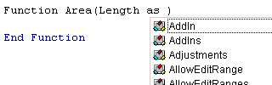
This feature is called Auto List Members. If it doesn't appear either it is switched off (turn it on at Tools > Options > Editor) or you might have made a typing error earlier. It is a very useful check on your syntax. Find the item you need and double-click it to insert it into your code. You can ignore it and just type if you want. Your code now looks like this...
Function Area(Length As Double, Width As Double)

End Function
Declaring the data type of the arguments is not obligatory but makes sense. You could have typed Length, Width and left it as that, but warning Excel what data type to expect helps your code run more quickly and picks up errors in input. The double data type refers to number (which can be very large) and allows fractions.
Now for the calculation itself. In the empty line first press the TAB key to indent your code (making it easier to read) and type Area = Length * Width. Here's the completed code...
Function Area(Length As Double, Width As Double)
Area = Length * Width
End Function
You will notice another of the Visual Basic Editor's help features pop up as you were typing, Auto Quick Info...
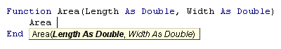
It isn't relevant here. Its purpose is to help you write functions in VBA, by telling you what arguments are required.
You can test your function right away. Switch to the Excel window and enter figures for Length and Width in separate cells. In a third cell enter your function as if it were one of the built-in ones. In this example cell A1 contains the length (17) and cell B1 the width (6.5). In C1 I typed =area(A1,B1) and the new function calculated the area (110.5)...
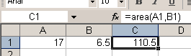
Sometimes, a function's arguments can be optional. In this example we could make the Width argument optional. Supposing the rectangle happens to be a square with Length and Width equal. To save the user having to enter two arguments we could let them enter just the Length and have the function use that value twice (i.e. multiply Length x Length). So the function knows when it can do this we must include an IF Statement to help it decide.
Change the code so that it looks like this...
Function Area(Length As Double, Optional Width As Variant)
If IsMissing(Width) Then
Area = Length * Length
Else
Area = Length * Width
End If
End Function
Note that the data type for Width has been changed to Variant to allow for null values. The function now allows the user to enter just one argument e.g. =area(A1). The IF Statement in the function checks to see if the Width argument has been supplied and calculates accordingly...
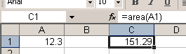
Now for a more practical example...

A Function to Calculate Fuel Consumption
I like to keep a check on my car's fuel consumption so when I buy fuel I make a note of the mileage and how much fuel it takes to fill the tank. Here in the UK fuel is sold in litres. The car's milometer (OK, so it's an odometer) records distance in miles. And because I'm too old and stupid to change, I only understand MPG (miles per gallon).
Now if you think that's all a bit sad, how about this. When I get home I open up Excel and enter the data into a worksheet that calculates the MPG for me and charts the car's performance.
The calculation is the number of miles the car has travelled since the last fill-up divided by the number of gallons of fuel used...
MPG = (MILES THIS FILL - MILES LAST FILL) / GALLONS OF FUEL
but because the fuel comes in litres and there are 4.546 litres in a gallon..
MPG = (MILES THIS FILL - MILES LAST FILL) / LITRES OF FUEL x 4.546
Here's how I wrote the function...
Function MPG(StartMiles As Integer, FinishMiles As Integer, Litres As Single)
MPG = (FinishMiles - StartMiles) / Litres * 3.79
End Function
and here's how it looks on the worksheet...
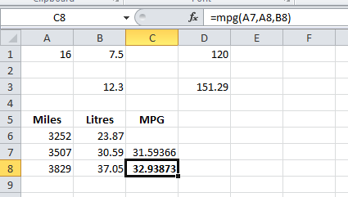

Visual Basic Editor
This following procedure shows you how to create a new blank workbook in which to store your macros. You can then save the workbook in the .xlsm format.

To create a new blank workbook
- Click the Macros button on the Developer tab.
- In the Macro dialog box that appears, type, Hello under Macro Name.
- Click the Create button to open the Visual Basic Editor with the outlines of a new macro already typed in.
VBA is a full-featured programming language with a correspondingly full-featured programming environment. This article examines only those tools that you use to get started with programming, and that excludes most of the tools in the Visual Basic Editor. With this caveat, close the Properties window on the left side of the Visual Basic Editor, and ignore the two dropdown lists that appear above the code.
Figure 2. Visual Basic Editor
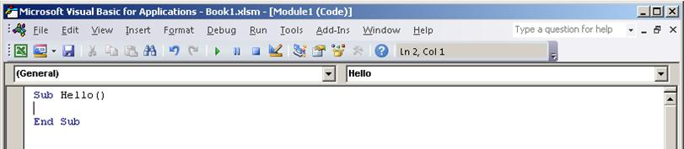
The Visual Basic Editor contains the following code.
VB
Sub Hello()

End Sub
Sub stands for Subroutine, which you can define for now as "macro". Running the Hello macro runs any code that is between Sub Hello() and End Sub.
Now edit the macro so that it looks similar to the following code.
VB
Sub Hello()
MsgBox ("Hello, world!")
End Sub
Go back to the Developer tab in Excel and click the Macros button again.
Select the Hello macro in the list that appears and then click Run to display a small message box that contains the text, "Hello, world!"
You just created and implemented custom VBA code in Excel. Click OK in the message box to close it and finish running the macro.
If the message box does not appear, check your macro security settings and restart Excel.

Making Macros Accessible
You can also get to the Macros dialog box from the View tab, but if you use a macro frequently, you might find it more convenient to access it with a keyboard shortcut or a Quick Access Toolbar button.
To create a button for the Hello macro on the Quick Access Toolbar, use the following procedure.
The following procedure describes how to make a button for a macro on the Quick Access Toolbar:

To create a button for a macro on the Quick Access Toolbar
- Click the File tab.
- Click Options to open the Excel Options dialog box, and then click Quick Access Toolbar.
- In the list under Choose commands from:, choose Macros. Find the text that is similar to Book1!Hello in the list that appears and select that text.
- Click the Add >> button to add the macro to the list on the right side, and then click the Modify… button to select a button image to associate with the macro.
- Click OK. You should see your new button on the Quick Access Toolbar above the File tab.
Now you can quickly run your macro at any time without using the Developer tab—give it a try.

A Real-World Example
Suppose that you have a workbook that contains lists on a large number of worksheets and that you want to change the name of each worksheet to match the heading of the list on that worksheet. Not every worksheet has a list on it, but if it does, the heading is in cell B1, and if it does not, cell B1 is blank. The names of worksheets without lists should be left alone.
Ordinarily, this could be a complex task that involves looking at each worksheet to see if it has a list, copying the name if it does, clicking the worksheet tab, and then pasting in the new name. Instead of performing all of those steps manually, use Excel VBA to rename the sheets automatically.

Learning about Objects
To solve a VBA programming problem, you must first find out which objects the code will manipulate. To research that information, an essential tool is the Excel Object Model Reference, which is part of the Excel 2007 Developer Reference on the Microsoft Developer Network (MSDN).
These reference materials will be updated for Excel 2010 when it is publicly released, but the Excel 2007 Developer Reference is adequate for most Excel 2010 purposes.
Figure 3. Excel Object Model Reference on MSDN
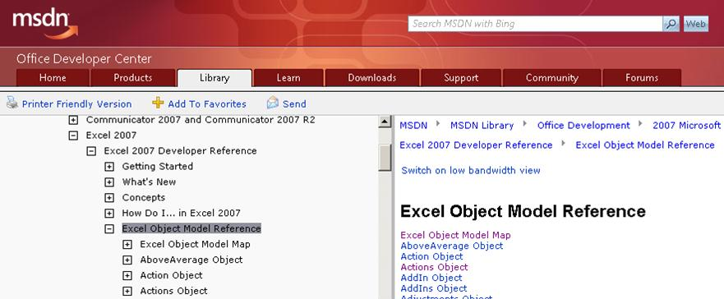
The first step is to find out how to manipulate the particular objects that you need to work with to accomplish your task; for example, worksheets, worksheet names, cells, and cell contents. In Excel, there are at least two ways to approach the problem:
- Go directly to the Object Model Reference.
- Record some of the actions that you want to automate, see how the recorded code manipulates the objects, and then go to the Object Model Reference for more information.
Opinions vary on which approach is preferable, but for now, try using the Macro Recorder first.

Using the Macro Recorder
Sometimes a simple recorded macro is all you need; in these cases, you do not even have to look at the code. More often, recording alone is not enough. Instead, it is a starting point in the following process.

To use the Macro Recorder as a starting point to your solution
- Record the actions that you want to code.
- Review the code and find the lines that perform those actions.
- Delete the rest of the code.
- Modify the recorded code.
- Add variables, control structures, and other code that the Macro Recorder cannot record.
Begin your investigation by recording a macro that renames a worksheet to New Name. You can then use the recorded macro to develop your own macro that renames multiple worksheets based on their contents.

To record a macro that renames a worksheet
- Click Record Macro on the Developer tab.
- Name the macro RenameWorksheets, rename Sheet1 to New Name, and click Stop Recording.
- Go to the Developer or View tab, click the Macros button, and choose Edit to open the Visual Basic Editor.
The code in the Visual Basic Editor should look similar to the following.
VB
Sub RenameWorksheets()
'
' RenameWorksheets Macro
'
'
Sheets("Sheet1").Select
Sheets("Sheet1").Name = "New Name"
End Sub
The first four lines after the Sub line are comments. Any line that begins with an apostrophe is a comment and has no effect on what the macro does. The main uses for comments are the following:
- To make the code easier to understand, not just for you, but for anyone else who might need to modify the code later.
- To temporarily disable a line of code (called commenting it out).
The four comments in this recorded macro serve neither purpose, so delete them.
The next line uses the Select method to select the Sheet1 member of the Sheets collection object. In VBA code, it is not generally necessary to select objects before manipulating them, even though that is what the Macro Recorder does. In other words, this line of code is redundant, so you can delete it as well.
The last line of the recorded macro modifies the Name Property of the Sheet1 member of the Sheets collection. This is the line to keep.
After you make your changes, the recorded code should now look like the following.
VB
Sub RenameWorksheets()
Sheets("Sheet1").Name = "New Name"
End Sub
Manually change the sheet called New Name back to Sheet1, then run the macro. The name should change back to New Name.

Modifying the Recorded Code
Now it is time to research the Sheets collection that the Macro Recorder used. The Sheets topic in the Object Model Reference includes the following text.
"The Sheets collection can contain Chart or Worksheet objects. If you need to work with sheets of only one type, see the object topic for that sheet type."
You are only working with Worksheets, so change the code to the following.
VB
Sub RenameWorksheets()
Worksheets("Sheet1").Name = "New Name"
End Sub

Looping
One limitation of the code up to this point is that it only makes a change to one worksheet. You could add another line for each worksheet that you want to rename, but what if you do not know how many worksheets there are, or what their current names are? You need a way to apply some rule for each sheet in the workbook.
VBA has a construction called a For Each loop that is ideal. The For Each loop examines each item in a collection object such as Worksheets and can be used to take an action (like change a name) to some or all of those items.
For more information about the For Each loop, see the VBA Language Reference. Click "Visual Basic Conceptual Topics", then "Using For Each...Next Statements". Also, be aware that the VBA Language Reference, like the Object Model Reference, will amply repay the time that you spend browsing it, and is an excellent place to look for ideas if you get stuck working on code.
Using the third example in the "Using For Each...Next Statements" topic, edit the macro so that it looks similar to the following code.
VB
Sub RenameWorksheets()
For Each myWorksheet In Worksheets
myWorksheet.Name = "New Name"
Next
End Sub
myWorksheet is a variable; that is, what it represents varies. In this case, the myWorksheet variable successively represents each worksheet in the Worksheets collection. You do not have to use myWorksheet; you could use "x", "ws", "WorksheetToRenameAfterTheContentsOfCellB1", or (with a few restrictions) almost any name that you want. A good rule of thumb is to use variable names that are long enough to remind you of what the variable stands for, but not so long as to clutter the code.
If you run the macro in its current state, it produces an error because Excel requires each worksheet in a workbook to have a unique name, but the following line instructs Excel to give every worksheet the same name.
VB
myWorksheet.Name = "New Name"
To correct the line so that you can verify that the For Each loop works, change the line to the following.
VB
myWorksheet.Name = myWorksheet.Name & "-changed"
Instead of trying to give each worksheet the same name, this line changes the current name of each worksheet (myWorksheet.Name) to the current name with "-changed" appended to it.

Useful Renaming
The macro is getting close to something that might actually solve the problem at hand. What you need now is a way to take information from the worksheets themselves—specifically from cell B1 on each worksheet—and put that information into the names of the worksheets.
This time, instead of using the Macro Recorder to find out how to refer to a cell, take a guess and see if using the Cell object will work. It is a good guess, but if you open the Object Model Reference and search for the Cell object, you find that there is no Cell object! There is a CellFormat object though.
The CellFormat object topic includes the following code in the first code sample.
VB
' Set the interior of cell A1 to yellow.
Range("A1").Select
It turns out that you use Range to specify a range of cells or just one individual cell. Again, you do not need the .Select portion, but you do need to find out how to refer to the contents of the Range object, as opposed to the Range object itself. If you go to the Range object topic, you can read that Range has both Methods and Properties. The contents of a Range is a thing, not an action, so it would probably be a Property. If you scan down through the list, you can see the Value property. So, try the following.
VB
Sub RenameWorksheets()
For Each myWorksheet In Worksheets
myWorksheet.Name = myWorksheet.Range("B1").Value
Next
End Sub
You get an error if you run this on a workbook that contains worksheets where B1 is empty, because an empty Range has a Value of "" (an empty text string), which is not a legal worksheet name. It is about time to create some sample data anyway. Make the three sheets in the workbook look similar to the figure below, and then run the macro.
Figure 4. Sample data for the RenameWorksheets macro
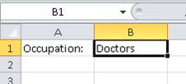

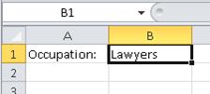

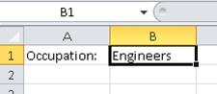
The worksheet names should change accordingly.

Checking for Empty Cells
As noted earlier, the macro fails if any of the B1 cells in the workbook are empty. Instead of manually checking every worksheet, you can code the macro to do it for you. Before the myWorksheet.Name line, add the following line of code.
VB
If myWorksheet.Range("B1").Value <> "" Then
And after the myWorksheet.Name line add the following text.
VB
End If
This is called an If…Then statement. The If…Then statement instructs Excel to do whatever is on the lines between the If line and the End If line, but only if the condition in the If line is met. In the example, the following line specifies the condition to meet.
VB
myWorksheet.Range("B1").Value <> ""
The <> means "is not equal to", and the quotation marks with nothing between them represent an empty text string; that is, no text at all. Therefore, whatever lines of code come between the If and the End If will only be executed if the value in B1 is not equal to nothing; that is, if there is text in cell B1.
For more information about the If…Then statement, see the VBA Language Reference. (The full name is "If…Then…Else statement", where Else is an optional component.)

Variable Declarations
Another improvement that you should make to the macro is to put a declaration of the myWorksheet variable at the start of the macro.
VB
Dim myWorksheet As Worksheet
Dim is short for "Dimension", and Worksheet is the type of this particular variable. This statement tells VBA what kind of entity myWorksheet represents. Note that after you type As, the Visual Basic Editor displays a popup that lists all the available variable types. That is an example of IntelliSense technology; that is, the Visual Basic Editor responds to what it determines you are trying to do and offers a list of appropriate options. You can choose an option from the list or just continue typing.
Although variable declarations are not required in VBA, using them is strongly recommended! Variable declarations make it much easier to keep track of your variables and to track down bugs in the code. Also, be aware that if you declare a variable with an object type (like Worksheet), IntelliSense displays an appropriate list of properties and methods associated with that object if you use the object variable later in the macro.

Comments
The macro is complex enough now to include some comments that remind you what the code is doing. The number of comments to use is partly a matter of personal style, but in general, too many comments are better than too few. Code usually needs to be modified and updated over time. Without comments, it can be hard to understand what is going on in the code, especially if the person who modifies the code is not the same person who wrote it in the first place. Adding comments for the If condition and for the line that renames the worksheets, results in the following code.
VB
Sub RenameWorksheets()
Dim myWorksheet As Worksheet
For Each myWorksheet In Worksheets
'make sure that cell B1 is not empty
If myWorksheet.Range("B1").Value <> "" Then
'rename the worksheet to the contents of cell B1
myWorksheet.Name = myWorksheet.Range("B1").Value
End If
Next
End Sub
To test the macro, rename the worksheets back to Sheet1, Sheet2, and Sheet3 and delete the contents of cell B1 on one or more of the worksheets. Run the macro to verify that it renames the worksheets that have text in cell B1 and leaves the other worksheets alone. The macro works for any number of worksheets, with any combination of populated and empty B1 cells.

More Things that You Can Do with VBA
This section looks at a few more things that you can do with VBA in Excel 2010. The examples in this section are designed to give you a sense of the capabilities of VBA instead of focusing on specific real-world scenarios. You might find it helpful to review the information in the Object Model Reference about the objects in each step as you work through the examples.

Importance of Being Open
A good way to learn programming in general, and Excel VBA in particular, is a strategy where you try something, get it to work, and then ask yourself questions such as:
- What could I try next?
- What do I want to learn first, given how I want to use VBA?
- What might just be fun or interesting to know?
- What am I curious about?
The reader is strongly encouraged to investigate whatever avenues open up on the path to knowledge.

Charts
One common task in Excel is to create a chart based on a range of cells. Create a new macro called AssortedTasks and then type the following text in the Visual Basic Editor.
VB
Dim myChart As ChartObject
Add a line to create the chart object and assign the myChart variable to it.
VB
Set myChart = ActiveSheet.ChartObjects.Add(100, 50, 200, 200)
The numbers in the parentheses determine the position and size of the chart. The first two numbers are the coordinates of the top left corner, and the second two numbers are the width and height.
Create a new blank worksheet and run the macro. The chart it creates is useless because the chart has no data. Delete the chart that you just created, and add the following lines to the end of the macro.
VB
With myChart
.Chart.SetSourceData Source:=Selection
End With
This is a common pattern in VBA programming. First, you create an object and assign it to a variable, then you use the With…End With construction to do things with the object. The example code instructs the chart to use the current selection for its data. (Selection is a value for the Source parameter of the SetSourceData method, not a value of an object property, so VBA syntax requires that you use a colon and an equal sign (:=) instead of just an equal sign (=) to assign the value.)
Type some numbers in cells A1:A5, select the cells, and then run the macro. The chart shows up as the default type, a bar chart.
Figure 5. Bar chart created by using VBA
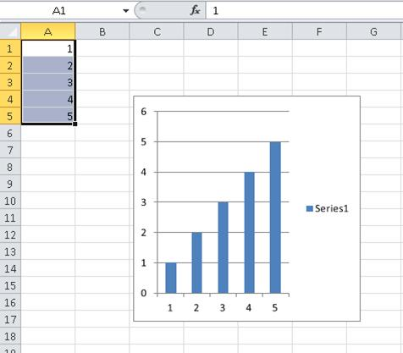
If you do not like the bar chart, you can change it to some other kind of chart by using code that is similar to the following.
VB
With myChart
.Chart.SetSourceData Source:=Selection
.Chart.ChartType = xlPie
End With
xlPie is an example of a built-in constant, also known as an enumerated constant. There are many of these throughout Excel, and they are exhaustively documented. For more information about built-in constants, see the Enumerations section of the Object Model Reference. For example, the constants for chart types are listed under "XlChartType Enumeration".
You can modify the data. For example, try adding this line right after the variable declaration.
VB
Application.ActiveSheet.Range("a4").Value = 8
You can get input from the user, and use that input to modify the data.
VB
myInput = InputBox("Please type a number:")
Application.ActiveSheet.Range("a5").Value = myInput
Finally, add the following lines to the end of the macro.
VB
ActiveWorkbook.Save
ActiveWorkbook.Close
The complete macro should now look something like the following.
VB
Sub AssortedTasks()
Dim myChart As ChartObject
Application.ActiveSheet.Range("a4").Value = 8
myInput = InputBox("Please type a number:")
Application.ActiveSheet.Range("a5").Value = myInput
Set myChart = ActiveSheet.ChartObjects.Add(100, 50, 200, 200)
With myChart
.Chart.SetSourceData Source:=Selection
.Chart.ChartType = xlPie
End With
ActiveWorkbook.Save
ActiveWorkbook.Close
End Sub
Verify that cells A1:A5 are still selected, run the macro, type a number in the input box, and then click OK. The code saves and closes the workbook. Reopen the workbook and note the change to the pie chart.

UserForms
The previous section showed how to use a simple input box to get input from the user. In addition to the corresponding message box that displays information, VBA provides extensive capabilities that you can use to create custom dialog boxes, to code controls that are placed directly on worksheets, or to manipulate the dialog boxes that are built in to Excel. For more information about these capabilities, see Controls, Dialog Boxes, and Forms in the Excel 2007 Developer Reference.
This section completes this introductory look at Excel VBA by taking a quick look at UserForms.
On the Developer tab, click the Visual Basic button to open the Visual Basic Editor, and then go to the Insert menu and choose UserForm to open the UserForm Design View.
You will see two windows. One represents the UserForm that you are creating and the other, the Toolbox, shows the various controls that you can add to your UserForm; for example, command buttons, option buttons, check boxes, and so on. You can move the mouse over a Toolbox control to see what type of control it creates.
Create a very simple UserForm with a single button that runs the Hello macro from earlier in this article. In the Toolbox, depress the the CommandButton control, and then drag it to the UserForm to create a command button. Right-click the command button and choose View Code.
The Sub that you see is a skeleton for an event procedure, which runs when a particular event occurs. In this case, as the name of the Sub indicates, the event that runs the code is a Click on CommandButton1. Add the following line to the event procedure.
VB
Run("Hello")
The Visual Basic Editor should now look similar to the following.
Figure 6. CommandButton1_Click event procedure
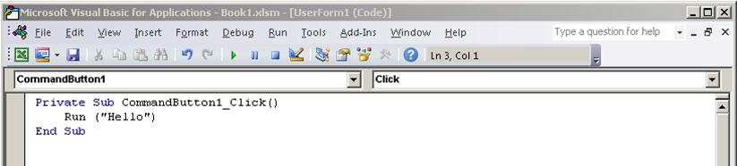
Save the workbook, go to the Window menu, and choose UserForm1 (UserForm) to redisplay the UserForm. Click the green arrow on the toolbar to run the UserForm. When the dialog box appears, click the command button to run the Hello macro, which displays the "Hello, world!" message box. Close the message box to return to the running UserForm, then close the running UserForm to return to Design View.

Programming Tips and Tricks

Start with Examples
The VBA community is very large; a search on the Web can almost always yield an example of VBA code that does something similar to what you want to do. If you cannot find a good example, try to break the task down into smaller units and search on each of those, or try to think of a more common, but similar problem. Starting with an example can save you hours of time.
That does not mean that free and well-thought-out code is on the Web waiting for you to come along. In fact, some of the code that you find might have bugs or mistakes. The idea is that the examples you find online or in VBA documentation give you a head start. Remember that learning programming requires time and thought. Before you get in a big rush to use another solution to solve your problem, ask yourself whether VBA is the right choice for this problem.

Make a Simpler Problem
Programming can get complex quickly. It is critical, especially as a beginner, that you break the problem down to the smallest possible logical units, then write and test each piece in isolation. If you have too much code in front of you and you get confused or muddled, stop and set the problem aside. When you come back to the problem, copy out a small piece of the problem into a new module, solve that piece, get the code working, and test it to ensure that it works. Then move on to the next part.

Bugs and Debugging
There are two main types of programming errors: syntax errors, which violate the grammatical rules of the programming language, and run-time errors, which look syntactically correct, but fail when VBA attempts to execute the code.
Although they can be frustrating to fix, syntax errors are easy to catch; the Visual Basic Editor beeps and flashes at you if you type a syntax error in your code.
For example, string values must be surrounded by double quotes in VBA. To find out what happens when you use single quotes instead, return to the Visual Basic Editor and replace the "Wow!" string in the code example with 'Wow!' (that is, the word Wow enclosed in single quotes). If you click in the next line, the Visual Basic Editor reacts. The error "Compile error: Expected: expression" is not that helpful but the line that generates the error turns red to tell you that you have a syntax error in that line and as a result, this program will not run.
Click OK and change the text back to "Wow!".
Runtime errors are harder to catch because the programming syntax looks correct, but the code fails when VBA tries to execute it.
For example, open the Visual Basic Editor and change the Value property name to ValueX in your Macro, deliberately introducing a runtime error since the Range object does not have a property called ValueX. Go back to the Excel 2010 document, open the Macros dialog box and run Macro1 again. You should see a Visual Basic message box that explains the run-time error with the text, "Object doesn't support this property of method." Although that text is clear, click Debug to find out more.
When you return to the Visual Basic Editor, it is in a special debug mode that uses a yellow highlight to show you the line of code that failed. As expected, the line that includes the ValueX property is highlighted.
Figure 4. Visual Basic debugger at work
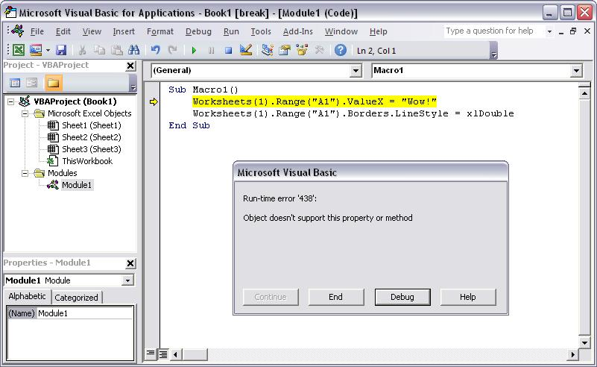

You can make changes to VBA code that is running, so change ValueX back to Value and click the little green play button underneath the Debug menu. The program should run normally again.
It is a good idea to learn how to use the debugger more deliberately for longer, more complex programs. At a minimum, learn a how to set break-points to stop execution at a point where you want to take a look at the code, how to add watches to see the values of different variables and properties as the code runs, and how to step through the code line by line. These options are all available in the Debug menu and serious debugger users typically memorize the accompanying keyboard shortcuts.

Using Reference Materials Well
To open the Developer Reference that is built into Office 2010 Help, open the Help reference from any Office 2010 application by clicking the question mark in the ribbon or by pressing F1. Then, to the right of the Search button, click the dropdown arrow to filter the contents. Click Developer Reference. If you do not see the table of contents in the left panel, click the little book icon to open it and then expand the Object Model Reference from there.
Figure 5. Filtering on developer Help applies to all Office 2010 applications
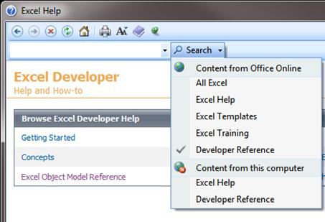

Time spent browsing the Object Model reference pays off. After you understand the basics of VBA syntax and the object model for the Office 2010 application that you are working with, you advance from guesswork to methodical programming.
Of course the Microsoft Office Developer Center is an excellent portal for articles, tips, and community information.

Searching Forums and Groups
All programmers get stuck sometimes, even after reading every reference article they can find and losing sleep at night thinking about different ways to solve a problem. Fortunately, the Internet has fostered a community of developers who help each other solve programming problems.
Any search on the Web for "office developer forum" reveals several discussion groups. You can search on "office development" or a description of your problem to discover forums, blog posts, and articles as well.
If you have done everything that you can to solve a problem, do not be afraid to post your question to a developers forum. These forums welcome posts from newer programmers and many of the experienced developers are glad to help.
The following are a few points of etiquette to follow when you post to a developer forum:
- Before you post, look on the site for an FAQ or for guidelines that members want you to follow. Ensure that you post content that is consistent with those guidelines and in the correct section of the forum.
- Include a clear and complete code sample, and consider editing your code to clarify it for others if it is part of a longer section of code.
- Describe your problem clearly and concisely, and summarize any steps that you have taken to solve the problem. Take the time to write your post as well as you can, especially if you are flustered or in a hurry. Present the situation in a way that will make sense to readers the first time that they read the problem statement.
- Be polite and express your appreciation.

Going Further with Programming
Although this article is short and only scratches the surface of VBA and programming, it is hopefully enough to get you started.
This section briefly discusses a few more key topics.

Variables
In the simple examples in this article you manipulated objects that the application had already created. You might want to create your own objects to store values or references to other objects for temporary use in your application. These are called variables.
To use a variable in VBA, must tell VBA which type of object the variable represents by using the Dim statement. You then set its value and use it to set other variables or properties.
VB
Dim MyStringVariable As String
MyStringVariable = "Wow!"
Worksheets(1).Range("A1").Value = MyStringVariable

Branching and Looping
The simple programs in this article execute one line at a time, from the top down. The real power in programming comes from the options that you have to determine which lines of code to execute, based on one or more conditions that you specify. You can extend those capabilities even further when you can repeat an operation many times. For example, the following code extends Macro1.
VB
Sub Macro1()
If Worksheets(1).Range("A1").Value = "Yes!" Then
Dim i As Integer
For i = 2 To 10
Worksheets(1).Range("A" & i).Value = "OK! " & i
Next i
Else
MsgBox "Put Yes! in cell A1"
End If
End Sub
Type or paste the code into the Visual Basic Editor and then run it. Follow the directions in the message box that appears and change the text in cell A1 from Wow! to Yes! and run it again to see the power of looping. This code snippet demonstrates variables, branching and looping. Read it carefully after you see it in action and try to determine what happens as each line executes.

