Macros
An Excel macro is a set of instructions that can be triggered by a keyboard shortcut, toolbar button or an icon in a spreadsheet. Macros are used to eliminate the need to repeat the steps of common tasks over and over. Tasks such as adding or removing rows and columns, protecting or unprotecting worksheets, selecting a range of cells, or adding the current date to a spreadsheet.
In Excel, macros are written in Visual Basic for Applications (VBA). For those who cannot write VBA code, Excel allows you to record a series of steps - using keyboard and mouse - that Excel then converts into VBA.
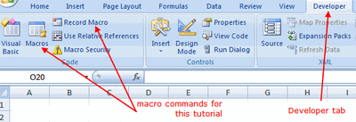

Adding the Developer Tab in Excel 2010
- In Excel 2010, click on File > Options to open the Excel Options dialog box.
- Click on the Customize Ribbon option in the left hand window to view the available options in the right hand window of the dialog box.
- Under the Main Tabs section of the options window check off the Developer option.
- Click OK.
- The Developer tab should now be visible in the ribbon in Excel 2010.
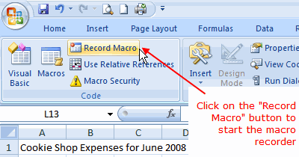
Before we start recording our macro, we need to add the worksheet title we will be formatting.
Since the title of each worksheet is usually unique to that worksheet, we don't want to include the title in the macro. Therefore we will add it to the worksheet, before starting the macro recorder.
- Click on cell A1 in the worksheet.
- Type the title: Cookie Shop Expenses for June 2008.
- Press the Enter key on the keyboard.

Excel Macro Recorder
The easiest way to create a macro in Excel is to use the macro recorder. To do so:
- Click on the Developers tab.
- Click on Record Macro in the ribbon to open the Record Macro dialog box.
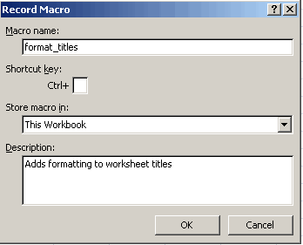

The Macro Recorder dialog box
Note: For help on these steps, refer to the image above.
There are 4 options to complete in this dialog box:
- Macro name - give your macro a descriptive name. The name must begin with a letter and spaces are not allowed. Only letters, numbers and the underscore character are permitted.
- Shortcut key - (optional) fill in a letter, number, or other character in the available space. This will allow you to run the macro by holding down the CTRL key and pressing the chosen letter on the keyboard.
- Store macro in
Options:
  - This workbook
    - The macro is available only in this file.
  - New workbook
    - This option opens a new Excel file. The macro is available only in this new file.
  - Personal macro workbook.
    - This option creates a hidden file Personal.xls which stores your macros and makes them available to you in all Excel files.
- Description - (optional) enter a description of the macro.

For this tutorial:
- Set the options in the Record Macro dialog box to match those in the image above.
- Do Not click OK - yet - see below.
  - Clicking the OK button in the Record Macro dialog box starts recording the macro you have just identified.
  - As previously mentioned, the macro recorder works by recording all keystrokes and clicks of the mouse.
  - Creating the format_titles macro involves clicking on a number of format options on the home tab of the ribbon with the mouse while the macro recorder is running.
- Go to the next step before starting the macro recorder.
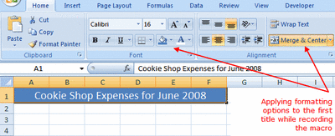

Recording the Macro
Note: For help on these steps, refer to the image above.
- Click the OK button in the Record Macro dialog box to start the macro recorder.
- Click on the Home tab of the ribbon.
- Drag select cells A1 to F1 in the worksheet to highlight them.
- Click on the Merge and Center icon to center the title between cells A1 and F1.
- Click on the Fill Color icon (looks like a paint can) to open the fill color drop down list.
- Choose Blue, Accent 1 from the list to turn the background color of the selected cells to blue.
- Click on the Font Color icon (it is a large letter "A") to open the font color drop down list.
- Choose White from the list to turn the text in the selected cells to white.
- Click on the Font Size icon (above the paint can icon) to open the font size drop down list.
- Choose 16 from the list to change the size the text in the selected cells to 16 point.
- Click on the Developer tab of the ribbon.
- Click the Stop Recording button on the ribbon to stop the macro recording.
- At this point, your worksheet title should resemble the title in the image above.
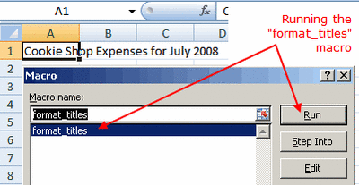

Running a Macro in Excel
Note: For help on these steps, refer to the image above.
To run a macro you have recorded:
- Click on the Sheet2 tab at the bottom of the spreadsheet.
- Click on cell A1 in the worksheet.
- Type the title: Cookie Shop Expenses for July 2008.
- Press the Enter key on the keyboard.
- Click on the Developer tab of the ribbon.
- Click the Macros button on the ribbon to bring up the View Macro dialog box.
- Click on the format_titles macro in the Macro name window.
- Click the Run button.
- The steps of the macro should run automatically and apply the same formatting steps applied to the title on sheet 1.
- At this point, the title on worksheet 2 should resemble the title on worksheet 1.
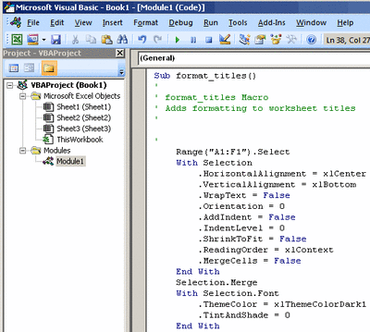

Macro Errors
Note: For help on these steps, refer to the image above.
If your macro did not perform as expected, the easiest, and best option is to follow the steps of the tutorial again and re - record the macro.

Editing/Step Into a Macro
An Excel macro is written in the Visual Basic for Applications (VBA) programming language.
Clicking on either the Edit or Step Into buttons in the Macro dialog box starts the VBA editor (see the image above).
Using the VBA editor and covering the VBA programming language is beyond the scope of this tutorial.

