**Association Rules for Book Store**

114 people bought a Youth Bk, Ref Bk, & Geo. Bk.

# of Trans involving purchase of Child Bk.

Support for A & C = # of Transactions where Youth, Ref, Geo as well as Child Bk were bought.

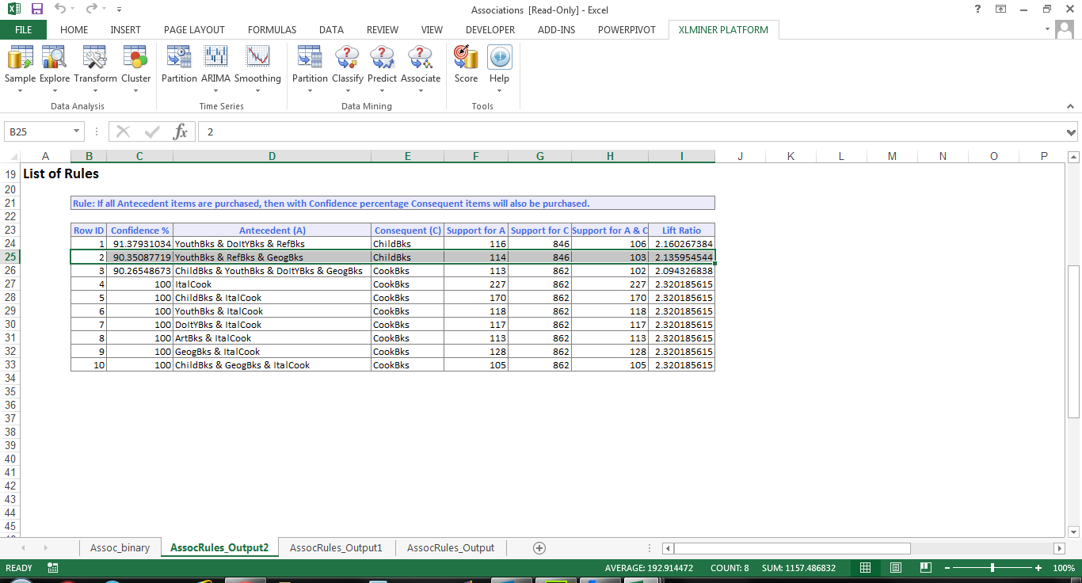

Lift Ratio = how much more likely a transaction will be found where all four book types were purchased as compared to entire population of transactions

The Lift Ratio is the Confidence/value for Support for C.

For rule 2 with a confidence of 90.35%, support is calculated as 846/2000 = .423. The Lift ratio is calculated as .9035/.423 or 2.136. Given support of 90.35% and a lift ratio of 2.136, this rule can be considered "useful"