Using Logical Functions in Excel

As an international sporting goods company, TheZone does maintain some of its own retail outlets. However, the most significant part of the company's sales are derived from selling large amounts of sporting goods equipment and apparel to other retailers and to large organizations, such as school systems and athletic teams. Most companies like TheZone have processes in place to determine the creditworthiness of potential customers before entering into business relationships with them, thereby ensuring that TheZone's accounts receivable group is able to collect payments from customers in a timely manner. The accounts receivables group at TheZone performs many vital tasks that affect the success of the company. The data provided by this group in the credit approval process has a direct impact on the cash flow and financial stability of the company. This process includes both obtaining financial data for new and existing customers and determining the current credit status of each customer's account. These tasks are ongoing and can be challenging due to customers' changing status and the variability of economic conditions.
Eric Carter is an accountant working in the accounts receivable group at TheZone. He has recently been asked to develop a formal system to streamline and automate the credit approval process. Eventually, the information compiled will be handed off to the finance group for final analysis and approval. The finance group is responsible for making the ultimate decisions, factoring in the effects that these decisions will have on corporate profitability, customer relations, adherence to government regulations, and so on.
REVIEWING FINANCIAL CRITERIA RELATED TO CREDIT
Before Eric can evaluate a customer's account for credit availability, he must first assemble the financial information required to make the credit decisions. The internal data, such as a customer's purchasing and payment history with TheZone, is available from TheZone's corporate accounting system. In addition, Eric plans to utilize information on each customer as compiled by Dun & Bradstreet. Dun & Bradstreet® (D&B) is one of the most widely used financial reporting services that provides, among other products, financial information about corporations and institutions and extensive analyses on each company's creditworthiness and payment history. The values supplied by D&B on the companies that TheZone does business with will be updated on a quarterly basis by one of the clerical staff in TheZone's accounts receivable group. Specifically, Eric plans to use D&B's services to obtain values on the net worth of companies requesting credit, a company's credit rating, and a company's payment record as follows:
- The net worth of a company is based on the assets and liabilities listed on its balance sheet.
- The credit rating consists of two parts, as listed in Table 4.1. The first is a classification ranging from 5A to HH indicating the net worth category of the company. The second is a value from 1 to 4 indicating a composite credit appraisal score, where 1 is the best and 4 is the worst. The score represents D&B's determination, of the company's risk factors that affect its ability to pay its bills.
Table 4.1: D&B credit rating system*
RatingClassification |  | Composite Credit Appraisal
Based on Worth from Interim or Fiscal Balance Sheet |  | High | Good | Fair | Limited
5A | 50,000,000 and over | 1 | 2 | 3 | 4
4A | 10,000,000 to 49, 999,999 | 1 | 2 | 3 | 4
3A | 1 ,000,000 to 9,999,999 | 1 | 2 | 3 | 4
2A | 750,000 999,999 | 1 | 2 | 3 | 4
1A | 500,000 to 749,999 | 1 | 2 | 3 | 4
BA | 300,000 to 499,999 | 1 | 2 | 3 | 4
BB | 200,000 to 299,999 | 1 | 2 | 3 | 4
CB | 125,000 to 199,999 | 1 | 2 | 3 | 4
CC | 75, 000 to 124,999 | 1 | 2 | 3 | 4
DC | 50,000 to 74,999 | 1 | 2 | 3 | 4

Table 4.1: D&B credit rating system* (cont.)
Rating Classification ^{r} |  | Composite Credit Appraisal
DD | 35,000 to 49,999 | 1 | 2 | 3 | 4
EE | 20,000 to 34,999 | 1 | 2 | 3 | 4
FF | 10,000to 19,999 | 1 | 2 | 3 | 4
GG | 5,000 to 9,999 | 1 | 2 | 3 | 4
HH | Up to 4,999 | 1 | 2 | 3 | 4
*Based on information available at www.dnb.com
• The PAYDEX® index is an indicator of the payment habits of the company, as listed in Table 4.2. The index provides a score from 1 to 100, with 1 representing the worst payment record and 100 representing the best.
Table 4.2: D&B PAYDEX score*
Score | Payment
100 | Payments received prior to date of invoice (Anticipate)
90 | Payments received within trade discount period (Discount)
80 | Payments received within terms granted (Prompt)
70 | 1 5 days beyond terms
60 | 22 days beyond terms
50 | 30 days beyond terms
40 | 60 days beyond terms
30 | 90 days beyond terms
20 | 1 20 days beyond terms
UN | Unavailable
*Based on information available at www.dnb.com
The financial stress risk class is a rating from 1 to 5 indicating the risk of a company in financial distress, where 1 represents businesses with the lowest probability of risk, as detailed in Table 4.3.
Table 4.3: D&B financial stress risk class*
Class  ; | % of Businesses Within This Class | Financial Stress Percentile | Financial Stress Score.
1 | 80% | 21-100 | 1377-1875
2 | 10% | 11-20 | 1353-1376
3 | 6% | 5-10 | 1303-1352
4 | 3% | 2-4 | 1225-1302
5 | 1% | 1 | 1001-1224
*Based on information available at www.dnb.com

Eric's first task is to develop a worksheet that will list these data elements for each of TheZone's customers. He will start with a small, selected customer list and develop the necessary formulas. Later he will expand the list to include all credit customers. He begins by entering data for each customer into a worksheet named CreditData in a workbook named Customer Credit and Payment History.xlsx, as shown in Figure 4.1. This worksheet includes the following information:
- Customer name (column A)
- Current credit limit (column B)
- Total sales to the customer from the previous fiscal year (column C)
- Current fiscal year's total sales to date (column D)
- Value of the customer's past due balance, which is for any unpaid invoices over 30 days (column E)
- Net worth of the company according to its D&B report in thousands of dollars (column F)
• D&B credit rating classification value (column G)
ª D&B composite credit appraisal value (column H)
- D&B PAYDEX score (column I)
- D&B financial stress risk class (column J)
Eric needs to develop die formulas that will allow him and other accounts receivable staff members to automatically reauthorize and approve new credit applications based on a set of criteria. The first step in this process is to apply several credit approval indicator rules to each customer's data. Each of these rules presents criteria that suggest credit approval might be warranted. Later, Eric will take the results of these indicator rules and combine them to make final credit recommendations. But first he needs to create die required formulas, which must be based on TheZone's credit determination rules, as follows:
Rule # 1; Accept a customer that has a past due balance that is less than 10% of this year's total sales. This is not calculated for new customers. A customer that has a past due balance of 10% or more of this year's sales, regardless of its financial stability, has failed to consistently pay its previous bills with TheZone and, therefore, has not demonstrated a satisfactory business relationship. A customer without such a past due balance demonstrates creditworthiness.
Rule #2: Accept a customer that has either a composite credit appraisal value of 1 or a PAYDEX score over 90. These values indicate a strong, financially stable enterprise with an outstanding reputation for paying its bills on time.
Ru]e_#3 Accept a customer that has all of the following: a net worth of at least $500,000; a composite credit appraisal value of 2 or lower; a PAYDEX score over 70; and a stress risk class of 1. These values indicate that the customer has a good overall financial position, a reasonable level of risk, and a reputation for paying its creditors.
CreditData worksheet in the Customer Credit and Payment History workbook
TheZone’s Accounts Receivable data
B & B data
.
New customer with no prior history
Note that companies used in this example are fictitious, the lab uses the investment ratings of the Dun & Bradstreet® credit rating system
What does it mean if a customer does not meet the criteria for a specific rule? Does this mean that credit should be rejected? Not necessarily. Consider the example of a college that might automatically accept an applicant if that applicant's SAT scores are above 1500. It cannot be assumed that if the applicant's scores are below this threshold, the school will automatically reject the applicant for admission—only that further evaluation is required. Similarly, in the case of TheZone, the three rules suggest a customer's creditworthiness, but failure to meet the criteria for any single rule does not translate to automatic denial of credit.
Evaluation of these rules is the first step in making Eric's worksheet operational. Additional information will be forthcoming from management to determine what combinations of results for these rules will cause a customer to be accepted automatically to a specific credit level or rejected outright. Automating this process in Excel will leave a greater amount of time for the accounts receivable staff to further analyze the more problematic accounts, such as customers with very large orders and less than perfect credit or smaller companies with limited assets.
Assignment (see Annotated sheet)
- Using the spreadsheet CreditData.xlsx enter the logical functions for the three rules.
- Add a column in which you indicate whether the bidder should be accepted or further evaluated. To be accepted all three rules must be met.
- Enter a logical function to determine if ANY bidders meet the rule (for each rule)
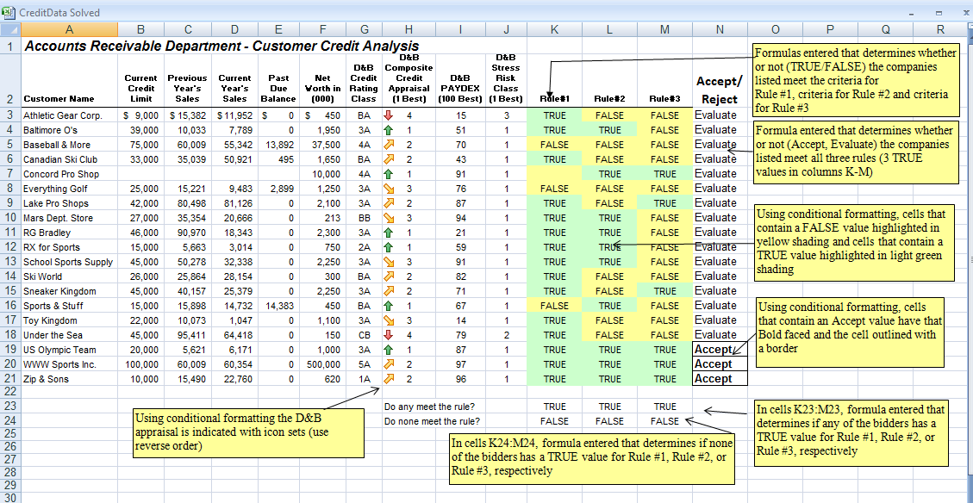
- Enter a logical function to determine if NONE of the bidders meet the rule (for each rule)
- Use conditional formatting to add icons indicating the D&B appraisal (use reverse order)

