Keeping Your Computer Fine Tuned
Do the following in this order:
- Run CC Cleaner (Free: click here for download) http://download.cnet.com/ccleaner/ (OPTIONAL)
- Run Disk Cleanup
When disposing of your computer along with its hard drive, in addition to deleting personal files you should also run disk cleanup and disk defragment

- Run Error Checking
- Run Disk Defragment

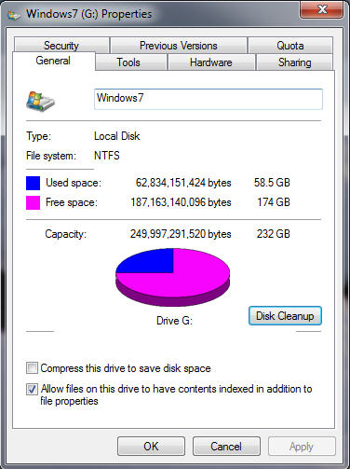
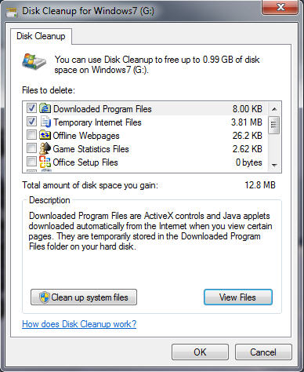
How often should Disk Cleanup be used? once a week Computer> right click on Properties

*To make it difficult for someone to review the Internet Web sites you've visited, you should clear temporary Internet files and the history file.

How often should Error Checking be used? twice a month Computer> right click Properties>Tools
To automatically repair problems with files and folders that the scan detects, select Automatically fix file system errors. Otherwise, the disk check will report problems but not fix them.
To perform a thorough check, select Scan for and attempt recovery of bad sectors. This scan attempts to find and repair physical errors on the drive itself, and it can take much longer to complete.
To check for both file errors and physical errors, select both Automatically fix file system errors and Scan for and attempt recovery of bad sectors.
How often should Disk Defragmenter be used? once a month Computer> right click Properties>Tools

- Disk Defragmenter performs all of the following functions
  - regrouping related sections of files together.
  - providing more efficient access to files and folders.
  - consolidating free space.

Other Notes:

When you restore files that you sent to the Recycle Bin, they are returned to their original location, since they are not actually deleted. The space they take on the hard drive is marked as available. When you defrag, the files are actually deleted.

The Task Scheduler enables you to create a maintenance schedule for your computer

