Object Linking and Embedding
Object Linking and Embedding (or OLE for short) is a technique used to insert data from one Microsoft application into another. We'll create a simple spreadsheet to illustrate the process, and place it in a Word 2007 document. When the Excel spreadsheet is updated, you'll see the Word version update itself as well.
If you don't want the data to update in Word it's called Embedding; if you do want the data to update, it's called Linking. We're going practice Linking. For this exercise, you’ll need Word 2007 as well as Excel 2007.
First, create the simple spreadsheet below, and enter the formula shown in cell E3:
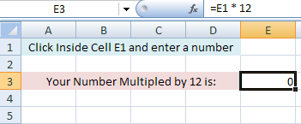
When you enter a number in cell E1, the answer is placed in cell E3 (don't do this yet).
With your spreadsheet created, highlight the cells A1 to E3. Click on the Home menu in Excel 2007. On the Clipboard panel, click on Copy.
Now switch to Word 2007. On the Home menu in Word 2007, locate the Clipboard panel, and the Paste item:
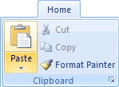
Click on Paste. From the Paste menu, select Paste Special:
When you click on Paste Special, you'll see the following dialog box appear:
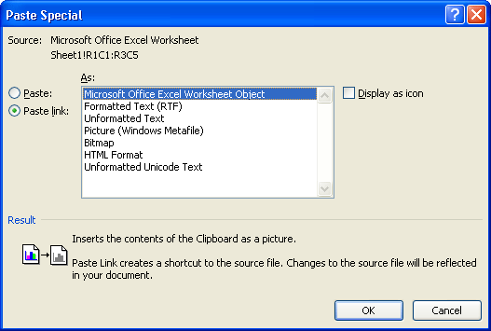
Select Microsoft Office Excel Worksheet Object from the dialog box. On the left hand side, select Paste Link. Click OK.
When you click OK, Word 2007 will insert the spreadsheet from Excel:
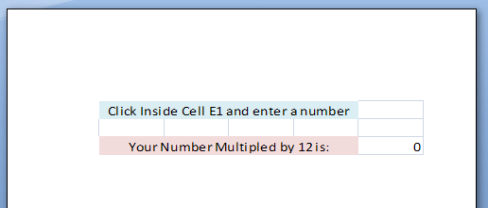
It's even retained the cell formatting!
To check that it really does update in Word 2007, switch back to Excel. Click inside Cell E1 and enter the number 7. Press the Enter key on your keyboard, and you should have the same answer as in the image below:
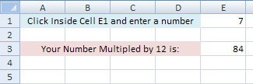
Now switch back to Word 2007, and you should see that it too has the same answer:
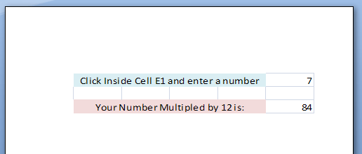
Word 2007 has successfully linked the data from Excel 2007! If you don't want the updates, you would choose Paste from the Paste Special dialog box instead of Paste Link.
You can link or embed Charts or Pivot Tables into Word 2007 using the same technique.
Note: You would use the same steps to link or embed an Excel spreadsheet into PowerPoint.

