Importing Data from the Internet
A Web Query is when you send a request to a web page and ask for some data to be returned. You'll see how to do that in this section, by importing data into your spreadsheet from a web page on our web site.
There are many reasons why you would want to do that. If, for example, you're a hard-working sales person out in the field, and a customer wants the latest prices, you could run a web query in Excel and pull the prices from your employer's website.

How to run a Web Query in Excel 2007
You'll now learn how to use Web Queries in Excel 2007. For this lesson, you'll need an active internet connection. We're going to connect to a web page, and download a product list straight into a spreadsheet. Off we go!
- Open Excel 2007
- Connect to the internet, if you're not already online
- Click inside A1 on your new worksheet
- From the Excel 2007 menu bar, click on Data
- From the Data Ribbon, locate the Get External Data panel:
From the Get External Data panel, click on From Web. You'll then see the following dialogue box appear:
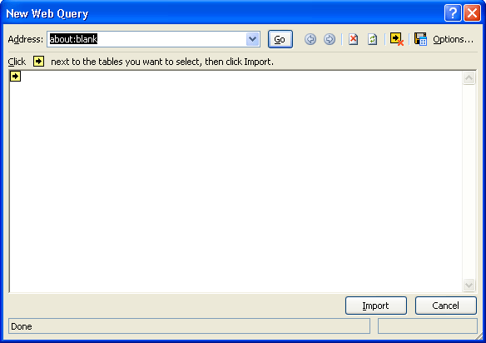
The idea is that you type the address of a web page and then click Go. Excel will then fetch the data for you.
So, in the Address box, where it says about:blank in the image, type the following address:
http://www.homeandlearn.co.uk/ME/webquery1.htm
Before you click Go, click the Options button in the top right of the New Web Query dialogue box. You'll see this dialogue box appear:
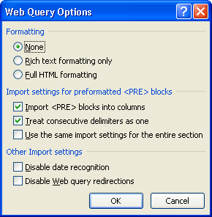
For this first web query, we're not going to change any of these settings. But the Formatting section is the one you'll use most. You can import the web page with all its current formatting, use just Rich Text formatting, or have no formatting at all. (Rich Text formatting will get you things like bold text, but won't give you any of the fancy stuff on the page.)
Click OK on the Options dialogue box to return to the New Web Query. Now click the Go button.
When you click the Go button, Excel will try to connect to the address you gave it. If it can't get through, you'll see a "Page Cannot be Found" error page:
If that's what you're getting, make sure you are connected to the internet. Check if you've typed the address correctly. Make sure that your firewall is not blocking Excel 2007.
If Excel is successful, you'll see the data appear in the Web Query window:
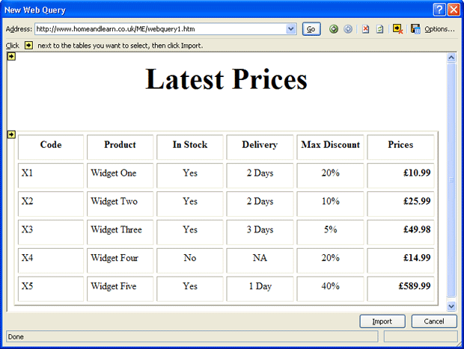
Note the black arrows in the yellow squares. You can select the tables you want to import. Click the first yellow box, and it will turn green and have a tick in it. Like this one:
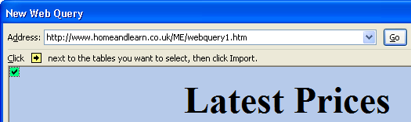
Once you have the data selected, click the Import button at the bottom of the New Web Query window. You'll get yet another dialogue box:
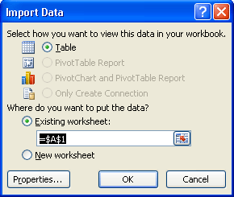
There's not much to do, here. But if you want to import the data to a different starting cell, or even a new worksheet, select the appropriate option. For this particular import, Excel is only giving us the option to view the data as a Table. Click OK and the import will begin. You should see this in cell A1 on your spreadsheet:
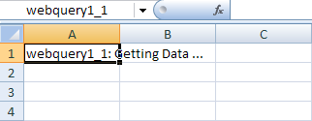
If the import is successful, your spreadsheet should look like ours below:
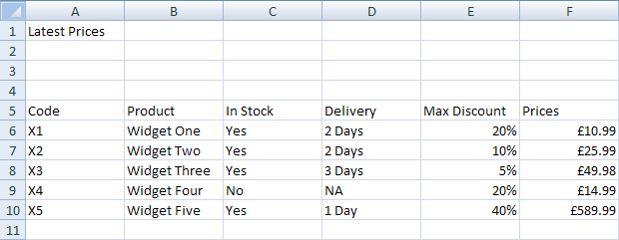
As you can see, the data from our web page has been imported into Excel 2007! Let's try another one.
You can easily set your query to refresh, or update in any desired fashion. Just right-click anywhere in the query results, select Data Range Properties, and change the Refresh Control settings. As shown in Figure below, we selected our query to refresh every minute and automatically refresh when the file is reopened.

Refresh settings for Web query
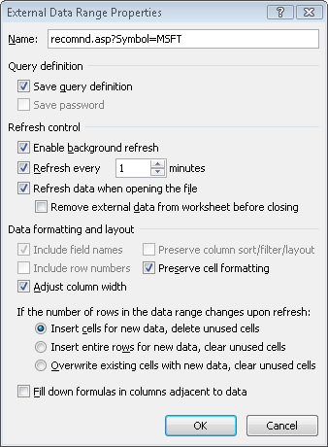
To edit this query, simply right-click anywhere within the query output and select Edit Query. By clicking the options button, you can control the fomatting of your query results. Off course, when you run this Web query again, you'll probably see different information because analysts are constantly changing their views of future stock price for Microsoft.

Web Query Two
The next web query we'll do will see an import of full HTML formatting. When you're finished, you'll see why this can be a problem.
- At the bottom of Excel 2007, click on Sheet1
- On the fresh worksheet, click inside cell A1
- Click on the Data menu, then on click From Web on the Get External Data panel
- In the New Web Query Address box, type the following Address (don't click the Go button just yet):
http://www.homeandlearn.co.uk/ME/webquery2.htm
Click the Options button in the top right of the dialogue box:
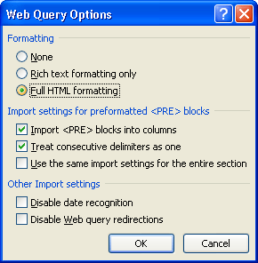
This time, select Full HTML Formatting, as in the image above. Click OK, then click the Go button.
Excel 2007 will bring back your data. Click the yellow box with the arrow in it to select all the data:
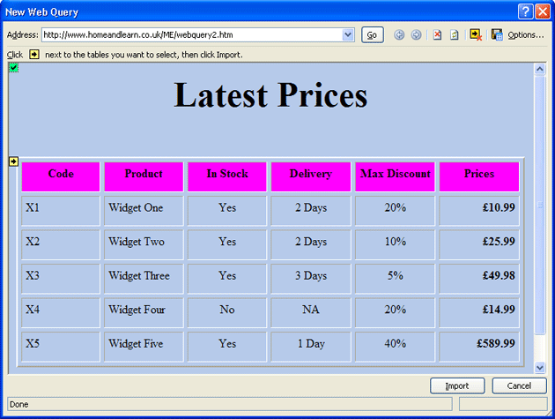
Click the Import button at the bottom when your dialogue box looks like the one above.
When you see the Import Data dialogue box, just click OK. The data will then be imported into Excel:
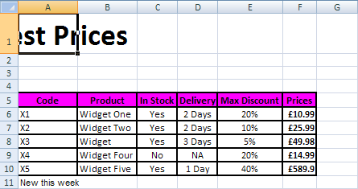
The problem with importing full HTML is that some of that fancy formatting you did won't convert very well in Excel. In the image above, our Latest Prices heading has been mangled!
In other words, you may have to spend time re-formatting your spreadsheet.
To get the full heading back, for example, highlight the first row, from A1 to G1. Click on the Home menu, and then locate the Alignment panel. Click Merge and Center.
Is there a way I can download current stock prices into Excel?
Excel comes with a built-in Web query that can be used to download current information about stocks. This Web query is a dynamic Web query, which means that you can set the query to update stock information as it changes in real time. All you have to do is select the data you want to update and on the Data tab, in the Connections group, click Refresh All. Let's see how to download real-time stock information about Microsoft (ticker symbol MSFT) and General Motors (ticker symbol GM) into Excel.
Open or create a worksheet in Excel. Display the Data tab of the Ribbon, and in the Get External Data group, double-click Existing Connections. Now select the Web query named MSN MoneyCentral Investor Stock Quotes. Click Open, and then use the Import Data dialog box to indicate where you want to place the data in the worksheet. Click OK, and then fill in the Enter Parameter Value dialog box as shown below. The query downloads information about Microsoft and GM into Excel. The figure below shows a sample of the downloaded information. Checking the options shown in Figure 34-5 on the next page ensures that the worksheet changes to reflect the most current information.

Use the Enter Parameter Value dialog box to designate the stocks for which you want the dynamic Web query to download information.
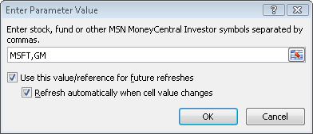

Downloaded information about Microsoft and General Motors stocks
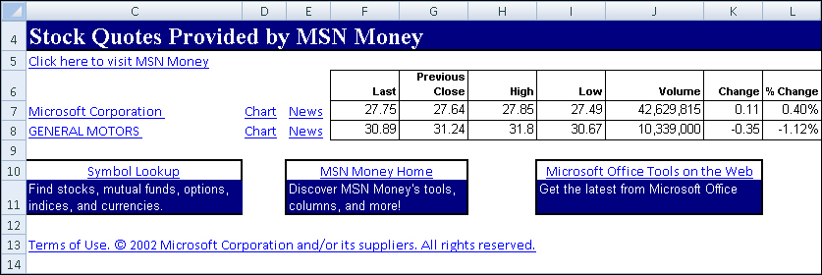
Excel also ships with Web queries designed to download currency exchange rates and information about major stock indexes. These Web queries are static, however, and will not update information in real time unless you rerun the query. Of course, you can create your own Web queries. Creating Web queries is beyond the scope of this assignment.

Problems (choose 1): Submit the spreadsheet and also a brief write up describing your analysis of the data for the problem.
1. | Download real-time information about Disney (ticker symbol DIS) and the Gap (ticker symbol GPS) into Excel.
2. | Use the built-in Web query designed to download current foreign exchange rate information into Excel.
3. | Go to NBA.com or MLB.com and download the career statistics of your favorite player into Excel.
5. | Go to Furman’s Academic records http://www.furman.edu/registrar/course_historical_data.html  Download the statistics of courses and create a pivot table.
6. | Go to http://www.boxofficeguru.com/blockbusters.htm and download data on the top moneymaking movies of all time into Excel.

