Management Information Systems, 13E

Laudon & Laudon

Lecture Notes by Barbara J. Ellestad

Chapter 7 Telecommunications, the Internet and Wireless Technology

Anytime, anywhere, anyway, is the mantra of many computer users. Improved telecommunications technologies, the process of electronically communicating information, are making it possible.

Looking for an example of how much this revolution is touching every aspect of how we work, live, play, and learn? Look no further than this page—you wouldn’t be reading this if it weren’t for telecommunication networks!

7.1 Telecommunications and Networking in Today’s Business World

This section shows you how these networks are actually constructed and discusses the various elements involved in connecting all these computers. Knowing how it all works can give you insight into the changes that have taken place and an idea of what the future holds. You can also get ideas about how you can take advantage of the future now!

Networking and Communication Trends

For the most part, all of us have grown up with separate service providers and networks for our land-based telephones, cellular phones, and computers. We’ve been used to the idea that television cable service was separate from landline telephone service. Radio was separate albeit free. Cellular telephone services were separated from all of them. Now all of these telecommunication services are converging on the Internet and either blurring or destroying the lines of demarcation. It will become harder to determine where one ends and another starts as high-speed broadband network connections continue to expand and companies continue to develop products that meet consumer demands.

“The need for broadband access has made satellite and the fiber optic cables, the two high bandwidth transmission media of choice in today’s telecommunications services. Fiber optic cables provide a high transmission capacity; it provides broad bandwidth and capacity to transmit all forms of communication (voice, data and video). A fiber-optic connection is faster than wireless by many orders of magnitude. A single optical fiber can carry about 3 trillion bits per second (bps). The fastest wireless service (fixed wireless access) approaches 2 million bps. So, fiber optics can be more than a million times faster.” (http://cbdd.wsu.edu/kewlcontent/cdoutput/TR501/page26.htm. Accessed Nov 2009)

What Is a Computer Network?

Before we go much further, let’s make sure you understand how computer networks are configured. Figure 7-1 shows a simple network structure.

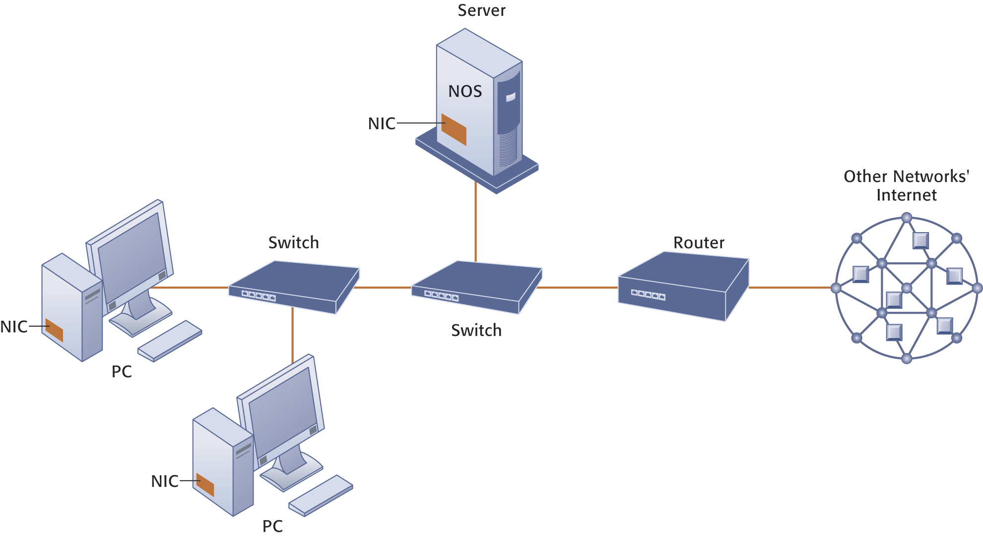

Figure 7-1: Components of a Simple Network

What you should keep in mind is that you can continually add components to this kind of network and expand it exponentially. You can take a simple desktop computer and by way of a Network Interface Card (NIC), incorporate it into an existing network. To share network resources such as printers, and to route communications on a LAN, you require special software called a network operating system (NOS). Hubs and switches help route traffic on the network to the right computing device. When two or more networks are connected to each other, you need a router that sends data transmissions to the correct network device. Very large networks may require multiple routers so transmissions flow more quickly.

Because of the ever-growing complexity of networks, a new approach is available for managing their configurations called software-defined networking (SDN). Network administrators use the software installed on inexpensive commodity servers to manage traffic loads in a more flexible and efficient way.

Networks in Large Companies

Compare Figure 7-1 above that diagrams a simple computer network to Figure 7-2 below that diagrams a corporate network infrastructure. You’ll see that the network you might use in a large company isn’t all that different from what you might use in your home. Obviously, there will be more computing devices and servers but basically you’ll have the same network infrastructure.

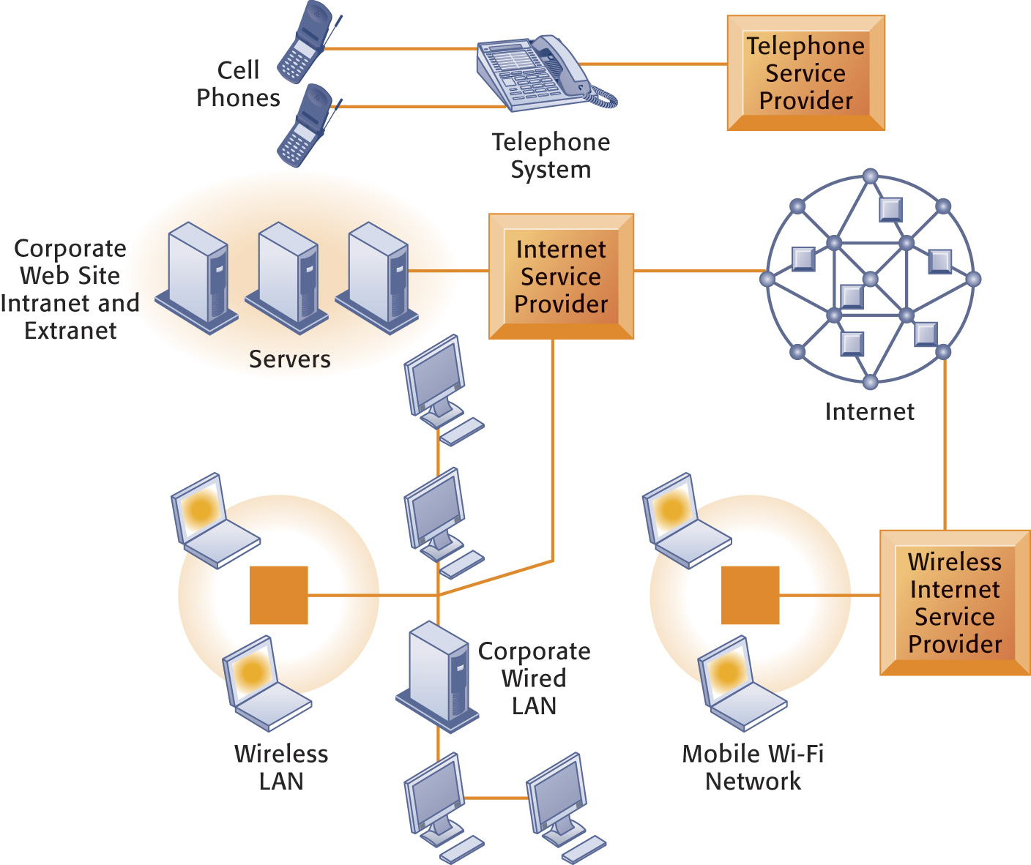
Figure 7-2: Corporate Network Infrastructure

Most corporations, large or small, will use a combination of public and private transmission mediums, including networks built separately for voice communication and computer transactions. Slowly, the separate networks are converging into one network that can transmit any type of data generated by any type of device.

Key Digital Networking Technologies

Let’s look at three key technologies necessary for network computing.

Client/Server Computing

The client/server network facilitates computing on all kinds of networks including the Internet. Instead of one huge mainframe with individual nodes, smaller computers called servers connect to many clients. This type of network is ideal for companies that are continually expanding their networks or replacing hardware components.

Packet Switching

Think about going to the grocery store and buying a week’s worth of food. For some of us that may be 20 packages of Ramen noodles; for others that could be quite a bit of food. You buy all the things, load them all into your cart, and head for the checkout line. You pay for your food while it’s being bagged. Assuming you bought lots of items, not all of them are packed into the same bag. You might have four or five bags, maybe more. You take them home, unpack the bags, and reassemble all your goods in the cupboard. You’ve just experienced packet switching.

Packet switching is a method of breaking large blocks of data into smaller chunks and routing them in the most economical way through whichever communication channel is available.

When you access this lecture file on the Web, it appears as though all the data came into your client computer together. But they didn’t. The data were broken into small packets on their way out of the server computer and then sent to and reassembled on the client computer. It happens so quickly and so efficiently that you don’t even notice. Packet switching also checks for transmission errors when data travel from one location to another.

TCP/IP and Connectivity

How does your Internet Service Provider manage to send your email to the right place? We’re talking millions and millions of people sending email and using the World Wide Web every day. How do you keep from getting Mary’s email intended for Billy in Atlanta? Notice that each computer user connected to a network has a separate, individual address. No two addresses are exactly the same. All of these addresses are stored on various computers placed around the networks. Software stored on routers uses these addresses to route the data to the right location. Routers use protocols to help route data around the many networks to get them to their correct destination.

The most popular model for connecting networks is the Transmission Control Protocol/Internet Protocol (TCP/IP). Even though this protocol was originally created for what we now call the Internet, it is easily transferred to networks of all sizes. It provides the easiest methodology for communicating between computers through standardized protocols that ignore the hardware and software platforms of the individual pieces of equipment.

Companies can create Web-based interfaces for different databases for data input/output and accessing information without actually combining the data physically in one huge computer. They do so by using TCP/IP models. With these protocols, they can reduce the disruption to the organization and decrease the overall costs of adding to their network.

This diagram shows you how TCP/IP works.

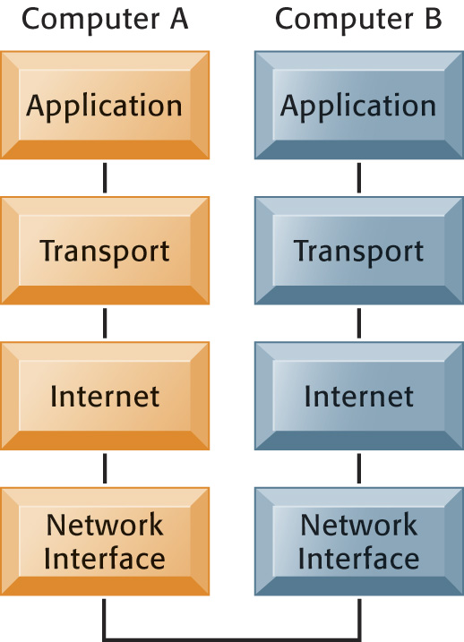

Figure 7-4: The Transmission Control Protocol TCP/IP Reference Model

The most important benefit of the TCP/IP model is that it allows two computers to communicate even if they are based on different hardware and software platforms.

Bottom Line: All computer networks are basically the same. Many small networks can be connected to form larger networks, which in turn can be connected to the Internet. Protocols are the rules used in networks to ensure that transmissions can pass between the various components. The world of telecommunications and networking has changed drastically over the last ten years. If the pundits and experts are correct, and there’s no reason to believe they aren’t, we haven’t seen anything yet!

7.2 Communications Networks

It’s likely that as a company grows, so will its networking needs and capabilities.

Signals: Digital vs. Analog

Everything going into a computer system must be transformed into the digital signals of the computer. That is, a computer understands only zeros and ones. However, in the networking world much of the data are transmitted over telephone lines. These lines don’t recognize zeros and ones. They only understand what are called analog signals— continuous waveform signals. To change the signals back and forth between analog and digital transmission methods, you need a modem.

Types of Networks

There are many different types of networks that organizations can use to connect their employees, managers, customers, suppliers, and business partners. It’s important that the right one is used.

Local Area Networks

The local area network (LAN) is probably the most common network setup. You can have as few as two computers or as many as you can possibly wire together in the local area. Other devices such as printers and even network-enabled pianos can be a part of a LAN. You can set up a LAN for local area processing within your company and then connect it to a larger outside network that could be linked to distant locations.

Many small businesses choose to forego a client/server network architecture in favor of a peer-to-peer network in which all the computers on the network are equal. Data on one computer can be accessed easily by any other computer. Setting up a small network with this configuration saves the cost of having a separate server computer.

Metropolitan and Wide Area Networks

A wide area network (WAN) is basically the same thing as a LAN, only for a broader geographic setting. This network is not limited by space and distance, and WANs use a combination of technologies to connect all the distant locations. A WAN may take on a derivative name such as MAN (metropolitan area network) simply to describe its physical location.

Transmission Media and Transmission Speed

Some experts call us a wired nation. If you consider all the methods we use to communicate, we should be referred to as a wireless nation. Our paging systems and cellular telephones use microwave and satellite technologies to transmit our voice and data communications from one place to another. We have cell phones, personal communication services (PCS), mobile data networks, and personal digital assistants (PDAs) to help us compute on the go. Now when people say they are “going to the office,” it could just as well be their car or truck!

All the transmission channels discussed in this section combine to give you what seems to be a single clear channel from one physical location to another physical location. In fact, it is very likely that when you access the Internet and call up a Web site you are using a combination of twisted pair wire, fiber-optic cable, microwave stations, and satellites to transmit data from your computer to another computer.

Table 7-2 provides a description and speed of each type of transmission medium you may use when communicating from one point to another.

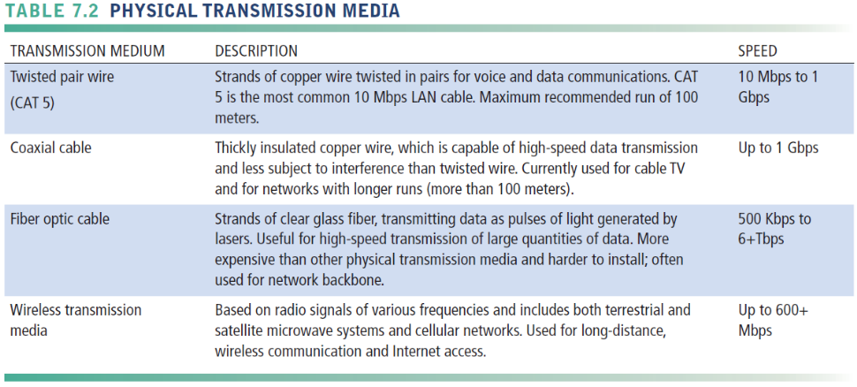

Bandwidth: Transmission Speed

When you transmit the latest information from a Web site to your personal computer, the speed at which it moves across all the transmission media is measured in bits per second (BPS). The speed at which the bits are transmitted in each cycle is referred to as hertz. If you transmit one million bits in each cycle, you would call that rate megahertz (one million bits per a single cycle). The bandwidth of a communication channel is measured by the difference between the highest and lowest frequencies that can be transmitted by that channel.

Bottom Line: Communication channels consist of wired and wireless media. Processors and software are combined with the protocols and transmission media to form a network. There are many different types of network infrastructure configurations. Which one is best for your organization depends on your situation. Many new network services are being introduced to increase the speed of network access and will probably reach your world in the next few years.

7.3 The Global Internet

The latest research numbers from the Pew Internet and American Life Web site show that 79 percent of American adults (including 95 percent of Americans age 18 to 29) use the Internet. (Pew Internet and American Life Web site, www.pewinternet.org, Oct 2010)

Try picking up a newspaper or magazine, listening to the radio or television, or simply talking to people, and you’ll be hard-pressed not to hear something about the Internet and how it’s changing businesses and the way people buy and sell items.

What Is the Internet?

The Internet was developed in 1969 for the U.S. military and eventually spread to universities and civilian researchers. Because of its open structure, interest in its use began to grow beyond these exclusive groups. Internetworking is the idea that computer networks are connected to other networks allowing data to flow freely.

The Internet is best described by what it isn’t. There is:
- No single computer
- No single control source
- No single owner
- No single entry point
- No single type of application

The Internet consists of computer networks spread all over the world, through wired and wireless transmission media, which contain software codes that allow them to talk to each other. That’s it. If you tried to find a single “front door” to the Internet, you’d be looking for a long, long time.

Small businesses and individuals connect to the Internet through Internet Service Providers (ISP) such as Earthlink or CoxMedia. In many areas the ISP is a small local company connected to a larger network. With recent mergers in the entertainment and Internet industries, some cable TV companies like TimeWarner may serve as the ISP for home users.

One way of physically connecting to the Internet is with a Digital Subscriber Line (DSL). It uses regular telephone lines to carry both voice and data transmissions at very high speeds.

Since many home computer users already have cable TV installed in their homes, the telecommunications industry is using cable Internet connections to pump data into the home. If you have many people on the same cable line, each individual accessing the line will notice progressively slower speeds as the number of users increases. It is much faster than a dial-up modem, though.

Larger organizations, such as universities and corporations, can afford a T1 line, which supports extremely high rates of data transmission. These lines are capable of carrying voice and data transmissions over 24 channels, which make them ideal for larger networks. Because they are expensive, it’s not something you’d install in your home.

Internet Addressing and Architecture

Every address used on the Internet whether it’s an email address or a Web site address is nothing more than a series of numbers called an Internet Protocol address or IP for short. Computers spread out around the Internet and various networks convert the series of numbers such as 195.128.15.11 to an easily read address such as www.USAToday.com .

The Domain Name System

The Domain Name System was devised because it’s much easier for people to read letters and words than to work with series of numbers. The DNS uses a hierarchical breakdown of addresses as Figure 7-6 shows.

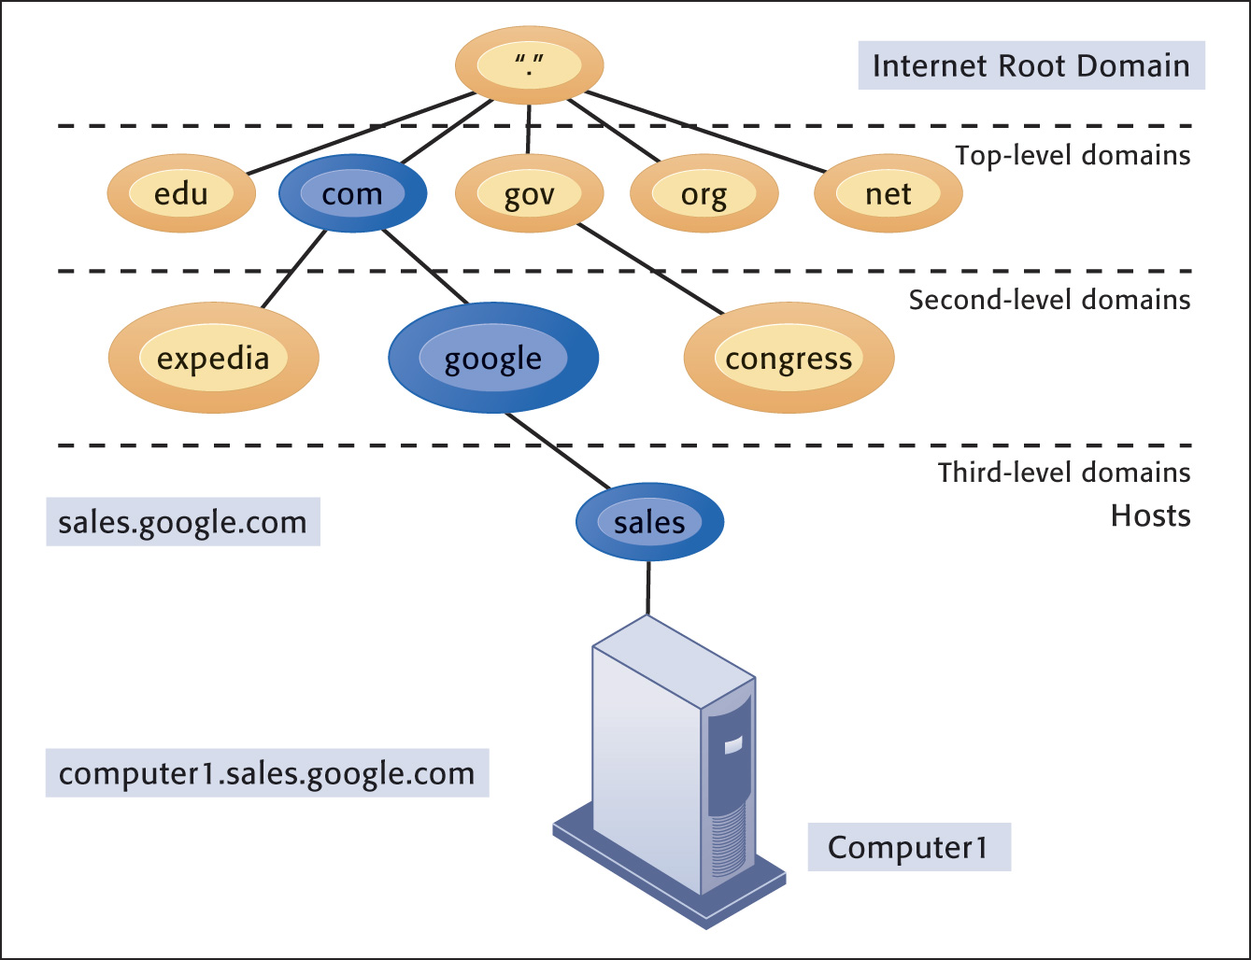

Figure 7-6: The Domain Name System.

Domain names used in email addresses and Web site addresses are easily obtained through several services such as www.networksolutions.com and www.register.com. How do you get a domain name? Be the first to request a unique name and pay the required fee. That’s all there is to it.

Internet Architecture and Governance

Even though no one owns the Internet as a whole, parts of it are owned and controlled by many different private and public entities. Network channels in the United States are largely private while in other foreign countries, for example China, the government owns the backbone. To ensure continuity and connectivity throughout the world, various organizations have been established to help administer the Internet:

- Internet Architecture Board: Defines the overall structure of the Internet
- Internet Corporation for Assigned Names and Numbers (ICAAN): Assigns IP addresses
- World Wide Web Consortium: Sets standards for the Web

Just remember, no one owns it. And, it’s not free.

Interactive Session: Organizations: The Battle over Net Neutrality (see page 262 of the text) introduces arguments for charging Internet users based on the amount of transmission capacity they use. There are some very good points made for both proponents and opponents.

Not only is bandwidth saturation becoming a problem on Internet connections and other network connections, but now the problem is spreading to mobile phone networks as evidenced by the article below lamenting AT&T’s difficulties with its iPhone users.
AT&T wants its iPhone users to use less wireless data, and it may consider new pricing models to curb users’ data usage as it tries to keep up with growing demand. At an investor conference in New York on Wednesday, Ralph de la Vega, AT&T’s head of wireless, said the wireless operator is considering incentives to get consumers to reduce their data usage. De la Vega said 3 percent of smartphone users are consuming 40 percent of the network capacity.
“We’re going to try to focus on making sure we give incentives to those small percentages to either reduce or modify their usage so they don’t crowd out the other customers in those same cell sites,” said de la Vega according to a transcript of the conference. “And you’ll see us address that more in detail.”
He went on to say that most consumers aren’t aware which applications use a lot of bandwidth and which do not. For example, email does not consume a lot of bandwidth, whereas streaming video and audio do consume a great deal of bandwidth.
“What’s driving usage on the network and driving these high usage situations are things like video, or audio that keeps playing around the clock,” he said, according to the transcript provided by AT&T. “And so we’ve got to get to those customers and have them recognize that they need to change their pattern, or there will be other things that they are going to have to do to reduce their usage.”
AT&T has been struggling to keep up with demand for wireless-data usage on its network. The iPhone, launched more than two years ago, has revolutionized mobile Web usage. The device, which was built more for accessing the Net than making calls, can access more than 100,000 applications, many of which use the mobile Internet.
iPhone users on average consume five to seven times more data per month than average wireless subscribers, according to analyst firm Sanford Bernstein. And all this usage is clogging the network, causing many iPhone users, especially in large cities such as New York and San Francisco, to experience dropped calls, slow 3G service, and issues connecting to the network at all. (AT&T considers incentives to curb heavy data usage, CNET News, Marguerite Reardon, Dec 9,2009)

The Future Internet: IPv6 and Internet2

As the Internet and other networks continue to proliferate, it’s becoming very difficult to work with the limited number of IP addresses available in the old system. Therefore new IP addressing schemas are being developed along with an expanded Internet architecture. IPv6 is an initiative designed to increase the available IP addresses to handle the burgeoning number of users on the Internet.

If experts’ predictions are correct about the increasing usage and reliance on the Internet, and there’s no reason to believe they aren’t, we need to improve and change the current configuration to meet future demand. The Internet2 project may help. The Next Generation Internet project has similar goals of advancing the use of the Internet in ways that will enhance our lives. Here’s how the Internet2 Web site (www.internet2.com) compares the two projects:

“Internet2 is a collaborative effort by more than 180 U.S. universities, working with partners in industry and government, to develop advanced Internet technologies and applications to support the research and education missions of higher education. Internet2 is a project of the University Corporation for Advanced Internet Development (UCAID).

The Next Generation Internet (NGI) initiative is a multi-agency federal research and development program that is developing advanced networking technologies, developing revolutionary applications that require advanced networking, and demonstrating these capabilities on testbeds that are 100 to 1,000 times faster end-to-end than today’s Internet.”

Don’t worry that personal users of the “old” Internet will be left behind. New technologies developed for Internet2 and NGI will trickle down to the traditional Internet and make it easier for everyone to use.

Internet Services and Communication Tools

With the recent introduction of new communication and information appliances, such as smart phones, PDAs, cell phones, and mobile data networks, organizations have found it necessary to upgrade their networks to incorporate these new technologies.

Internet Services

We keep complaining about information overload, yet we crave more. The Internet provides access to data about any topic you can imagine through software-based services such as discussion groups, newsgroups, chat functions, instant messaging, Telnet, and FTP (file transfer protocol). Keep in mind that false information is as readily available as is true and correct information. Just be careful about the source of information you access.

The most useful feature of email is the ability to attach files to a message and send them to colleagues anywhere in the world. This feature alone makes it a valuable tool for telecommuters and for collaborating with coworkers, wherever they may be. Unfortunately, the effectiveness of email as a viable communication tool is diminished by spam and junk mail. The sheer numbers of email message sent are overwhelming some corporate email servers. Some businesses are now encouraging “no email Fridays.”

Companies are using chat and instant messaging as a viable alternative to email.

Use one of the search engines or directly access a popular portal page such as www.yahoo.com or www.msn.com and you’ll probably see a link to instant messaging services. AOL’s instant messaging technology is available to anyone, even those who don’t use AOL as their service provider. Most IM services let you set up private chatrooms and will tell you when family, friends, or colleagues are online so you can “talk” to them. Some cell phones also allow you to send and receive IM messages from wherever you are.

Interactive Session: Management: Monitoring Employees on Networks: Unethical or Good Business? (see page 266 of the text) discusses both sides of a very sticky situation between employers and employees. It points out the need for every company to have corporate policies regarding employee use of email and the Internet.

Voice over IP

Internet telephony services like Skype.com have vastly improved over the last few years and are now becoming a popular way for a growing number of people to communicate over the Internet. The VoIP (Voice over Internet Protocol) technology threatens traditional telephone companies unless they adapt their business model to include this technology. You make long distance telephone calls free (from PC to PC) or for a much reduced price (PC to regular telephone) using this technology.

Here are a couple excerpts from the Web site, VoIP-Info.org

“Internet and computer technology have already changed the way people live, work and communicate. VoIP (Voice over Internet Protocol) is one of the converged technologies behind this communication revolution.
An ever growing number of Internet connections around the world allow VoIP which turns Internet infrastructure into a giant global telephone network. VoIP works in conjunction with other technology such as 3G cellular network and wireless (Wi-Fi) that eventually could create a huge global mobile phone network.
It is the good news for consumers who can make phone calls worldwide at a very low or no cost and with great features that traditional telephone companies can't offer for free now.
Looking forward, we believe Internet Telephony innovations are far beyond what we can imagine now. Let’s utilize those technology advances and enjoy the feature-rich, low cost and evolutionary communication tools.”
“VoIP on WiMax will make the latest 3G technologies obsolete before they are completely installed. The reason is because 3G cell phone technology is capable of 2Mbs while WiFi is at 11Mbs in bursts and WiMax will be even greater therefore 3G is not needed as VoIP over WiMax is going to provide more data, faster speeds and greater numbers of users.

WiFi and WiMax may actually solve the goals of conquering the digital divide. There will be a small price for this disruptive technology. There will be small legal battles fought such as this one over territory with government agencies and private sector. In the WiFi Online Newsletter commenting on a Wall Street Journal Article we saw Verizon fighting with the City of Philadelphia over their city wide WiFi and if you think about it they do potentially have quite a bit to lose don't they?” (www.einfoxp.com, copied Nov 2012)

The important thing to remember with all this new technology is that nothing is standing still. The telecommunications and computer industries are working at breakneck speed to improve technologies in order to improve the networking experience not just for companies, but also for home users. By combining all the divergent networks into converged networks, businesses are able to save money. More importantly, they are able to offer more efficient use of all the new technology.

Unified Communications

You use email. Then you switch to the telephone. Then you move to electronic conferencing. On to instant messaging. Each of these has a separate channel and separate platform. Don’t you wish you could merge them all into one unified communication package and save yourself time, aggravation, and headaches? Now you can thanks to a single universally accessible service that lets you switch back and forth between all these methods of communicating with others.
“Unified Communications from Cisco combines all forms of business communications into a single, unified system that provides powerful new ways to collaborate. Cisco Unified Communications gives companies the ability to:
- Collaborate across any workspace: Advanced collaboration tools make it possible to create high quality, secure, adaptive workspaces throughout your organization. When co-workers, partners, vendors, and customers can collaborate more effectively, organizations can quickly adapt to market changes and build competitive advantage.
- Accelerate decision making: Sophisticated unified communications capabilities such as presence, instant messaging, and rich media services help ensure that information reaches the right person right away. This dramatically improves end-user and enterprise productivity.
- Innovate across the value chain: Embedding unified communications capabilities into business applications allows organizations to transform business processes, and enjoy new levels of customer satisfaction and innovation.
- Integrate with other industry-leading applications: Cisco Unified Communications is open. It integrates with other industry-leading applications and a wide variety of endpoints, so workers can collaborate in real time using their choice of tools and applications.” (www.cisco.com, Nov 2008)

Virtual Private Networks

Companies all over the world are building virtual private networks (VPN) to help reduce costs and make it easier for customers, suppliers, and employees to communicate. And why not? The Internet technology offers organizations a much cheaper alternative to the high cost of building and maintaining their own technology or using other technologies that aren’t built on the open standards of the Internet. VPNs also offer companies an extra layer of security protection through the tunneling process because of the “wrapping” effect not offered with generic transmissions.

The Web

In 1989, a scientist named Tim Berners-Lee created a software program to help him keep track of his personal information. He eventually offered the software to other users and called it the World Wide Web. In 1991, commercial use of the Internet was permitted for the first time and that’s when its use started to explode. In 1993, Netscape Communications Inc. was formed by Marc Andreeson and Jim Clark to market a new software application for the Web called a browser. This graphical user interface allowed users to maneuver around Web sites using a point-and-click method instead of textual commands.

The World Wide Web is a vast repository of data and information connected through hyperlinks. When you think about the fact that it didn’t even exist 20 years ago, it’s amazing to realize how much it has permeated everything we do in our personal and business lives.

Hypertext

We discussed protocols before: The rules by which data are transmitted over networks. The Hypertext Transfer Protocol (http) is what allows the Web to operate. When you see a Uniform Resource Locator (URL) address on a Web site, it will generally start with http://www. Most software browser programs now automatically insert that for you so you can simply enter the domain name of the Web site you want to access— businessweek.com, for instance. A URL that begins with https: indicates a site using secure socket layers that offers more secure transmission protocols than the plain http.

Web Servers

All Web sites are stored on Web servers scattered throughout the Internet. Rather than a small business owning and maintaining their own Web server computers, they can pay a Web hosting service to maintain the site. It’s often cheaper and easier and the small business doesn’t have to worry about downtime, scalability issues, or security.

There is a difference between a Web site and a Web page. A Web site has the short domain address, such as www.prenhall.com. It is the central repository for many, many individual Web pages that are included at the end of the address after the domain name and a slash. For example, www.prenhall.com/paper.html is a Web page within the Web site for Prentice Hall. A Web page is a single document stored within the Web site and probably linked to other pages on the site. Generally, the home page is the first page you’ll see when you initially access a Web site. It’s usually identified through the file name index.htm or default.html.

Searching for Information on the Web

Search engines and directories use various methods to help you find information on the Web. You shouldn’t restrict yourself to just one or two search engines, but should try many different ones. You may be surprised at the different results you’ll get using the same keyword search.

Some search engines use special software programs to monitor the Web for new or updated sites or pages. When they reach a new site or page, they analyze the contents and determine the correct category in which it will be listed. They then add it to their database so that it will appear on the search result list when someone enters the appropriate subject. You can search for FTP sites, videos, blogs, newswires, business news, stock quotes, and weather using these search engine capabilities. Figure 7-12 diagrams how the Google search engine operates behind the scenes.

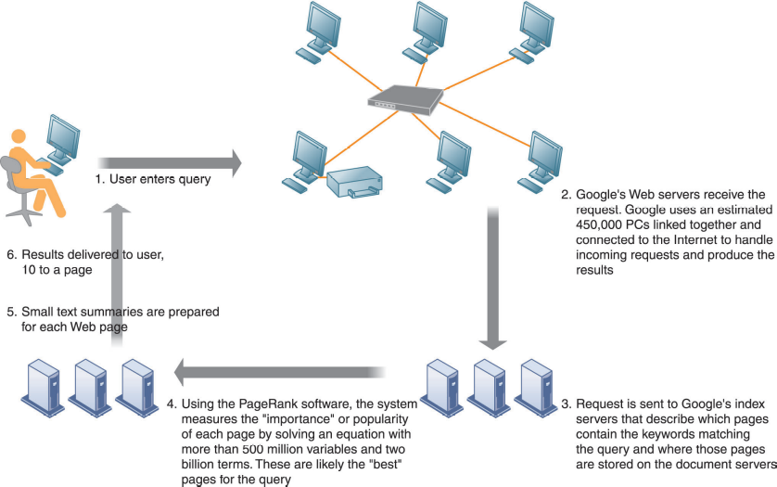

Figure 7-12 How Google Works

When you’re shopping for products in a brick-and-mortar store, how many times have you wondered if the price on that new bicycle is the best you can get? With mobile search capability on your smartphone or tablet, you can access other stores or dealers and determine on-the-spot if you’re getting the best deal. Mobile search also comes in handy if you’re trying to find restaurants, hotels, or popular sight-seeing spots in an unfamiliar area.

“It’s fair to say people aren’t searching for different things on mobile, they’re just searching at different times,” says Feng. With mobile, you can search for a restaurant, a museum or a shop right then and there, so mobile search tends to pick up in the evenings and on weekends, when consumers are on the go. Not surprisingly, desktop search is higher during the day, when people are at work—aside from a mobile spike during lunchtime.
While it may take a few years for mobile search volume to exceed PC search volume, mobile is taking an increasingly large stake in search queries. On Mother’s Day, 33% of searches for “flowers” were from mobile devices.

One shortcoming of mobile search, however, is that people’s thumbs aren’t very nimble—search sites see 1.5x more typos in queries on smartphones than on PCs. (Mashable.com, 6 Hot Mobile Search Trends From Google & Bing, Lauren Drell, July 12, 2011)

Search result listings show you which Web sites contain information related to your search words or phrases. The listings may also include sponsored links to sites related to your search request. Sponsored links are part of a burgeoning business known as search engine marketing. It provides businesses a new way to connect to potential customers through the special links at the top of the search result list or a special box on the right side of the search result page. Each time a user clicks on a sponsored link, the advertiser pays a fee to the search engine.

Because most people tend to stick to the first ten results of a search list, it’s important that Webmasters and site owners do what they can to have their sites listed as close to the top of the list as possible. Search engine optimization is the art and science of creating Web sites and pages so that happens. For instance, if your Web site is devoted to selling African violets, you can include keywords in your home page in such a way that your site will rank higher than others in search results. Another trick is to link your site to similar sites devoted to the same subject—link your site to the African Violets Society of America’s site.

Sometimes search engines can be too thorough or too mechanical in producing results for search phrases. Social search uses results of your friends’ searches, their friends’ searches, and recommendations from other people to produce results of a search query rather than using mathematical algorithms. Chances are greater that you'll get more relevant site listings.

Let’s assume you want to find the specifications online of an Apple iPad so you can compare it to an Amazon Kindle. You enter the search term iPad specifications in Google’s search engine and voila, you get a hundred suggested sites to purchase the product rather than the specifications themselves. Google is working hard to fix that problem through its development of semantic search. It’s goal is to build a search engine that understands human thoughts and phrases rather just finding words in its database. It’s also working hard to improve its search engine results to return videos and pictures that may be relevant to your search.

Many search engine home pages such as altavista.com have shopping bots available at a single click. Other shopping bot sites, www.pricingcentral.com gather information from many sources and combine it for ease in comparing prices and availability. Keep in mind that some of the prices available through these kinds of sites may not be the absolute lowest you could find on your own. Some companies pay a service fee to the shopping bot sites to have their products listed regardless of whether they are the lowest price. Buyer, beware.

Web 2.0

Making the Web convenient, easy to use, and having it work for us, is the idea behind Web 2.0 services.

Let’s say you’re looking for a new home in a new city that you’re not familiar with. You’d like to see information about local schools and perhaps crime statistics for your new neighborhood. You could spend hours researching data and trying to figure out how all the information correlates. Or, you could use a Web 2.0 service called a mashup and have the computer connect the dots for you.

You don’t have to search for information at all if you don’t want. Perhaps you’re an avid reader of blogs about golf. Rather than checking the entire blogosphere every day for new information, you register your information needs with a RSS (Real Simple Syndication) service. When new information is available you’ll automatically receive a notification on your desktop similar to the newscast ticker tapes you see on your television screen. What began as a convenient method of receiving blog updates has now spread across a variety of news, sports and information services to provide a convenient method of staying connected. Twitter.com produces microblogging posts that are limited to 140 characters.

Wikis are becoming a popular way to share information between employees, managers, suppliers, partners, and even customers. For instance, your collaborative team is devising a new advertising campaign. You have lots of input that previously was passed around the team via email. But that’s unwieldy and doesn’t give any of your team members a convenient method of searching for information. Who wants to sort through 83 emails looking for one piece of information?

Instead your team could use a wiki to post ideas, information, or details of the latest version of your campaign in one consolidated location. All your team members could post comments, edit comments from others, and collectively store all the files associated with the project. Searching for a particular piece of data is easy and fast. Wikis are much easier to use than more sophisticated knowledge management systems and the software is much cheaper.

What started out as a way for teenagers and college students to connect to their friends online and share photos and gossip, is now a multi-billion dollar social networking industry embraced by the likes of IBM, Ford Motor Company, and Coca-Cola. They have gone far beyond simply staying in touch with a few dozen—or few hundred—friends to an almost necessity in corporate life.

It looks as though 2009 is likely to be the breakout year for social networks in the enterprise. Internal and external spending on social networking solutions from IT providers and carriers may approach $500 million. Social networks are likely to be considered an inexpensive solution in a financially constrained IT spending environment. Globally, social networks have enjoyed a 25 percent growth in unique visitors in the last year. Some sites have doubled their user base. And their demographic profiles now include users over 35. Social networking is no longer a tool just for high school and college students. On some networks, around 40 percent of users are over 35. While questions grow about consumer social networks’ varying ability to monetize their hundreds of millions of users, enterprises are looking at how they can harness the hierarchy-flattening, information-sharing, teambuilding power of social networks.

Enterprise Social Networking (ESN) goes well beyond the consumer experience of social networking. It can include social discovery, social search, microblogging, visualization and new scalable architectures for social software, such as cloud computing. Enterprises are also experimenting with other ESN or Web2.0 applications, include wikis, mash-ups, online meetings, and syndicated feeds. And of course toolmakers are supporting ESN with their latest generation of content management tools.

Social networks look to be a powerful tool and a way of tapping into the ‘wisdom of crowds.’ But the enterprise versions of these solutions are still being refined. IT departments need to develop the tools in such a way that they engender productivity. Measuring returns on investment for ESN will be challenging, as will balancing an enterprise’s need to control a social network with its employees’ desire for privacy. On the other hand, most early versions of ESN look to be inexpensive, easy to roll out and require little employee training. Cash constrained companies should look at ESN as a way of capturing value that already exists within an enterprise at a relatively low cost. Telecommunications operators and IT solutions providers need to invest in ESN so they have the expertise and credibility to deploy these solutions if or when they become more broadly adopted, and start becoming a more significant source of revenues. (Deloitte TMT Trends: Predictions, 2009; www.deloitte.com)

Web 3.0: The Future Web

The same individual, Tim Berners-Lee, who began the Web, is now involved in creating Web 3.0, also called the semantic Web. Basically, data and content on the Web are currently stored in individual files that don’t easily connect one to another. A Word file may be stored on a corporate database server while a spreadsheet file about the same subject is stored on your laptop. What if all that data were automatically connected so when you try to find all the information you need about your company’s latest marketing campaign, the semantic Web would do it for you?

“Some Internet experts believe the next generation of the Web—Web 3.0 —will make tasks like your search for movies and food faster and easier. Instead of multiple searches, you might type a complex sentence or two in your Web 3.0 browser, and the Web will do the rest. In our example, you could type “I want to see a funny movie and then eat at a good Mexican restaurant. What are my options?” The Web 3.0 browser will analyze your response, search the Internet for all possible answers, and then organize the results for you.

That’s not all. Many of these experts believe that the Web 3.0 browser will act like a personal assistant. As you search the Web, the browser learns what you are interested in. The more you use the Web, the more your browser learns about you and the less specific you’ll need to be with your questions. Eventually you might be able to ask your browser open questions like ‘where should I go for lunch?; Your browser would consult its records of what you like and dislike, take into account your current location and then suggest a list of restaurants.” (Copied from http://computer.howstuffworks.com/web-30.htm, Jonathan Strickland, Dec. 2011)

Bottom Line: The Internet is a vast worldwide compilation of networked computers. IP addresses and the Domain Name System help ensure transmissions are routed to the correct recipient. Many applications such as email, FTP, newsgroups, instant messaging, and chatting are available. The Internet2 and NGI projects will improve on the current Internet configurations and make it easier and faster to exchange information and data. Companies wanting to gain a competitive advantage need to incorporate Internet and Web-based services into their business model.

7.4 The Wireless Revolution

Much as we’ve seen a convergence in wired digital devices such as computers, televisions, and telephones, we’re seeing a widespread convergence in wireless technology and the services it offers. If content can be digitized it can be transmitted over wireless networks. That includes voice, documents, photographs, music, movies, television shows, you name it. Why should we wait to show pictures of our vacation until we get home when we can instantly transmit them over the Internet via a photo-equipped cell phone? Why can’t we take a thousand songs loaded on a wireless device with us wherever we go?

On the ground, wireless communications use a variety of gadgets such as paging systems, email handheld devices such as the BlackBerry PIM, and cell phones. One of the hottest emerging communication appliances is the smart phone equipped with Web browser software. Some merchants are teaming with Web portals to use global positioning systems to pinpoint your location. Once the merchants know you’re in the local area, they offer you discounts on meals, clothing, and movies if you respond within the hour. As you’re walking down the sidewalk, you can use your smart phone to locate restaurants, check movie schedules, review sports scores, take and send photographs, and use maps to find your way.

Cellular Systems

Interestingly enough, the United States is not among the most “wired wireless” countries in the world; that honor goes to South Korea, Japan, and many European countries. Many developing nations are bypassing traditional, old-fashioned communication infrastructures and going straight to wireless. It’s easier and cheaper.

Unfortunately, each world region has adopted different standards for wireless networks and very often the standards don’t allow for cross transmissions. Two major standards used in the world are:

- Global System for Mobile Communication (GSM): Bandwidth is based on time division multiple access and is used in Europe, China, and Asia, and some regions of the United States.
- Code Division Multiple Access (CDMA): Transmits over several radio frequencies and randomly assigns users to a range of frequencies over time. It is used mostly in the United States.

Just as we’ve experienced generations of computers and computer languages, we allocate generational labels to wireless phone systems. Basically, we are working with two generations of cell technology:

- 3G networks: Appeared in the early 2000s and are based on packet-switch technology that allows large amounts of data transmission. Supports voice, video, graphics and wireless broadband Internet access.
- 4G networks: Just beginning to roll out in 2009 and 2010. Provides speeds between 1Mbps and 1Gbps with premium quality and high security.

Wireless Computer Networks and Internet Access

In order for wireless networks to work in tandem with each other it is necessary to create standards such as we have with Internet protocols and other network technologies.

Bluetooth

The Bluetooth wireless technology standard comes installed on some computers, which helps create small personal area networks (PANs). It’s more appropriate to use Bluetooth technology in battery-powered devices that are within close proximity to each other. Bluetooth technology is mostly used to connect keyboards, printers, computers, and handheld devices all within very close range.

“Bluetooth technology is a short-range communications technology that is simple, secure, and everywhere. You can find it in billions of devices ranging from mobile phones and computers to medical devices and home entertainment products. It is intended to replace the cables connecting devices, while maintaining high levels of security.

The key features of Bluetooth technology are robustness, low power, and low cost. The Bluetooth Specification defines a uniform structure for a wide range of devices to connect and communicate with each other.
When two Bluetooth enabled devices connect to each other, this is called pairing. The structure and the global acceptance of Bluetooth technology means any Bluetooth enabled device, almost everywhere in the world, can connect to other Bluetooth enabled devices located in proximity to one another.

Connections between Bluetooth enabled electronic devices allow these devices to communicate wirelessly through short-range, ad hoc networks known as piconets. Piconets are established dynamically and automatically as Bluetooth enabled devices enter and leave radio proximity meaning that you can easily connect whenever and wherever it's convenient for you.” (Copied from www.bluetooth.com , Dec 2011)

Even though the Bluetooth technology got off to a slow start in the early 2000s, it is now being used for all kinds of applications, even automobiles. Vehicles are coming equipped with Bluetooth technology and allow the use of hands-free cell phones, stereos, global positioning systems, and security devices. Figure 7-13 demonstrates a typical Bluetooth network.

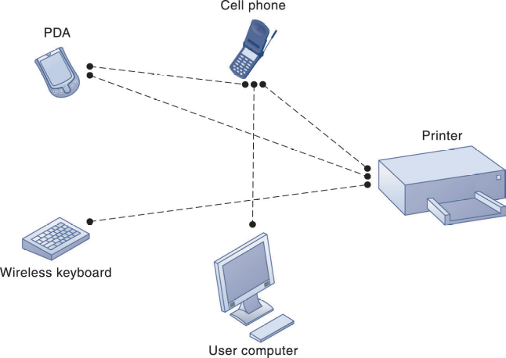

Figure 7-13 A Bluetooth Network (PAN)

Wi-fi and Wireless Internet Access

We mentioned earlier that today’s computing environment should be referred to as “wireless.” The recent proliferation of wireless technology is technically known as the 802.11 networking standard. It’s more commonly, and easily, called wi-fi for wireless fidelity. Wi-fi can be installed on your existing computers and connect them through a router hub via access points. If you have several computers at home or in the office, a wi-fi network can help save money by negating the need for additional phone lines for Internet access or to use a single peripheral device such as a printer among several different computers. Each computer requires a wireless NIC (network interface card) containing a built-in radio and antenna. These cards are relatively inexpensive and you can avoid duplicating more expensive equipment by using a wireless network.

You can access wi-fi networks in public areas such as libraries, Internet cafes, hotels, and airports. Access points to a wireless network are called hot spots and are proliferating in many public places. You should be aware of the dangers in using these hot spots. They lack strong security measures typical of wireless networks. You may experience interference problems as more users try to access the network.

One of the biggest challenges facing the wi-fi industry is creating enough hotspots all around the country to provide blanket coverage without interruption. Currently, there are still not enough continuous connections and many times users are dropped without warning. It’s similar to the situation cell phones users have experienced with dropped calls and service interruptions.

WiMax

Unfortunately, there are still large regions of the United States that must continue to rely on old telephone systems for Internet access. That prevents users from taking advantage of new high-speed access and many of the feature-rich applications available on the Internet. And because of limitations in frequency ranges associated with wi-fi, Bluetooth, and other technologies, many users are left out of the Internet evolution. A new technology called WiMax is being developed to help fill the gaps all across the country. WiMax increases the range of transmissions up to approximately 30 miles and increases the transmission speeds significantly over that available on regular telephone lines and dial-up modems.

RFID and Wireless Sensor Networks

Radio Frequency Identification (RFID) systems are an excellent example of how wireless technology is totally remaking supply chain management systems. RFID tags are small microchips that contain information about the product. This technology holds a distinct advantage over the old bar codes because it doesn’t require line-of-sight readers. Instead the tags transmit data via radio frequencies to computing devices that track the product. The tags can be either active or passive. Let’s compare the characteristics of each:

- Active RFID tags: Battery powered; data can be rewritten; have a longer read range, shorter operational life
- Passive RFID tags: No power source, smaller, lighter, and less expensive; unlimited operational lifetime; shorter read range

Figure 7-15 shows how the RFID technology works.

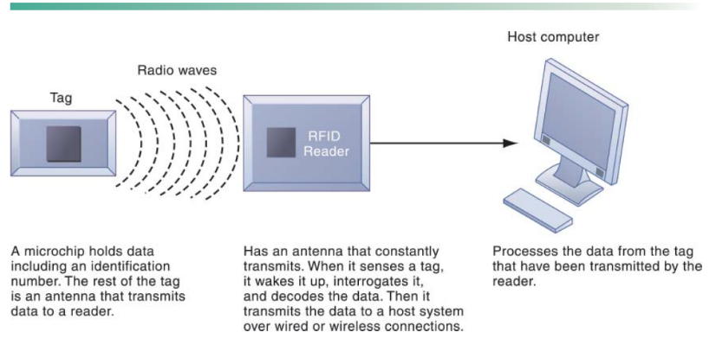
Figure 7-15: How RFID Works

RFID tags offer more inventory management control over products than the current bar code technology for several reasons:

- More data can be written to RFID tags
- More real-time data can be provided by RFID tags
- RFID tags can trigger other processes within the computer system
- RFID tags do not require line-of-sight readers

Even though RFID tags are more expensive than bar-code technologies, costs are dropping as they become more prevalent and the system switch-over is completed. For example, in 2001 a single RFID tag cost approximately $2.00. An RFID tag in 2010 costs approximately $0.10.

“In 2011, the cost of passive tags started at US$0.05 each and special tags, meant to be mounted on metal or withstand gamma sterilization, can go up to US$5. Active tags for tracking containers, medical assets, or monitoring environmental conditions in data centers all start at US$50 and can go up over US$100 each. Battery Assisted Passive (BAP) tags are in the US$3–10 range and also have sensor capability like temperature and humidity.” (Copied from Wikipedia.com, Dec. 2011)

Wireless Sensor Networks

Businesses use wireless sensor networks (WSNs) to connect handheld devices with data storage devices and allow workers to roam untethered through warehouses and office buildings. In the long run, WSNs will be cheaper for businesses and homes because no structural changes will need to be made to the building’s walls, ceilings, or floors. If you want to add equipment, you’ll simply add another node to the network. You won’t have to cut holes, run wires, or alter the physical structure at all.

Bottom Line: Wireless technologies such as Bluetooth and wi-fi create small networks that connect just about any kind of computing device. They are easier to configure and connect than wired technologies and allow users more flexibility and access. Wireless access points, or hotspots, are springing up in airports, hotels, coffee shops, and rest stops all across the country and world. RFID technology is giving companies new opportunities and challenges for supply chain management.

Discussion Questions:

- Discuss the advantages of a company using the TCP/IP standard to build a network.

- Discuss some of the Internet services available to businesses and how they can provide value.

- Discuss the emerging Voice over Internet Protocol (VoIP) technology and some of the advantages it may provide to businesses.

4. Use your imagination and come up with ideas of how your organization or company can use a wireless network. What current processes will you have to change to incorporate your idea?

5. Describe the advantages of using RFID tags rather than bar code technology.

Answers to Discussion Questions:

- The TCP/IP provides a universally agreed-on method for breaking up digital messages into packets, routing them to the proper addresses, and then reassembling them into coherent messages. Businesses using the TCP/IP standard can use a wide variety of hardware and software that is readily available thus sidestepping the need to create proprietary software and special hardware. Because of the universal acceptance of the TCP/IP standard, businesses can build networks that anyone anywhere can use.

- A few of the Internet services available to businesses include email, wikis, electronic discussion groups, chatting, instant messaging, Telnet, FTP, and of course the World Wide Web. All of these services provide a universal method of connecting employees, customers, suppliers, and business partners in an inexpensive way.

- Voice over IP (VoIP) enables companies to use Internet technology for telephone voice transmission over the Internet or private networks. VoIP technology uses the Internet Protocol (IP) to deliver voice information in digital form using packet switching, avoiding the tolls charged by local and long-distance telephone networks. VoIP calls can be made and received with a desktop computer equipped with a microphone and speakers or with a VoIP-enabled telephone.

- Answers will vary but should include information about the benefits of linking functional areas of an organization to increase communication between co-workers and teams, making information more accessible to employees and suppliers, and reducing costs associated with disseminating information. Answers should address how to integrate wireless technology into the rest of the firm’s IT infrastructure, how to maintain security and privacy, and how the relationships between employees, customers, suppliers, and business partners will change.

- RFID tags provide wireless transmission of more data in a real-time mode than does bar code technology. The RFID tags can trigger other processes with an information system based on the data contained in the tag. Because RFID tags do not require line-of-sight readers, data transmissions are faster and easier.

