Management Information Systems, 13E

Laudon & Laudon

Lecture Files, Barbara J. Ellestad

Chapter 11 Managing Knowledge

“When people leave organizations today, they are potentially taking with them knowledge that’s critical to the future of the business,” says David DeLong, a business consultant and author of Lost Knowledge: Confronting the Threat of an Aging Workforce. Whether it’s a key client relationship, mastery of an outdated computer language, or simply knowledge about where certain files are saved on a company server, every business has stored up bits of information and knowhow that isn’t written in a manual or recorded in a training video.” (BusinessWeek.com, The Knowledge Handoff, Douglas McMillian, Aug 26, 2008)

As we’ve mentioned in other chapters, information, therefore knowledge, is becoming an important corporate resource that must be captured, protected, preserved, and grown. How you do that is the focus of this chapter.

11.1 The Knowledge Management Landscape

Creating and using knowledge is not limited to information-based companies; it is necessary for all organizations, regardless of industry sector. It’s not enough to make good products. Companies must make products that are better, less expensive to produce, and more desirable than those of competitors. Using corporate and individual knowledge assets wisely will help companies do that. They must harness as much knowledge as they can and make it easy to share with others.

Important Dimensions of Knowledge

We discussed the difference between data and information in previous chapters. The next step up from information literacy is knowledge. An organization must transform the information it gathers and put it into meaningful concepts that give it insight into ways of improving the environment for its employees, suppliers, and customers. Wisdom then is using information to solve problems and knowing when, where, and how to apply knowledge.

You may have associated with the long-time employee that seems to know how to fix the intricate piece of machinery in his sleep. He’s been doing it for years, he would tell you. All of the knowledge he retains in his mind is tacit knowledge. On the other hand, you may have dealt with an employee who seems to grab the operating manual every time he turns around. The manual is an example of explicit knowledge—that which is documented.

Table 11-1 below shows that every organization has four dimensions of knowledge:
- Knowledge is a firm asset.
- Knowledge has different forms.
- Knowledge has a location.
- Knowledge is situational.

How it handles them is what can make the organization a successful one that seems to outrun the competition, or one that seems to muddle through the best it can. Examine your organization and determine how well it values its knowledge.

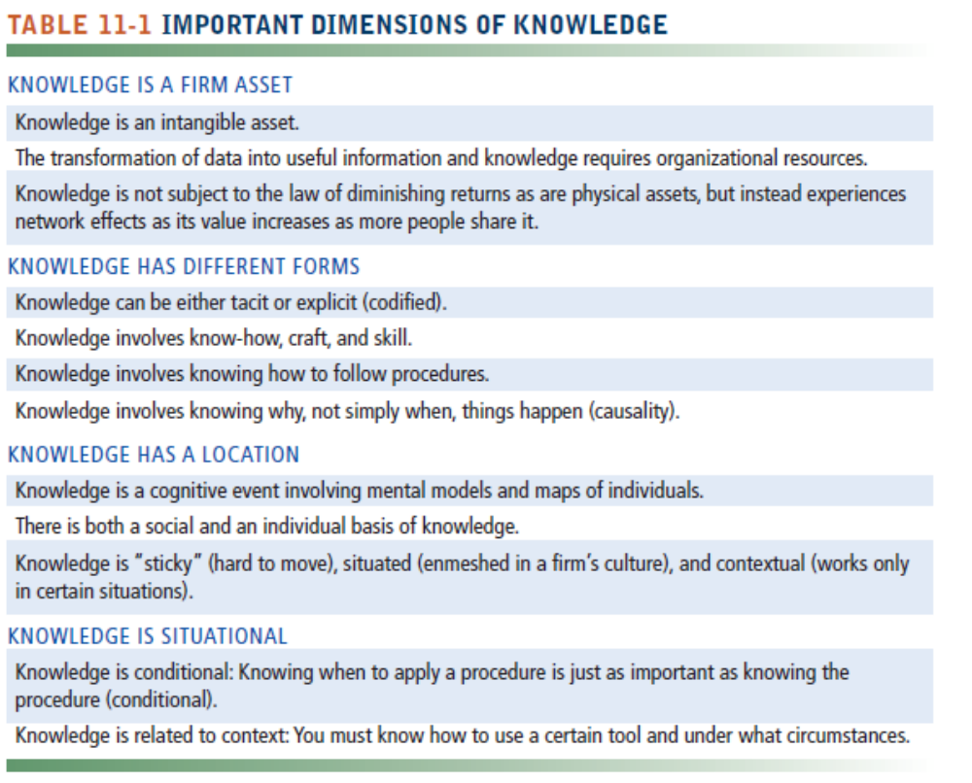

Organizational Learning and Knowledge Management

In the last few years, companies have downsized and flattened their organizations. Many employees who were laid off had been with these companies for years. When they walked out the door, they took experience, education, contacts, and information with them. Companies are finding out how important human resources are to their success and are establishing organizational learning mechanisms to capture and use this corporate knowledge.

That is, organizations gain experience by:
- Collecting data
- Measuring planned activities
- Experimenting through trial and error
- Gathering feedback from customers and the environment

Successful organizations then incorporate what they’ve learned into new business processes and new management decision-making skills.

The Knowledge Management Value Chain

To understand the concept of knowledge management, think of knowledge as a resource, just like buildings, production equipment, product designs, and money. All these resources need to be systematically and actively managed.

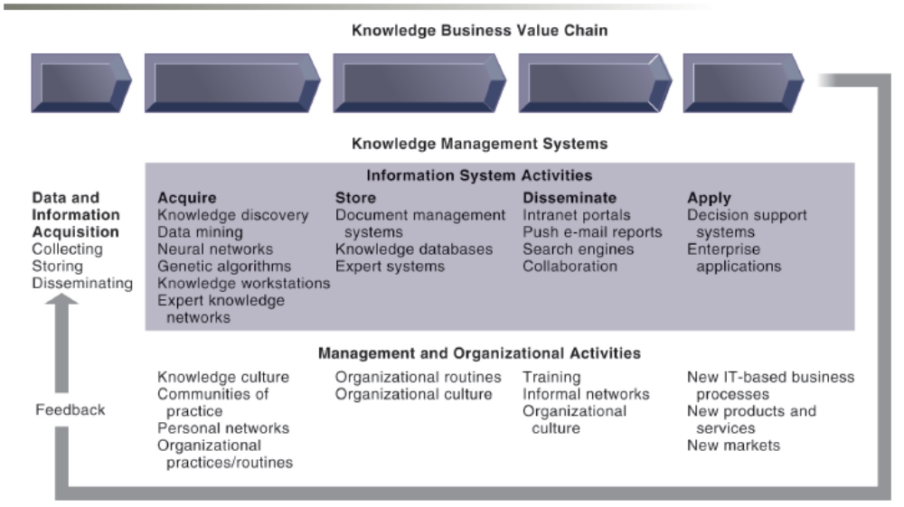

Figure 11-1: The Knowledge Management Value Chain

Figure 11-1 shows you the activities that go into successfully managing knowledge from acquiring it to applying it throughout the firm. It’s not just technology related to the activities that’s important to recognize. In fact, as the text points out, technology applications of managing knowledge account for only about 20 percent. The other 80 percent deals with organizing and managing the knowledge assets.

Knowledge Acquisition

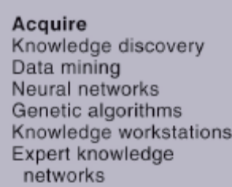

Figure 11-1a: Acquiring Knowledge

Knowledge comes from a variety of sources. Early attempts of gathering knowledge were a hodgepodge of documents, reports, and employee input. Now companies are using more sophisticated technologies to gather information and knowledge from emails, transaction-processing systems, and outside sources such as news reports and government statistical data. It’s important to remember that a great deal of knowledge should come from external sources since no organization exists in a vacuum.

Knowledge Storage

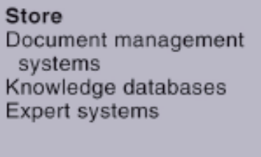

Figure 11-1b: Storing Knowledge

Remember, knowledge management is a continual process, not an event. As you gather knowledge you must store it efficiently and effectively. Document management systems are an easy way to digitize, index, and tag documents so that employees can retrieve them without much difficulty. Probably the most important element of any knowledge system is the people that feed the machine. One of the biggest reasons knowledge systems have failed in the past is because the employees and management either didn’t place enough importance on the system or felt threatened by it. All the people in the digital firm need to realize how important a resource knowledge is and help take care of the system.

Knowledge Dissemination

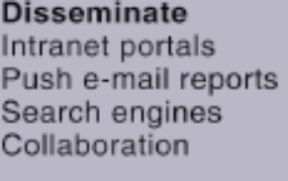

Figure 11-1c: Disseminating Knowledge

Once you’ve built the system, acquired and stored the knowledge, you need to make it easy and efficient for employees to access the knowledge. Portals, wikis, social networks, IM, and email are just some of the tools you can use to disseminate information easily and cheaply. Everyone complains nowadays of having too much information. The organization needs to make knowledge dissemination unobtrusive and easy to master or the employees and managers will ignore it or underutilize it.

Knowledge Application



Figure 11-1d: Applying Knowledge

You can have all the information and knowledge you need to master any task, but if you don’t build knowledge application into every functional area and every system used throughout the organization you are doing a disservice to both the knowledge and the company. As old systems are revamped and revised or new ones built, pay attention to how you can draw knowledge into them. The digital firm also needs to explore how it can use the knowledge system to build new processes for its employees and suppliers, or new products for its customers. Once it masters that, it can outrun the competition and build a stronger organization.

Building Organizational and Management Capital: Collaboration,

Communities of Practice, and Office Environments

As knowledge becomes a central productive and strategic asset, the success of the organization increasingly depends on its ability to gather, produce, maintain, and disseminate knowledge. One way companies are responding to the challenge is by appointing a chief knowledge officer. His/her responsibilities involve designing new programs, systems, and methods for capturing and managing knowledge. In some cases, the hardest part of the CKO’s job may be convincing the organization that it needs to capture, organize, and use its corporate knowledge to remain competitive.

“Basically, the CKO concept is rooted in the realization that companies can no longer expect that the products and services that made them successful in the past will keep them viable in the future. Instead, companies will differentiate themselves on the basis of what they know and their ability to know how to do new things well and quickly.” (copied from Business.com Web site, Nov 2008)

No one person has all the knowledge a digital firm needs. For that you must rely on many different people from many different locations. Communities of practice (COP) are built on the idea of combining ideas and knowledge from various sources and making it available to people inside and outside the organization. Professional conferences, newsletters, journals, and online newsgroups are excellent sources of information that center on the communities of practice concept.

Four areas where COP can make a difference are:

- Reuse knowledge
- Facilitate gathering new information
- Reduce learning curves
- Act as a spawning ground for new knowledge

Types of Knowledge Management Systems

Let’s look at three major types of knowledge management systems as shown in Figure 11-2.

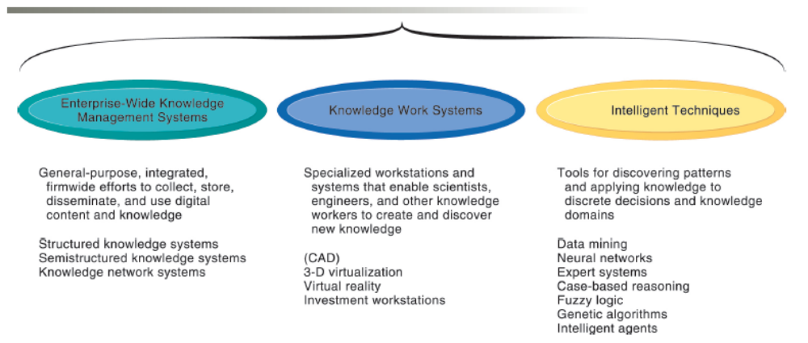
Figure 11-2 Major Types of Knowledge Management Systems

Enterprise-wide knowledge management systems are spread across the organization and offer a way to systematically complete the information system activities we just reviewed: acquiring, storing, disseminating, and applying knowledge.

Knowledge work systems use powerful workstations that can process the huge graphics files some professionals need or to perform the massive calculations other types of professionals require. We’re not talking clip art or simple adding or subtracting. We’re talking huge amounts of data that must be processed quickly and the necessary storage capacity for large files. The workstations must also have the necessary equipment and telecommunication connections that enable the knowledge workers to connect to external sources of information via extranets, intranets, or the Internet. These systems must have system and application software that is easy-to-use and manipulate, and intuitive to learn so the workers can “get right to it.”

Intelligent techniques, which we’ll look at more closely at the end of this chapter, include expert systems, neural networks, and genetic algorithms, to name a few.

Bottom Line: Knowledge is an important asset that must be managed throughout the enterprise. Knowledge must be acquired, stored, distributed, and applied effectively and efficiently. The Chief Knowledge Officer is responsible for ensuring that the digital firm uses its knowledge assets wisely. Communities of practice help people reuse knowledge easily and cheaply.

11.2 Enterprise-Wide Knowledge Management Systems

There are three primary types of knowledge in every organization:
- Structured documents: stored in reports, letters, or presentations
- Semistructured: stored in emails, videos, digital pictures, or brochures
- Tacit knowledge: stored in the employees’ heads

With so many sources of information and knowledge available, how does an organization go about collecting, storing, distributing, and applying all of it? That’s what we’ll investigate in this section.

Enterprise Content Management Systems

Traditionally, knowledge wasn’t considered a corporate resource. Many systems were built without the necessary infrastructure for gathering, storing, and retrieving knowledge. That started changing in the 1990s when companies started realizing how much knowledge was lying dormant in text documents and reports. The structured knowledge systems were the first attempts at capturing this type of knowledge and making it easily available to a wider range of people inside the organization.

As people started using newer forms of communications such as emails, chat rooms, voice mail, and digital-based reports, graphics, and presentations, organizations had to adapt their systems to accommodate the semistructured knowledge. Enterprise content management systems are designed to piggyback on the more rigidly structured knowledge systems to incorporate a wider range of information. Centralized knowledge repositories include information from the structured and semistructured knowledge systems. The knowledge repository is then easily accessed by employees throughout the organization and can also be properly managed by the CKO.

Before you get all the data, information, and knowledge into your enterprise content management system, you need to create a taxonomy that will help organize the information into meaningful categories. That makes it easy to find things later on. For example, you have lots of digital renderings of your company logo. Set up a taxonomy called “Logo.” Now, whenever you add another digital file of a logo, you tag it with the taxonomy.

For those firms whose knowledge is contained in objects other than simple documents, digital asset managements systems help them collect, store, and process knowledge contained in photographs, graphic images, videos, and audio files.

Interactive Session: Organizations: Denver Goes Alfresco (see page 427 of the text) describes how the City-County government was able to combine 14 different document management systems used by more than 70 agencies into an integrated system that improved employee processes and citizen engagement.

Knowledge Network Systems

Because it’s simply too expensive and too time-consuming to continually reinvent the wheel, corporations are turning to knowledge network systems in an attempt to link those who hold the knowledge with those that need the knowledge. Employees who have the tacit knowledge about a product or project in their head are easily connected with employees who need to know the information through these kinds of networks. Corporations save time and money by placing data pertaining to the subject matter experts in a directory that all employees can access. Users are easily connected to the experts through these networks and can communicate and collaborate on a variety of subjects.

Collaboration and Social Tools and Learning Management Systems

Knowledge systems are often used by and support professional employees such as engineers, researchers, analysts, and highly skilled technical workers. Portals provide easy-to-use access to these systems and help provide internal and external information others have discovered to be successful solutions or best practices. The organizational memory we spoke of earlier is shared among other workers more efficiently with knowledge systems. No reinventing the wheel, thank you!

If you thought that blogs, wikis, and social networking sites were only for kids or twenty-somethings that want to gossip and share their innermost thoughts and feelings, you would be wrong. Companies are discovering the power of using these tools for collaboration among and between employees—especially teams, customers, suppliers, and business partners. They are easy to use and often don’t require any help from the IT staff to set up or support. And they sure are easier to search and organize than thousands and thousands of emails.

As you surf through the Web and find news articles, videos, pictures, or soundtracks that you want to track or share with others, you can use social bookmarking techniques to tag the information with keywords. You store the shared bookmarks in folksonomies so that your friends or co-workers can easily find the bookmarks.

Because business processes and work methods are constantly and continually changing, organizations must devise ways to make learning less expensive and easier to deliver. By using a learning management system to provide the necessary tools for delivering, tracking, and assessing employee learning, companies can reduce costs and ensure employees receive the right training at the right time. A company can make these systems even more productive if they are used in conjunction with Web-based multimedia systems. Regardless of where the employee and educator are located, they can collaborate together whenever necessary.

Bottom Line: Enterprise content management systems, knowledge network systems, and collaboration tools help organizations build knowledge repositories that employees, suppliers, customers, and business partners can access through knowledge networks. Learning management systems help the firm deliver, track, and assess employee learning.

11.3 Knowledge Work Systems

Many of the systems we’ve discussed centered on how to collect, store, distribute, and apply knowledge. Let’s talk about how to create knowledge in this section.

Knowledge Workers and Knowledge Work

Knowledge work systems support the creation and integration of new knowledge that is beneficial to the organization. KWS are often used by and support professional employees such as engineers, researchers, analysts, and highly skilled technical workers. They are connected to knowledge systems that provide information others have discovered to be successful solutions or best practices. Knowledge workers have three key roles in helping an organization develop its knowledge base:
- Bring external knowledge into the firm
- Serve as internal consultants
- Act as change agents

Requirements of Knowledge Work Systems

The first requirement of a KWS is that it provides knowledge workers with the following necessary tools:

- Graphics tools
- Analytical tools
- Communication tools
- Document management tools
- User friendly interface

Figure 11-4 shows the required elements of a KWS.

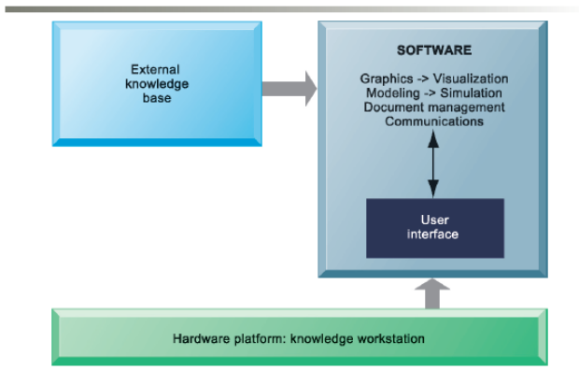

Figure 11-4: Requirements of Knowledge Work Systems

Examples of Knowledge Work Systems

Pick up any business or technology magazine or surf news channels and you’ll find numerous examples of how companies are using knowledge work systems to re-create their core processes, create new products or services, or improve old ones.

Computer-aided design (CAD) applications are used by design engineers to build new products or improve old ones. It used to take 3–4 years and millions of dollars to design a new car. With improved CAD systems, automobile manufacturers have reduced the time to 18–24 months and cut the cost by millions of dollars. Boeing Company has seen the same startling results in its design process for airplanes.

CAD systems supply data to 3-D printing technologies that use machines to produce prototypes and small items on a computer. As manufacturers go through the design process, traditionally they have produced mock-ups of the real thing, using valuable time and resources to construct items they most likely will discard. With 3-D printing, they can instead create the parts on a computer system, saving time and money.

Virtual reality systems have sophisticated imagery that makes you feel like you’re “right there!” You may have seen this system on TV shows or in the movies. You’re usually required to wear special equipment that feeds your reactions back to the computer so that it can plan its responses to your input. The U.S. Air Force uses virtual reality systems to help train pilots.

Augmented reality allows you to keep one foot in the real world and put one foot in an enhanced computer-generated imagery world. If you’ve ever watched a professional football game you’ve experienced augmented reality. You know, that yellow line across the field that shows you where the team has to get to for a first down. With every set of downs, the augmented reality line moves to a different location. It’s so real some people are surprised that it only appears on televised broadcasts of football games. Marketers are especially enamored with the idea of interacting with customers in new and different ways. The technology has a bright future as people become more used to the idea that they can experience a myriad of services in new, more fun, and better ways.

Interactive Session: Technology: Firewire Surfboards Lights Up With CAD (see page 432 of the text) describes how one company uses new CAD technology as a way to attract new customers and improve its design and manufacturing processes.

VRML (Virtual Reality Modeling Language) is a set of specifications for interactive 3-D modeling on the Web. Many companies are putting their training systems right on the Internet so that people can have access to the latest information and can use it when they need it. Some Web sites use Java applets to help process the programs on a local workstation.

How would you like to make investment decisions based on information that is 90 days old or older? Would you have very much faith in a system that told you only how the company did financially last year, or would you also like to know how the company performed last quarter? That’s the idea behind investment workstations. They combine information about companies that is internal and external, new and old, in order to advise clients on the best use of their investment dollars. The amount of data is massive and must be processed quickly in order to keep up with the changing market conditions and the changing nature of the industries themselves.

Bottom Line: Information and knowledge are key business assets that must be nurtured, protected, grown, and managed for the benefit of the entire organization. Knowledge work systems create and manage knowledge using computer aided design systems, virtual reality systems, augmented reality, and VRML.

11.4 Intelligent Techniques

There are quite a few ways organizations can capture knowledge using technology. Knowledge discovery tools and techniques help people find patterns, categories, and behaviors in massive amounts of data. Artificial intelligence (AI) is not all about computers taking over the world and turning on their human inventors. Rather, many of the systems under the AI umbrella are useful tools for capturing, storing, and disseminating human knowledge and intelligence. Still over intelligent techniques help generate solutions to problems that can’t be solved by humans alone.

Capturing Knowledge: Expert Systems

Expert systems are a common form of intelligent techniques. They are used to assist humans in the decision-making process, but they don’t replace humans. Many of the decisions we make are based on past experience, but we have the added benefit of reasoning and intuition. Expert systems ask questions, then give you advice and reasons why you should take a certain course of action based on hard data, not on hunches. Again, they don’t make the final decision.

Most of the problems an expert system helps resolve can, in fact, be solved by a human. But since the computer is faster or safer, businesses choose to use them instead of a person.

How Expert Systems Work

Expert systems rely on a knowledge base built by humans based on their experiences and knowledge. The base requires rules and knowledge frames in which it can process data. When you think about it, humans work the same way. You look out the window to see if it’s raining. If it is, then you grab your umbrella. If it’s not raining, then you don’t. There you have it, a rule base.

Yes, we used a very simplified example. Most expert systems require thousands of rules and frames in which to operate in a rule-based expert system. The knowledge must be specific. In the example above, you wouldn’t take any action if the only information you had was “It rains 350 days a year in the Amazon rain forest.” Neither would an expert system.

The programming environment of an expert system uses rules, frames, and an inference engine to accomplish its tasks. The inference engine uses forward chaining or backward chaining to move through the rules and the frames.

In our example, using a forward chaining inference engine, you would start with the idea that it’s raining. You’d move through a series of decisions until you reached a conclusion and acted on it. You would determine that it’s raining, then you’d decide how much, then you’d decide how wet you don’t want to be, then you’d decide to take an umbrella. As long as the answer continues to be yes, you keep moving forward.

In a backward chaining inference engine, you’d start with a hypothesis and work backward until your hypothesis is proved or disproved. You got wet because it was raining; using an umbrella would prevent that.

You build an expert system in a similar fashion as other information systems in terms of hardware and software. However, it’s even more important to continually maintain and update an expert system: You never want to make decisions based on outdated or incorrect information. You can build a transaction processing system and perhaps not update it for six months to a year. With an expert system, you have to update the data and the processing software almost immediately and continually so that it’s never out of date.

Examples of Successful Expert Systems

You measure the success of an expert system by the following criteria:

- Reduced errors
- Reduced cost, reduced training time
- Improved decisions
- Improved quality and services
- Happy users and happy customers

Most problems solved by expert systems are mundane situations. “If it’s raining, then take an umbrella.” But what happens if it’s cloudy and only “looks” like it will rain? Expert systems only do well in situations in which there are definitive outcomes. They aren’t good at making decisions based on guesses or hunches. The expert system might advise to take the umbrella along or to leave it home based on the input. The human makes the final decision to take or leave the umbrella.

If you understand that expert systems can only do so much, you’ll be just fine. If you understand that they aren’t people with the powers of reasoning and intuition, and therefore they can’t make every decision, you’ll know when to override the system and when to go with its output. Remember that everything in an expert system is based on IF this, THEN that. We know not everything is black and white and there are many gray areas.

Expert systems should not replace managers. They can aid managers in the decision-making process, but managers have to make the final call. For instance, you suggest to your boss that you should receive a pay raise. You have many subjective reasons why you should receive the raise; you arrive early and stay late, your work is always (well, almost always) turned in on time, you filled in for Sam while he was on vacation, and you’re a good worker. What happens if your boss relies on an expert system that uses only facts? You submitted the last two projects late (because the boss made last minute changes), you took an extra week’s vacation (when your child was in the hospital), and you were late to work three times in one month (because the subway broke down). You may or may not get the raise. Your boss still needs to use intuition, reasoning, and gut reaction to make the final decision.

Organizational Intelligence: Case-Based Reasoning

So far, we’ve concentrated on capturing the individual knowledge in an expert system. Through practical experience, you’ve realized that “two heads are better than one.” Very seldom will only one individual work on a project. Or perhaps one individual works on the candy bar ad campaign while another works on the breakfast cereal campaign. They have different and yet similar experiences. What if you could tap into each person’s experience and knowledge on a collective basis? Take the best of the best from each one and apply it to your needs. Then you give your knowledge to someone else who will combine it with knowledge from others and continue building on “the best of the best.” That’s what a case-based reasoning (CBR) system does best.

The Help files you find in most desktop software applications are built on a case-based reasoning model. The technical support staff combines thousands of customer queries into a single database of problems and solutions and refines that information into a series of IF this is the problem, THEN try this. Access the Help files in your desktop software and try it.

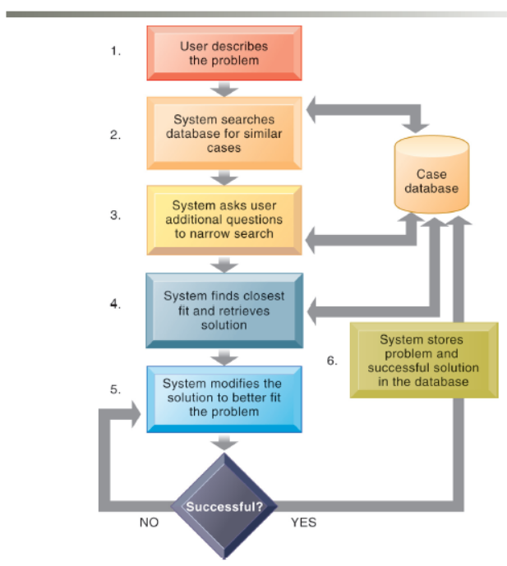
Figure 11-7: How Case-Based Reasoning Works

Figure 11-7 gives you an excellent overview of how a case-based reasoning system works.

Fuzzy Logic Systems

Okay, one more time, back to our umbrella. If it’s only cloudy outside, how do you know whether to take the umbrella? “It depends on how cloudy it is,” you say. If it looks like rain, you know to take the umbrella; there is a strong possibility that it will pour buckets. If it’s only a little cloudy and doesn’t look like rain, you’ll take the chance that you won’t get wet and leave the umbrella at home. That’s fuzzy logic!

Fuzzy logic is based on approximate values and ambiguous data. A fuzzy logic system will combine various data into a range of possibilities and then help solve problems that we couldn’t solve before with computers.

Machine Learning

If you’ve made a purchase on Amazon.com or a clothing Web site like JC Penney, you’ve probably seen a feature displaying suggestions about what other people purchased when they purchased your item. How does the Web site know that? Because as people make purchases and view similar items, the computer running the Web site captures all that data and feeds it into an algorithm. The machine running the Web site “learns” about the preferences. As thousands and millions of people make purchases and view other items the machine learning capabilities of the knowledge management system used by Amazon.com and Penney’s are altered for future use.

Machine learning allows computer systems to recognize patterns in data and change their behavior based on their recognition of patterns, experience or prior knowledge. The use of machine learning has greatly expanded over the past few years because of improvements in algorithm design, growth of databases including “Big Data,” and the increase in raw computing power available in today’s computer systems.

Neural Networks

This type of knowledge system is as close to emulating the human ability to learn as we’ve been able to come. Let’s return to our umbrella example. How do you know to take an umbrella when it’s raining? You probably got wet a few times without one. Then you tried using one when it rained and discovered that you didn’t get wet. You learned that when it rains, an umbrella will keep you dry. That’s basically how neural networks work.

You give a neural network data for which you already know the output, so that it has a base of correct information upon which it can build. When you give it new, different data, the computer will compare it with the previous data to determine what the correct outcome of the situation should be. If the data don’t fit, it figures out why. It adds that information to its current database of knowledge and then keeps taking in more data. It eventually learns the right outcome. The more data it takes in, and the more situations it gets right, the better it becomes at knowing the right answer to the next set of decisions.

If you want an excellent online demonstration of neural networks, <A HREF=“http://www.emsl.pnl.gov:2080/proj/neuron/neural/demos.html” target=”new”>Pacific Northwest National Laboratory’s Web site</a>.

The Difference between Neural Networks and Expert Systems

- Expert systems emulate human decision making.
- Neural networks learn human thought processes and reasoning patterns.

- Expert systems use rules and frames in which to make their decisions.
- Neural networks adjust to inputs and outputs.

- Expert systems provide explanations for solutions.
- Neural networks cannot explain why they arrived at a particular solution.

- Expert systems require humans to update their database of information.
- Neural networks continue to expand their own base of information.

Genetic Algorithms

We’ve evolved as a human race through genetics. We are made up of many combinations of generations of humans. That’s how genetic algorithms work. Solutions to problems are examined by the system. The best solution is retained for future use, while the worst solutions are discarded. The solutions that are retained are used to help provide better solutions to future problems. They are combined and changed the next time they are used.

Businesses often need to solve problems that are dynamic, complex, and have many variables. Very few problems are clear-cut, black-and-white. Genetic algorithms are good systems for businesses to use because it’s almost like having millions of people coming at a problem from all directions.

Hybrid AI Systems

We’ve mentioned before about taking the best of the best and that’s just what hybrid AI systems do. They take the best parts of expert systems and the best parts of fuzzy logic, and the best parts of neural networks, and combine them into one system that solves a problem. You can look forward to more of this hybridization as we continue to expand our knowledge of technology and of human behavior.

Intelligent Agents

Jump on the Web and find the best price for computer printer supplies. Simply typing the words “computer printer supplies” into your favorite search engine will result in thousands of pages with more than just price information. You can find specific information on prices much faster using an intelligent agent. These software programs learn your personal preferences for accomplishing simple tasks and can take the drudgery out of repetitive, specific work. Figure 11-11 in the text demonstrates intelligent agent technology at work.

Businesses can use intelligent agents to help train users on new systems, schedule appointments, or monitor work in progress. By far though, the most popular use of this nifty little software program is as a “shopping agent” that surfs the Web for you looking for specific items to purchase or the lowest prices on a particular item.

If you’d like to try a shopping bot yourself, try www.mysimon.com . The Web site explains its service this way “Our secret is a team of helpers built with patent-pending software. The Virtual Learning Agent™ technology creates ‘intelligent agents’ trained by our own team of shopping experts to collect information from any online store.” It’s fun and fast.

Another way companies are using intelligent agent technology is by developing agents that mimic real entities—customers, supply chains, and stock markets. Agent-based modeling uses the agents to model behavior and help managers make decisions. For example, it seems reasonable to assume that it’s better to wait until you have a full truckload of supplies before you dispatch the truck. But P&G discovered through agent-based modeling that the amount of lost sales because of out-of-stock conditions actually cost the company more than the transportation expenses associated with partial truckloads of supplies.

Bottom Line: Businesses are interested in artificial intelligence to preserve the intelligence and knowledge of their employees and use it to their competitive advantage. Expert systems emulate humans in the decision-making process but cannot replicate the intuition and reasoning that still require the human touch. Many new technologies can help humans solve difficult problems or take advantage of new opportunities. Neural networks learn how to make decisions. Fuzzy logic uses “ranges of possibilities” instead of giving black-and-white, yes-no answers. Intelligent agents take much of the drudgery out of repetitive and predictable tasks.

Discussion Questions

- Discuss the difference between tacit knowledge and explicit knowledge and give some examples of each.

- Discuss management and organization activities necessary to enable information system activities in a knowledge management system. Refer to Figure 11-1 in the text.

- Describe how an organization can use Web 2.0 collaboration tools to enhance enterprise content management systems.

- How is an expert system different from a neural network?

- Discuss some potential business uses for augmented reality technology.

Answers to Discussion Questions

- Tacit knowledge is undocumented experience and expertise employees keep in their heads. Explicit knowledge is documented usually through reports, emails, voice mail, graphics, and video files.

- There are four information system activities in a knowledge management system: acquire, store, disseminate, and apply. Each of them has multiple management and organization activities that must take place to ensure as much knowledge as possible is included in the knowledge business value chain. Figure 11-2 aligns the two sets of activities.

- Organizations can use consumer Web 2.0 technologies, including portals, blogs, wikis, and social bookmarking, to collaborate with other employees, customers, suppliers, and business partners. The common tools help capture, consolidate, and centralize the knowledge and make it easy to share. Social bookmarking, along with folksonomies, allows users to share information of interest with others.

- Expert systems require people to input all decision-making rules into the rule base. A knowledge engineer pulls information from various sources and fits it into the expert system. A neural network builds upon a base of information and continually learns by itself. Very little human intervention is required for the neural network’s knowledge base to grow.

- Augmented reality combines the real world with computer-generated graphics or other effects that enhance users’ experiences. Some potential uses include:
  - Landscape architects could enhance a photo of your front yard with potential changes.
  - Geologists could use an aerial photo to demonstrate potential flood plains and the effects a flood would have on the area.
  - City planners could project how changing a street’s traffic flow pattern would look before they began construction.
  - Automobile manufacturers could use the technology to show potential customers what a car would like look with various changes in upholstery, colors, or more dashboard features.

