Management Information Systems, 13E

Laudon & Laudon

Lecture Notes by Barbara J. Ellestad

Chapter 13 Building Information Systems

“What do you mean we have to change the way we make our candy bars? They are the number one selling product we have. Everyone loves them. Why can’t we just keep doing things the way we’ve always done them? It’s worked fine this long.”

It’s not unusual to hear this type of dialog in companies, large and small, all across the world. Change is hard on people and organizations. But it’s one of those necessary evils that keeps companies in the lead or helps destroy them. In this chapter, we’re going to focus on using information systems as a way to successfully help redesign organizations so they can improve their current processes or establish new ones.

13.1 Systems as Planned Organizational Change

It would be nice if we could give you a precise checklist of how to smoothly introduce a new information system, but we can’t. No one can. What we provide in this chapter is information you can use to help plan and analyze organizational changes associated with new systems development.

The triangle that we’ve used before is back…
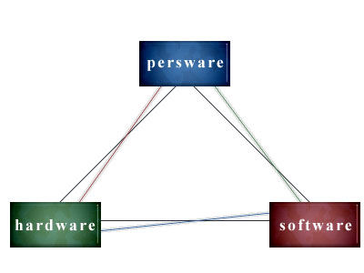
All three elements will pose their own unique challenges to managers, but you may be surprised to learn that the hardware and software will probably be the easiest of the three to manage. Successfully reorganizing the company relies on more than just bringing in new equipment and new programs. Understanding and incorporating changes in the social and political climate in any organization is one of the most important aspects managers will have to deal with.

Systems Development and Organizational Change

Change is disruptive. Change is dangerous. Change is good. Change is necessary. Change is constant.

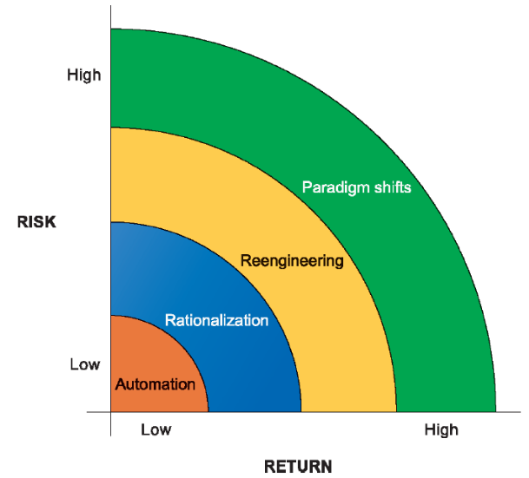
Figure 13-1: Organizational Change Carries Risks and Rewards

This figure shows the four degrees of organizational change. Automation is the easiest (except for those people losing their jobs), and the most common form of change. But that doesn’t mean you don’t have to plan for the change first.

Rationalization of procedures causes the organization to examine its standard operating procedures, change the ones that don’t work well anymore, eliminate those no longer needed, and make the organization more efficient. It’s a good thing, as Martha Stewart would say!

Both of these types of change cause some disruption, but it’s usually manageable and relatively accepted by the people.

Total quality management, making quality control everyone’s responsibility, relies on an excellent information system that supplies workers and management with the data necessary to improve products and drive down costs. The lack of good, useful information may not be apparent until the organization can’t figure out what it’s doing wrong, or doing right. Data from all the types of information systems we discussed can be fed into quality management and make it easier to develop and improve products that blow away the competition.

Six Sigma is another initiative companies use to spot problems and correct them before they are too deeply embedded in the company’s processes. It just stands to reason that the longer a flaw is allowed to fester in the system, the more problems it may cause. And the more problems, the higher the costs. So if you can identify the defects early on and eliminate them, you can achieve more efficient production at lower costs. That’s the premise behind Six Sigma.

Business process redesign, on the other hand, can cause radical disruption. The mere mention of the term nowadays strikes fear in the hearts of workers and managers at all levels. Why? Because many companies use it as a guise for downsizing the organization and laying off workers. Business process reengineering causes planners to completely rethink the flow of work, how the work will be accomplished, and how costs can be reduced by eliminating unnecessary work and workers.

But if you want to talk radical change, take a look at paradigm shifts. Now we’re talking about changing the very nature of the business and the structure of the organization itself. We’re talking whole new products or services that didn’t even exist before. We’re talking major disruption and extreme change!

The Internet is causing all kinds of industries and businesses to alter their products, their services, and their processes in radical ways. Entire organizations are being created to handle the paradigm shifts caused by the Web and other Internet applications. Look at the automobile industry as an example of this type of change: Traditional dealerships are being disrupted by automalls and online buying opportunities. How can a local dealer compete on price with these two environmental challenges? What is the dealers’ role in the revolutionary changes taking place all around them?

If business process reengineering and paradigm shifting are so disruptive and so dangerous, why even try to do them? Because companies realize they have to take on the challenges in order to stay competitive. They have had to cut costs and streamline their operations because of global economic pressures, in addition to meeting the demands of their shareholders. And done well, the rewards can be tremendous.

Business Process Redesign

Take a seemingly simple task such as sending out customer invoices and really analyze how many steps are involved in the process. Even in a small business, you may be surprised how many steps there are. Business process management (BPM) is the art and science of analyzing every task in a business and helping firms continually optimize them. BPM includes work flow management, business process modeling, quality management, change management, and standardizing processes throughout the organization. Every business, from the smallest to the largest should continually analyze how they accomplish every task and look for ways to improve everything. The business doesn’t have to accomplish this with the idea that every process should be automated even though many can. The business simply has to continually look for better methods of performing the work.

BPR attempts fail 70 percent of the time. That’s an astonishing figure when you think about it. What if your car failed to start 70 percent of the time? Some of the reasons for the high failure rate are lack of planning, management’s inability to fully comprehend the enormity and complexity of the effort, and the fact that BPR usually takes much longer than expected.

Here are a few guidelines that organizations, their managers, and workers can follow to help make BPR a success.

First, decide which business processes you need to focus on. Sometimes it’s not the information system that’s the real problem but rather the process itself. Understanding the difference can help prevent fixing the wrong thing. By determining what business processes are most important to the organization and improving them, you can improve the overall business performance.

Second, make a diagram of how your processes work now, including inputs, outputs, resources, and the sequence of activities. Figure 13-2 in the text shows an example of the proper way to diagram an existing business process. Try just a few processes to get your feet wet and then expand it to other units or processes within the organization. Document how much your current processes cost. You’ll be able to measure costs savings (or costs increases) better if you have a baseline for comparison.

The third step is to design and document the new process. Does the new process save time and money or improve customer service? Sometimes you can accomplish all three objectives. For instance, instead of ten people handling a single bank loan application, you can install software that will speed up the process, allow several people to work on the document at the same time, and decrease the total number of people who handle it. Or, you can migrate the application process to the Web and make it even more efficient and customer-friendly. Wells Fargo Bank allows customers to complete an online application and receive a preliminary approval or disapproval within minutes. Wells Fargo’s computer system is connected to the credit reporting agencies’ computers for quick access of customer credit data. If customers have questions about the application or the types of loans available, they can initiate an instant messaging session with a bank employee and get all their questions answered on the spot. After the application has been submitted, the customer can check its progress online. Once the loan is approved, the money is allocated to the customer through an online account. Wells Fargo processes more bank loans faster and more efficiently. The customer is happier with less effort. And all of this can take place 24/7.

The fourth step in business process redesign is to translate the (hopefully) improved process into new procedures and work rules. You may encounter new problems or determine that portions of the new process must be improved or changed, but that’s okay. Work through them and continually improve what you do.

Last, you need to understand that every process requires continuous measurement to ensure you keep up with changes and technological improvements. That’s where the documentation you created in the second step can help.

Tools for Business Process Management

Fortunately, you have a lot of tools that will help you manage these aspects of the BPM process:
- Identifying and documenting processes
- Creating models of improved processes
- Capturing and enforcing business rules for performing processes
- Integrating existing systems to support new or redesigned process
- Providing analytics for verifying improvements in process performance
- Measuring the impact of process changes

The tools for BPM generally fall into one of three categories:
- Documenting and monitoring business processes to help identify inefficiencies and identifying trouble spots
- Automating some parts of a business process and enforcing business rules
- Integrating existing systems to support process improvements

Interactive Session: Organizations: Burton Snowboards Speeds Ahead with Nimble Business Processes (see page 496 of the text) shows how every company can use technology to improve its business process management regardless of the products it makes.

Bottom Line: Continual change is a necessary part of corporate life. Four types of organizational change each carry their own level of risk and reward: automation, rationalization, redesign/reengineering, and paradigm shifts. The quality of a company and a product can be improved through business process redesign.

13.2 Overview of Systems Development

Systems development includes every resource and every step that goes into producing an information system that solves a problem or helps the organization take advantage of new opportunities.

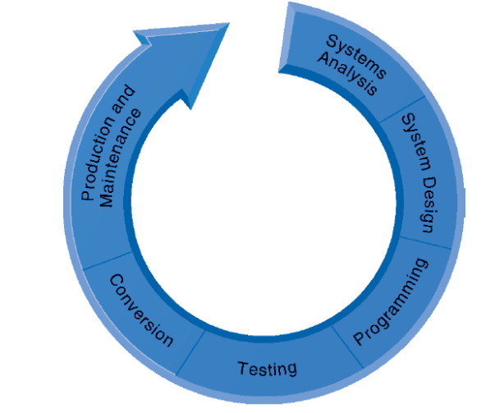
Figure 13-4: The Systems Development Process

Don’t start by thinking, “Oh, we’re going to develop a new computer system? Well, that problem belongs to the IT (Information Technology) department.” Nowadays, system development belongs to you as much as it belongs to the techies. You have to work hand-in-hand from start to finish within the entire organization to develop a usable system that will serve everyone.

The arrow in Figure 13-4 goes in only one direction. Remember that just because you apparently completed one step doesn’t mean you can never go back to it at some point in the development process. In fact, many of the steps should be revisited several times, especially if you are using the prototype method of development.

Systems Analysis

So what’s the problem? Answering that question is harder than you might think. You have to analyze the current situation to determine the real cause of the problem. Make sure you’re addressing the real problem and not just the symptoms. Effective systems analysis, adequately determining the real problem, is the key.

Write down everything you do in this stage, especially when it comes to what the real problem or opportunity is. Constantly review it throughout the rest of the system development process to remind you and others of what you’re trying to do and where you’re trying to go. It’s natural to stray from the path! Most of all, determine how your objective fits in with the rest of the current information systems and the business plan itself.

Is your idea even feasible? You might be surprised how often organizations fail to ask this question. A feasibility study helps you determine if your proposed solution is achievable before you spend thousands of dollars. The study will review the technical, financial, and organizational feasibility of hardware, software, and persware and help you decide whether your proposed answer is the right one. Too often organizations underestimate the cost of a new system, especially in the persware area: training, downtime, lost productivity, and employee disruption.

Establishing Information Requirements

Figuring out who needs what information, where, when, and how will challenge the political dynamics of any organization. No system can answer every need, so you’re going to have to decide who gets what. That’s why you must write down the problem and then keep referring to your notes throughout the development process. It is too easy to get sidetracked by politics.

You must think and then rethink the proposed solution. Make sure you thoroughly investigate the information requirements—you’re going to live or die by the outcome. Whatever happens at this stage will carry through to all the other stages. A significant cause of system failure in development projects is because organizations failed to properly analyze and understand their information requirements.

The final dilemma is whether a new information system is really the answer. Would it be better to address the problem through management changes, more training, or changing existing organizational processes?

Systems Design

Congratulations! If you get to the systems design stage, it means you managed to live through the analysis phase. Now you can get down to figuring out how the system will actually solve the problem or help you take advantage of new opportunities. Remember, your goal is to fit the system into the organization and not make the organization fit the new system. Or at least you want to keep them in tandem; that is, the organization should decide what technology is necessary, while the system capabilities can help reshape the organization.

When we discussed database management systems, we distinguished between two methods of viewing data: the physical design (how the data would actually be stored in the system) and the logical design (how the data would look to the user). Use the same definitions when you are designing your system, and concentrate on the logical design. In addition to elements that the authors point out in the text, the physical design should determine how the new system will support the current organizational structure, or spell out the changes in that structure that will successfully integrate the new system. Table 13-1 in the text categorizes all of the design specifications that you’ll need to develop for a new system.

The Role of End Users

Unfortunately, the physical design sometimes overrides the logical design. Why? Because the nontechies give up too much control to the techies. This is a reminder that both sides have to work together, keeping the goals of the organization as the number one priority, and remembering that the best system is one that meets the users’ needs.

Don’t forget that people are the most important component of any system. As soon as users begin to feel they have little input into the development process, you are courting disaster. Keeping the end user involved will produce a better system. The number one reason so many system development projects fail is due to insufficient user involvement.

Completing the Systems Development Process

Now that you’re through the analysis and design phases, you can move on to the remaining steps in the process. Just remember, you can always go back to those two steps and probably should at some point.

Programming

The actual programming phase will in all likelihood be carried out by the IT department. If you’re using a fourth-generation language, the programming could very well be done by the end user. Either way, make sure that the programming supports the analysis and design phases. If not, go back and work through them again. It could very well be that what was designed simply can’t be programmed. The usual impulse is to program around the design flaws. Don’t! Redesign instead.

Testing

“Hey, it works!” But does it really work as it was designed for a real-world situation? Was every aspect thoroughly tested by independent testers in an actual setting? Several things that go wrong in the testing phase of the development process can severely hamper the projects success.

For one thing, this step is glossed over by both techies and nontechies. People assume that because something was designed and programmed according to the specifications in the analysis stage, it is right. So they just fly right through the testing process. Or they run one or two tests, usually by the very people who designed and programmed the system. “Hey, I know it works ’cause I programmed it.” Uh,oh! Wrong! You should never have the people who were involved with the design and programming stages do all the testing. Get a fresh pair of eyes to look at the system according to the test plan that was developed by the programmers and the users.

Most of all, if you do find a flaw in the testing, do not give into the temptation to ignore it or explain it away. Go back to the analysis, design, and programming stages. Get rid of the flaw the right way.

Of the three types of testing explained in the book, unit, system, and acceptance, the last is the one that is most important and yet the most underrated. Managers and users must be adamant about testing the system, measuring it against the analysis and design requirements, and then accepting the system only when it does in fact measure up.

You’re getting close to the end. You’ve been through the agony of analyzing, designing, programming, and testing. The system meets the requirements, works right, the end users love it, and the bosses are clamoring to see some results. Now you need to figure out which conversion process will work best for you.

There is no right way or wrong way to implement the system; you have to look at it in the context of your particular organization.

- You can use the parallel strategy, but it’s expensive to run two separate systems at one time. If you don’t have a lot of confidence in your new system, you might want to go with this one.

- If you’re really confident in your development process or, if the old system simply doesn’t work anymore, you can use the direct cutover strategy. For instance, Friday you’re using the old system; come Monday you’re using the new one.

- If neither of the above describes your organization or your new information system, you might want to consider the pilot study strategy. You can introduce the new system into a single area of the organization. If all goes well there, you can install the new system in other areas. You’re still going to have to figure out how to run two systems at once and also figure out how to integrate the new system with the old system.

- The phased approach is similar to the pilot strategy, but now you install parts of the new system slowly into specific areas of the organization. Again, two systems, two methods, integration problems, support problems, etc.

However you convert, make sure everyone knows what’s going on. Tell them through documentation of a formal conversion plan and not the grapevine. Use the information you gathered in the earlier stages of the development process to help guide the implementation plan. Make sure you figure out how to convert the data and train the users. User resistance through fear of the unknown can destroy all your hard work and planning.

Production and Maintenance

You buy a new car and think your problems with the old junker are over. Only for a while. Eventually, you’re going to have to change the oil, buy new tires, get a new air filter. Sooner or later, the new car will become an old car. The same is true with an information system.

After you install the new system and it’s in production, you want to go back one more time and make sure it’s meeting your needs through a postimplementation audit. Eventually you’re going to have to perform maintenance on the system no matter how well you designed and built it. And someday you’ll have to make major changes or replace it altogether.

It’s interesting to note the statistical breakdown of system maintenance that Laudon and Laudon include in the text:
- 20 percent—debugging or correcting emergency production problems
- 20 percent—changes in data, files, reports, hardware, or system software
- 60 percent—making user enhancements, improving documentation, recoding system components for greater processing efficiency

You can easily reduce the largest proportion of maintenance by using better systems analysis and design practices that we’ve discussed. Try it, you might like it.

Modeling and Designing Systems: Structured and Object-Oriented Methodologies

There’s always more than one way to accomplish a task. The trick is to use the one that works best for the job you’re trying to accomplish.

Structured Methodologies

Traditionally, systems have been structured in a very orderly manner. The methods used to build the systems begin at the top and progress to the lowest detail always with an eye toward keeping the processes separated from the data. The designers sketch out how the data moves through the system by using data flow diagrams. That way the designers can easily track all the processes and their interrelationships. The DFDs can be used to help spot trouble areas before the system is actually built. Figure 13-6 shows a typical data flow diagram.

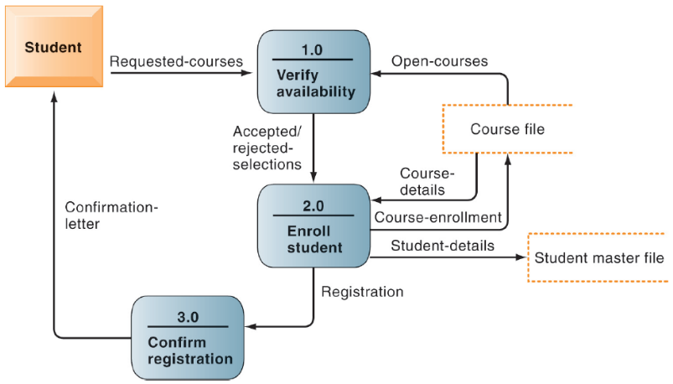

Figure 13-6: Data Flow Diagram

The advantage of using data flow diagrams is that they can be used to show a very general, high-level process or very minute detail using the same tools. Anyone can view the overall system and then easily drill down through the diagrams to lower levels of the system. Couple the DFDs with a data dictionary and you can develop process specifications that describe how the data is transformed into useable information. Hierarchical structure charts complete the structured methodology by providing top-down charts that show each level and how they interrelate.

Object-Oriented Development

The structured development method keeps data and processes separate. Object-oriented development combines the two and treats them as one object. More importantly, the objects are created once and, if they are done right, can be used many times over. That reduces the cost of creating new objects once you have built up a library of them. It also makes it easier to create new software, because you aren’t continually starting from scratch.

The terms used in this section, class and inheritance, describe how object-oriented modeling uses objects to develop a program. It may sound complicated, but it really isn’t. Figure 13-8 shows you how classes inherit the common features of their superclass. Take a few minutes to study it.

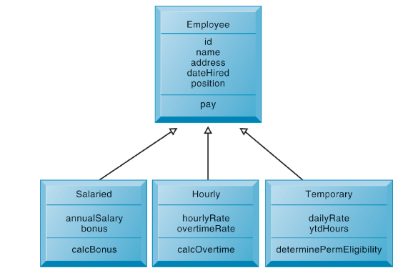

Figure 13-8: Class and Inheritance

Object-oriented development is an iterative and incremental way of building programs.

The steps in the analysis phase are:
- Document functional requirements
- Specify the most important properties
- Decide what the proposed system must do
- Analyze interactions between the system and users to identify objects

Steps in the design phase are:
- Describe how the objects will behave
- Describe how objects will interact with one another
- Group similar objects together to form a class
- Group classes into hierarchies

Computer-Aided Software Engineering

If we’ve automated just about everything else with software, it shouldn’t be a surprise that we’re also automating software design and development. Computer aided software engineering (CASE) provides developers with an easy to use method of developing software code that is well-documented, well-designed, and easily reused. Because software programs are becoming so complex it’s not unusual to have teams of programmers develop the code. CASE tools provide an element of coordination and management for the programming teams. CASE tools also help keep programming elements such as data flow diagrams and data dictionaries synchronized. CASE tools bring discipline and structure to the program design and development process that may otherwise be lacking.

Bottom Line: The system development process is a straightforward one with distinct activities that bring order to the chaos of building new systems. The most important piece of the puzzle in systems development is the user. Managing organizational information requirements through planned analyses and structured system development rather than a haphazard approach will help you succeed. Object-oriented development combines data and processes into one object rather keeping them separate.

13.3 Alternative System-Building Approaches

If you’ve ever watched a house being built, you know everything starts with the blueprints. One page of the blueprint set has an overall picture of how the house will look when it’s done. Another page gives a front view, a side view, and a back view. There are several pages with extremely detailed drawings showing where and how everything fits together. You wouldn’t dream of building a house without all of this documentation—at least we hope not.

Traditional Systems Life Cycle

The systems life cycle is primarily used for large systems projects. It has existed for years and uses tried-and-true methods that help ensure the success of the system from its humble beginnings as an idea to an old relic that eventually needs replacing.

The traditional lifecycle may seem rigid today. This approach works well for major systems but doesn’t fit the bill for smaller ones. It’s expensive, time-consuming, and sometimes doesn’t allow techies and nontechies to work together as they should. In fact, the user is left out of the loop on a lot of the development and implementation. Even though end users or managers have to sign off and accept the system at the end of each stage, they are not as involved in this method as some of the others we’ll look at later.

Prototyping

Fast, cheap, user-centered. Prototyping may be the best way to develop a new system if end users don’t have a clue about what they really want the system to look like. Even if they have a few clues, prototypes works well because the user can guide the process based on what they see as the system is built.

Have you ever watched a television show where a police artist draws a picture of a criminal as the victim looks on? The artist draws the eyes and gets approval from the onlooker. Then the mouth is sketched in and approved. Pretty soon a composite drawing is completed, and the cops are off and running. That pretty much describes the iterative process used in building a prototype system.

Generally, you use prototyping for very small systems or small parts of a larger system. You wouldn’t want to use this method to build a company-wide information system. It can be too unstructured, making it harder to manage large development projects. Prototyping works well when you’re developing user interfaces and output reports— areas the users will see the most.

Steps in Prototyping

The text outlines the four steps you use when developing a prototype. The important thing to keep in mind is that these steps should be repeated many times over. If you work through them just once, you might be in trouble. Some additional tips:

Step 1: Ask lots of questions.
Step 2: Sketch an informal flowchart with a pencil and paper. Pay attention to the decision trees.
Step 3: Have users try every part of the new system.
Step 4: Repeat, repeat, repeat.

If you are the developer, make sure the user signs off on every step of the process. Verify that the prototype does in fact meet the user’s needs. If you’re the user, are you happy with the new system and does it work well for you? If not, why not? If not, use Step 4 frequently.

Advantages and Disadvantages of Prototyping

Prototyping can be less costly than the traditional systems approach, but if you fail to follow some of the basic principles of systems development, it can be more costly. For instance, if you ignore the basic principle of how the prototype fits into the other information systems in the organization, or how it supports the business plan in general, you may be costing the organization more money than you realize. Did you just create an island of information that is incompatible with other systems, or is it fully supportive and easy utilized in other areas?

The greatest advantage of the prototyping method of developing end-user interfaces is that users see the product, or at least a pretty good replica of it, right away. If they like it, you press on. If they don’t like it, changes can be made immediately. There’s less red tape and bureaucracy (perceived or otherwise) to work through in this method.

But be careful if you use the prototype as the actual production version. Is it the best it can be, or are you just tired of fiddling around with it?

End-User Development

Taking matters into their own hands. This method of system development is a bit like prototyping, but the end user designs and develops the new system using fourth-generation languages. It’s convenient for small applications, and the user has complete ownership of the system.

The tools available to the end user are getting easier to use all the time and increase the likelihood that the system will meet the user’s specifications, because the user is building it. There’s no one else to blame if the system doesn’t do what the user wants it to do. But don’t attempt to build larger and more complex systems using this method: The capabilities of the tools are limited.

Managers should be aware of some inherent dangers with end-user development processes. Standardization can be a tough issue when you use it. You’re almost begging for conflicts in data processing and storage, because each user will have his own method of creating, defining, and developing data using query languages.

The most frequent risks of end-user development methods are:
- Testing and documentation may be inadequate.
- Control over data may be lost.
- Costs may exceed benefits.
- Hardware, software, and quality standards may be violated.

We’re not trying to discourage this type of system development. The advantages of having users develop their own mini-systems are tremendous. You just need to be aware of the risks.

Application Software Packages and Outsourcing

We mentioned earlier that software programs are becoming extremely complex to design, develop, and build. Many companies either don’t have the in-house staff to accomplish the task or they decide to focus on their core competencies and have someone else develop the software they need.

Application Software Packages

Fast, easy, convenient, user-driven. Many software packages are extremely convenient for nontechies to use to develop their information products. Commonly called “off-the-shelf” software, these packages can be the best method of creating an information system if that system is fairly standard across different types of businesses.

You don’t have to worry about system documentation, because that usually comes with the software. You still have to write local procedures for using the program, but you don’t have to start from scratch. Training is easier because once you learn how to use the menus and toolbars in one program, the same skills can be carried over to other programs. Training manuals often come with the program or are available through online help functions.

Application software packages also provide an easier method of obtaining code corrections, updates, and enhancements: Simply go to the Web site of the company that wrote the software and download the latest version. Need technical support for the program? Log on to the Web and you’re there. No telephone calls, no waiting on hold for hours, no begging the IT staff to fix your problem. In fact, you’ll probably find answers to questions you didn’t even know you had!

Most of the common programs still need to have usage standards within the organization. For instance, if you use an accounts receivable application software program, you should still set standards for how you will adapt that program to meet the unique requirements of your company.

Most off-the-shelf software can’t be changed, so you have to take what comes. The unique requirements of your organization probably won’t be met. You’ll end up having to change your methods to match the software, instead of the other way around. Some software packages do allow some customization, but not as much as a program developed solely for your organization.

Application software packages still need lots of planning, especially when it comes to integrating them with the other information systems throughout the organization. Compatibility is key.

You should determine the total cost of ownership with these programs beforehand. What are the training costs, implementation costs, and integration costs? They all add up.

Selecting software packages can be just as demanding as developing a system on your own. You have to evaluate:
- The program’s functions to make sure they fit your needs.
- Flexibility to adapt to your business.
- User-friendliness (persware).
- Hardware and software resources.
- Database requirements.
- Installation and maintenance efforts.
- Documentation.
- Vendor quality (including follow-up).
- Cost.

Just as you would for any piece of equipment, you would seek Requests for Proposal (RFP) from several vendors to fully evaluate the software package according to your needs. Remember, you give up a lot of control when you choose to go with a prewritten software package.

Outsourcing

What happens if an organization decides it doesn’t have the in-house expertise to support the system development process or any of the system maintenance required? No problem—outsource. There are hundreds of outside companies that will do the job. These companies offer expertise and experience, often at a lower cost than in-house staff. That’s the primary reason companies choose offshore outsourcing. They can also offer smaller organizations economies of scale that make overall information processing cheaper.

The total cost of ownership of a system can be cheaper because of outsourcing. Perhaps the outsourcing company can keep up with changing technologies better than the organization. It may simply be that the organization decides to spend in-house information resource dollars in other ways.

Should you decide to use an outsourcing company to develop an information system, you must be more careful than ever to ensure that everything, right down to the smallest detail, is in writing and agreed upon by both sides. You are signing a contract with the outsourcer that carries the full force of law. You must agree on how changes will be made to the current system. How responsive will the outsourcer be to changing requirements? You still have some responsibilities for the system; what will they be? Get it in writing!

You must continually analyze the outsourcing company’s performance and cost and make sure it remains the cheaper, better way to handle the organization’s needs. At some point in time, you may find a different method is in fact cheaper. Figure 13-11 provides information on the total cost of offshore outsourcing.

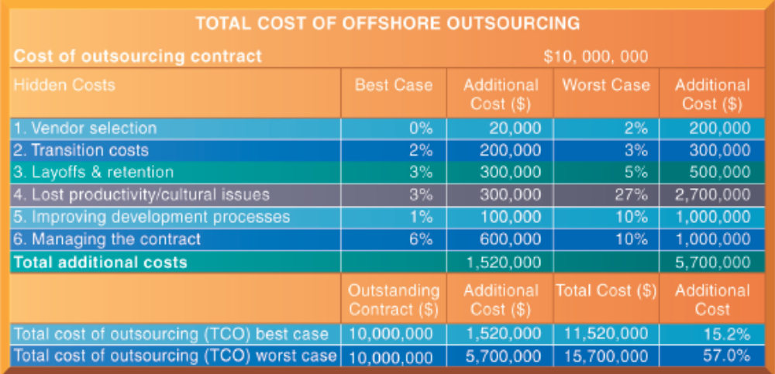

Figure 13-11 Total Cost of Offshore Outsourcing

Bottom Line: There are different ways to develop information systems: prototyping, application software packages, end-user development tools, outsourcing. Analyze each and then pick the right tool for the right job.

13.4 Application Development for the Digital Firm

Until a few years ago it was common for system development to take months if not years. That time frame has shortened to days or weeks. Pundits refer to “Internet time” as a reference for the much more rapid development of systems that some companies experience now. Unfortunately, some of the more important steps of development may be slighted or overlooked altogether in the rush to get a product out the door. Unfortunately, customers may be the ones to suffer the most from the mistakes.

Rapid Application Development (RAD)

Supply and demand. The supply of technical specialists is not enough to support the demand for new systems, or maintenance of the old ones. Something has to fill the gap—that’s why you see so many new methods already on the market and more advanced, easier-to-use tools coming down the road. The shortage of skilled technicians is also why you see more and more companies moving away from the structured methods we’ve reviewed. There just isn’t enough time.

Rapid Application Development (RAD) reduces the time it takes to build systems by using many of the tools that we’ve discussed. You can choose from prototyping or fourth-generation tools to develop systems much more quickly. End users and techies can work hand-in-hand with joint application design (JAD) tools to reduce the development time for new applications.

Because of the collaborative environment so prevalent in today’s business world, agile development is a popular way of developing systems. This method takes a large project and breaks it down into small sub-projects. Teams use iteration and continuous feedback to develop plans, establish requirements analysis, design the project, code it, test it, and document it.

Component-Based Development and Web Services

Component-based development is simply the practice of developing reusable components that are commonly found in many software programs. Create a “Save File” function for one application and use it in all applications. Not only does it save development time but creates functions that users have to learn only once and use multiple times. In short, why keep re-inventing the wheel when it works just fine across a multitude of vehicles.

Web Services and Service-Oriented Computing

Both of these system development methods rely on reusable components obtained from Web sites on the Internet. They are independent of operating systems, programming languages, or client devices. That makes them cheaper and easier to incorporate than proprietary software development.

“Service-oriented computing (SOC) is a programming paradigm shift in the computer and information technology industry. Unlike object-oriented programming, SOC deals with modules or components that can be represented as reusable entities with service interfaces. Each entity may have a specific goal or objective. The entities can be composed and reused in various applications or solutions.” (BusinessWeek.com, Dec 2008)

Mobile Application Development

People are moving away from total dependence on desktop and laptop computing to mobile computing access on iPads, iPhones, smartphones, and tablet mobile devices. Obviously the screens are much smaller on the handheld devices so they must react and interact differently than those on larger screens. It’s not enough nowadays to simply design one Web site and hope it works okay across multiple devices.

Smaller smartphone screens make better use of multi-touch gestures than larger desktop screens although the new Windows 8 operating system will bring touch computing to the desktop. Still, smartphone apps must be optimized for specific tasks but not too many at one time. They need to be designed for usability. Other features that are top priorities for smartphone screens and apps are:
- Saving resources and optimizing bandwidth usage.
- Reducing screen space.
- Reducing the amount of memory necessary.
- Improving processing speed.
- Optimizing and reducing data entry.
- Reducing the number of user gestures required.

You have a choice. You can design three different Web sites for desktops, tablets, and smartphones. Or, you can use responsive Web design that enables Web sites to automatically change layouts according to a user’s screen resolution regardless of the device used to access the site.

Here are the advantages of using responsive Web design:

- Uses a mix of flexible grids and layouts.
- Uses flexible images.
- Media queries are optimized for different viewing contexts.
- Web sites automatically accommodate changing resolutions and image sizes.
- Eliminates the need for separate design and development work.
- Users have access to a single source of content.
- Content is easy to read and navigate with a minimum amount of resizing, panning, and scrolling.

Interactive Session: Technology: What Does It Take To Go Mobile (see page 517 on the text) explains how companies are developing mobile apps or mobile Web sites to accommodate the changing behaviors of users and customers. By 2013 more people will use their mobile phones than PCs to go online and there will be one mobile device for every person on earth by 2015. Companies must adapt if they want to maintain their competitive advantage.

Bottom Line: New methods of developing systems are continually being introduced. These new technologies, rapid application development, joint application development, component-based development, agile development, and Web services are reducing the time, effort and cost for businesses and organizations. Developing mobile applications for handheld computing devices is becoming more important.

Discussion Questions

- In the spectrum of organizational change, which is the most radical type of change: automation, rationalization of procedures, business process redesign, or paradigm shifts? Why?

- What are some of the reasons business process management efforts fail?

- What are the advantages of using object-oriented development methods instead of the traditional system life cycle?

- What is the advantage of using an application software package? What types of application software packages could you use in your organization?

- What advantages lie in using Web services instead of proprietary, closed systems?

- Why is it important to pay close attention to mobile application development and why is it better to use responsive Web design for mobile apps?

Answers to Discussion Questions

- Paradigm shifts are the most radical type of change because they require the organization to rethink the very nature of the business and the necessity for moving into whole new markets. Paradigm shifts can cause major disruptions and extreme change throughout the organization.

- The largest single barrier to successful business process change is organizational culture. Employees do not like unfamiliar routines, and often try to resist change. Business process management efforts fail because of the high cost and extended time they take to implement. Business process management involves rethinking work flows and business processes. Too often businesses fail to plan for the changes their employees and customers will experience. Many businesses simply don’t communicate with their people enough to make it work.

- Object-oriented development combines data and processes into a single object that becomes the basic unit of systems analysis and design. Because processing logic resides within objects rather than in separate software programs, objects must collaborate with each other to make the system work. Object-oriented development reduces costs and time because objects are reusable as building blocks for other objects.

- Application software packages are prewritten programs and are convenient for non-techies to use. The system documentation is prewritten and updates to the program are easy to obtain from the vendor. Technical support, updates, bug fixes, and enhancements are available from Web sites.

- Web services use open standards that any piece of hardware or software program can access. Web services can be written once and used many different times or different ways. The open standards used by Web services allow companies to connect their business processes easier and more reliably. Web services also enable organizations to tie together disparate systems foregoing the need to build new systems from scratch.

- The user experience for mobile device interaction is fundamentally different from using a desktop or laptop PC. Saving resources, bandwidth, screen space, memory, processing, data entry, and user gestures are top priorities for mobile app design. Rather than designing three different Web sites for three different types of computing devices, responsive Web design allows developers to design one Web site that automatically changes layouts according to the user’s screen resolution, whether on a desktop, tablet or smartphone.

