Introduction | Click Instructions | Presenter Script
Click Here |  | In this demo, you'll learn how you can use the familiar environment of Microsoft Excel 2010 with the PowerPivot add-in to create compelling self-service Business Intelligence solutions.
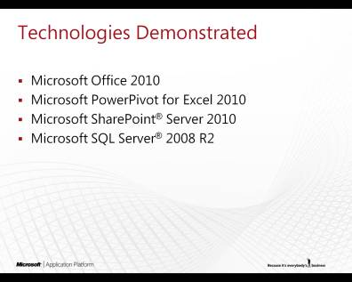  Click Here |  | Users can share and collaborate using the secure, managed environment of Microsoft SharePoint Server 2010 and Microsoft SQL Server 2008 R2-based management tools.
Demo
My Profile | Click Instructions | Presenter Script
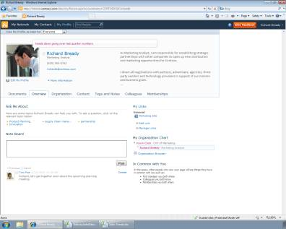  Click Here | - On the taskbar, click on Sales Trends.xlsx. | Richard is a typical analyst in his organization and was just tasked by his VP to gather data. Richard’s VP has a hunch on trends that are happening by product class and region, and wants to compare these trends versus third party industry data. To do this, Richard’s VP wants him to access information that is in the corporate data warehouse as well as external data outside the organization.  How would Richard even start? Let’s see how he can pull all of this together in a single analytical model to perform some truly remarkable analysis.

Sales Trends | Click Instructions | Presenter Script
Click Here | - Switch to the PowerPivot tab. | Let’s start in Excel. You can see this is the familiar user interface with the Fluent Ribbon that was introduced with Office 2007, but it’s got a new tab called PowerPivot.
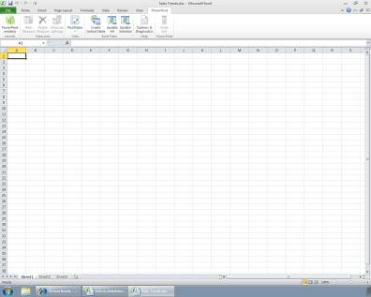  Click Here | - Click on the PowerPivot window button. | PowerPivot is an optional add-in for Excel 2010 that allows end-users like Richard to connect to data from multiple sources. This enables interactive modeling and analysis of massive amounts of data at lightning-fast processing speeds.
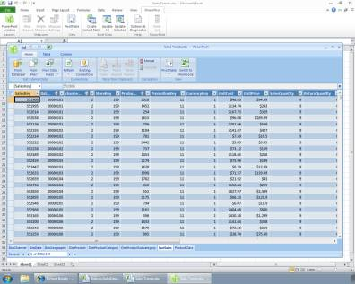  Click Here | - Click the From Database button. | The Table Import Wizard lets you add business data from your corporate network, your local computer, or ad hoc data sources on the web. You can connect to external data sources directly, or use predefined connection objects such as ODBC to get the data. You can also enter or copy in data from other worksheets, documents, websites, or text files.
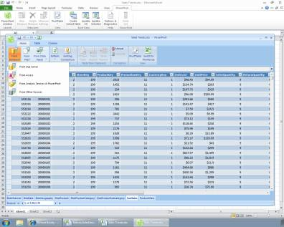  Click Here | - Select From Other Sources.
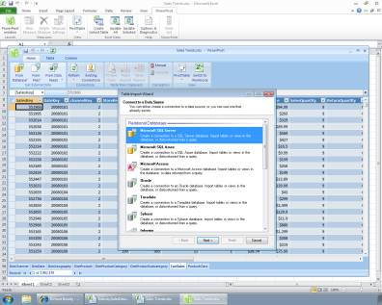  Click Here | - Scroll down. | PowerPivot can connect to any of your existing IT systems or data sources, such as Oracle, IBM DB2, or Terradata.
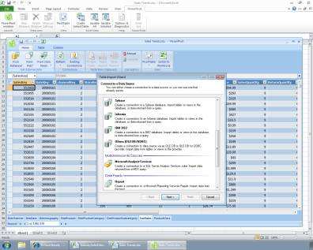  Click Here | - Scroll down.
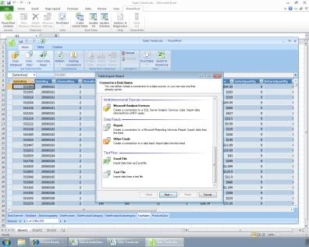  Click Here | - Click Cancel.
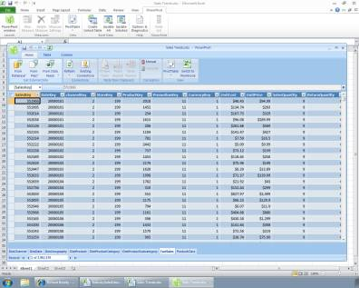  Click Here | - Click on the header for the UnitCost column. | Notice that there are almost 4 million records loaded in this FactSales table. Despite this large size, Richard is able to easily perform operations on the data, such as sorting a column.
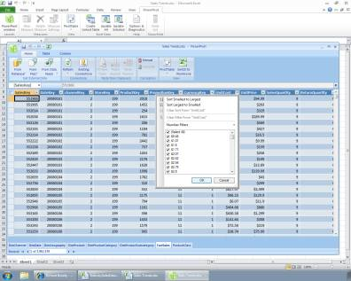  Click Here | - Select Sort Largest to Smallest. | PowerPivot is extremely fast, even when sorting millions of rows of data.

Industry Data | Click Instructions | Presenter Script
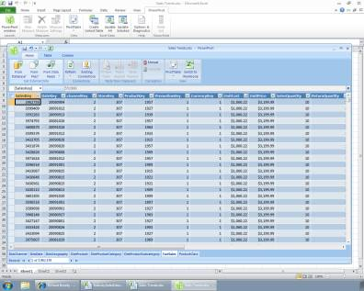  Click Here | - On the taskbar, click on IndustrySalesData.xlsx.
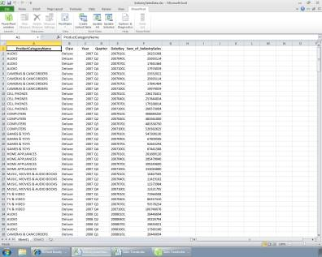  Click Here | - Click on the upper-left corner of the spreadsheet. | Remember that Richard needs to compare his company data with industry trends. With data from his corporate data warehouse already loaded, Richard combines this analysis with external data such as industry sales trends.
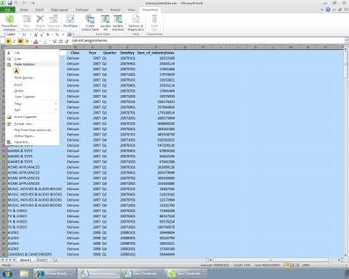  Click Here | - Select Copy.
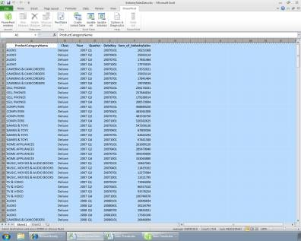  Click Here | - On the taskbar, click on the PowerPivot window for Sales Trends.xlsx.
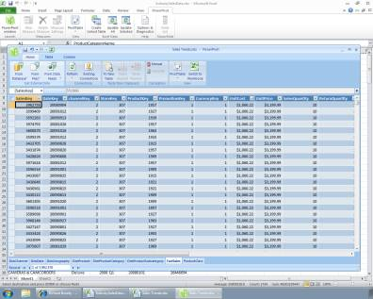  Click Here | - Click the To New Table button. | PowerPivot lets you simply copy and paste data as a new table in the model.
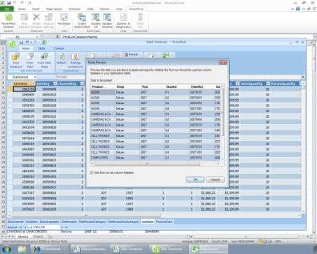  Click Here | - Click OK. | It will even analyze the field names and row data to automatically create relationships between the data outside of the warehouse and existing structured data.

Insert PivotTable | Click Instructions | Presenter Script
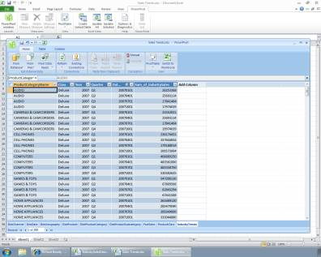  Click Here | - Click on the PivotTable button. | Now, all of this data - from the SQL Server data warehouse, and from external data sources - is combined in a single model that can be used to perform analyses that would not previously have been possible from a single analytical tool. This is something uniquely available in Microsoft Excel and PowerPivot.
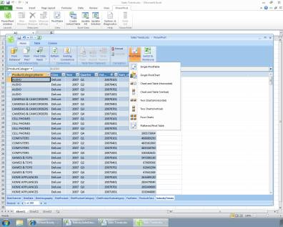  Click Here | - Select Chart and Table (Vertical). | Now let’s look at the ways Richard can use all this combined data to visualize comparisons that may not have been apparent or easily drawn before.  Richard is going to use Excel to organize the data in a chart and table that will make it easier to visualize relationships between all these different sources.  Since we’re working in Excel, the functions we use and the actions we take are all familiar. We can create a traditional PivotTable by adding values, rows, and columns.
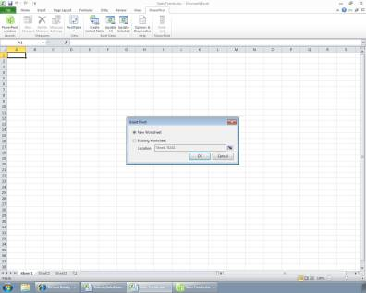  Click Here | - Select Existing Worksheet.
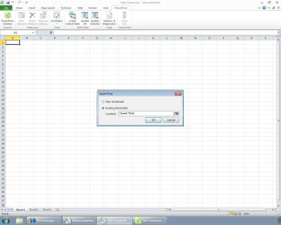  Click Here | - Click OK.
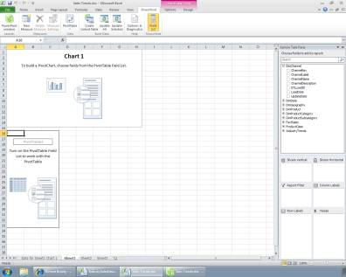  Click Here | - In the Gemini Task Pane, expand the FactSales node. | The difference is that the fields we’re drawing from are coming from the model we just created.
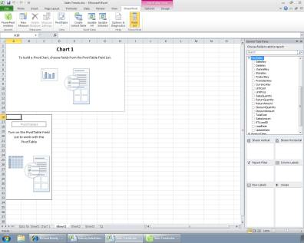  Click Here | - Select SalesAmount. | We’ll start building this PivotTable by adding Sales Amount.
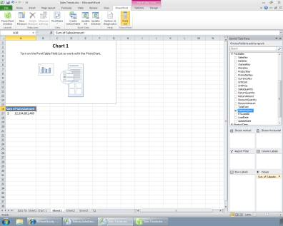  Click Here | - Collapse the FactSales node.
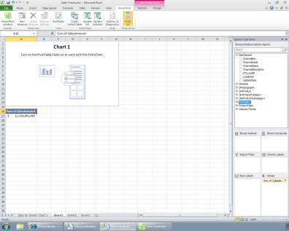  Click Here | - Expand the DimDate node. | We’ll add some Year columns and then add Product Category and Sub-category rows.
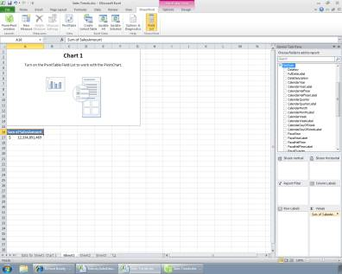  Click Here | - Click on CalendarYear.
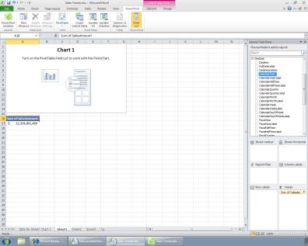  Click Here | - Click on Column Labels.
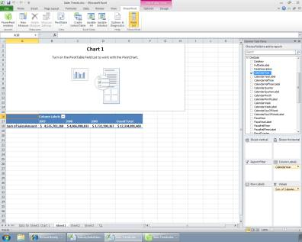  Click Here | - Collapse DimDate.
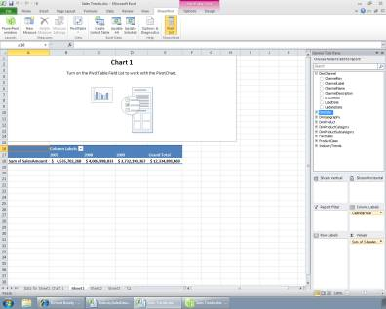  Click Here | - Expand DimProductCategory.
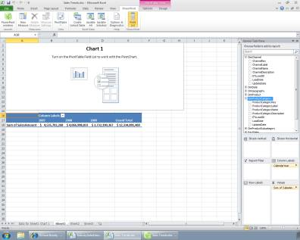  Click Here | - Select ProductCategoryName.
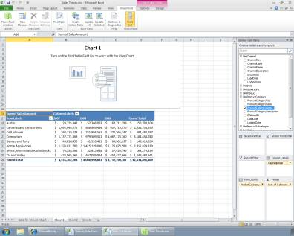  Click Here | - Expand DimProductSubcategory.
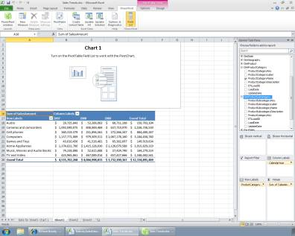  Click Here | - Select ProductSubcategoryName.

Cond. Format | Click Instructions | Presenter Script
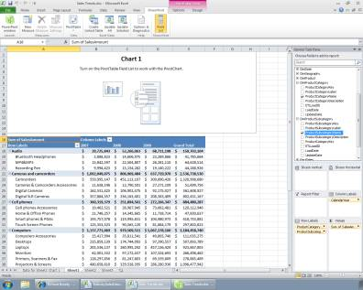  Click Here | - Select the three year columns. | And just like that we have a basic PivotChart, pulling data from our model and calculating fields near-instantaneously from millions of rows of data.
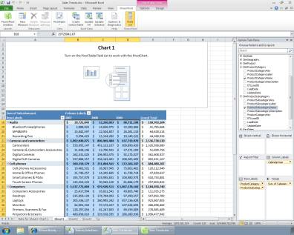  Click Here | - Switch to the Home tab.
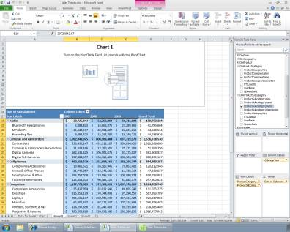  Click Here | - Click on the Conditional Formatting button. | Let’s add a few visualizations to this report to make it easy for end-users to understand the numbers.  We’ll start with Conditional Formatting, a native feature of Excel. Then add Data bars to the annual numbers for each category.
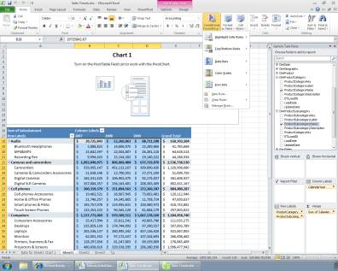  Click Here | - Select Data Bars.
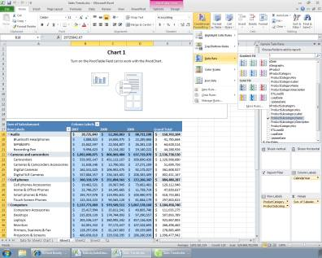  Click Here | - Select the Green Gradient Fill.

Sparklines | Click Instructions | Presenter Script
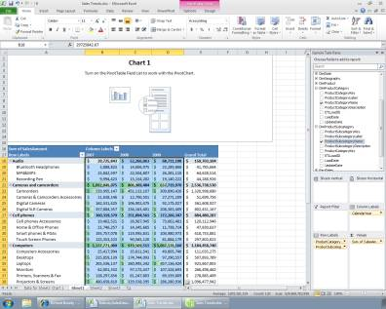  Click Here | - Switch to the Insert tab. | Excel 2010 includes new formatting and visualization features that further enhance the way complex data can be visualized to improve understanding and help business users like Richard’s boss make better decisions.
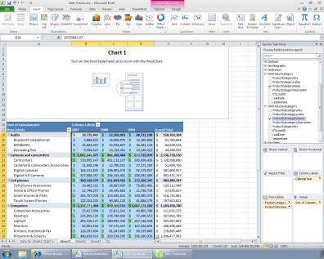  Click Here | - Click on the Line sparkline type. | The new Sparklines feature works like a mini-line chart to give you a quick, cell-based historical or series visualization. This makes it easier to draw comparisons across a number of rows.
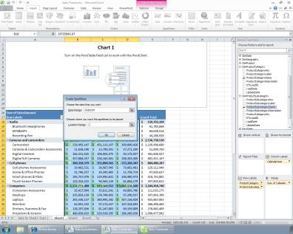  Click Here | - Select the Grand Total column.
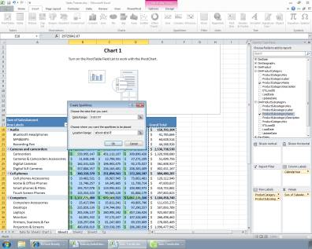  Click Here | - Click OK.

PivotChart | Click Instructions | Presenter Script
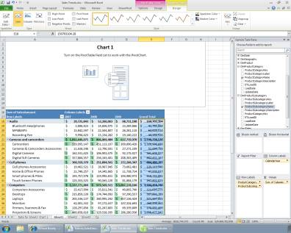  Click Here | - Click in the PivotChart. | Richard can take advantage of the new multiple data sources we just added by building a PivotChart that compares internal and external trend data.
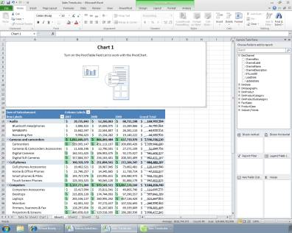  Click Here | - Expand IndustryTrends. | Let’s begin to add some of these fields to the Chart, starting with Industry Sales.
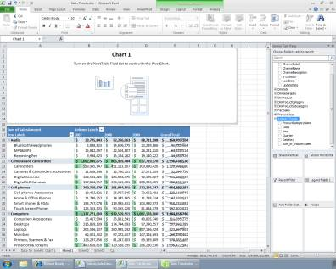  Click Here | - Select Sum_of_IndustrySales.
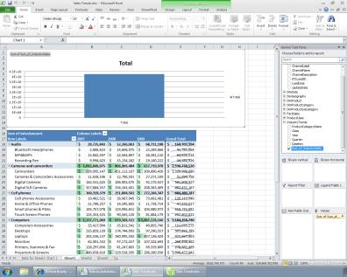  Click Here | - Expand ProductClass.
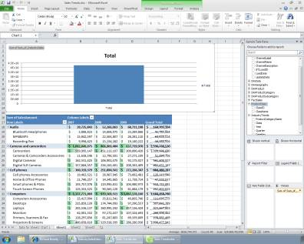  Click Here | - Click on ClassName. | Now when we add this Product Class Name field, we get an alert at the top of the Task Pane.
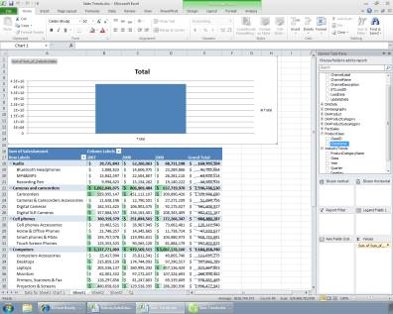  Click Here | - Click on Slicers Vertical.
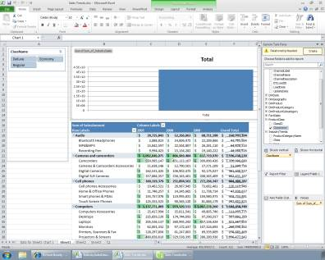  Click Here | - Click the Create button. | Underlying the model are the relationships between the tables and fields for all the data that’s been imported. The PowerPivot add-in to Excel is smart enough to alert you when relationships are needed, and even detect relationships between some data automatically.
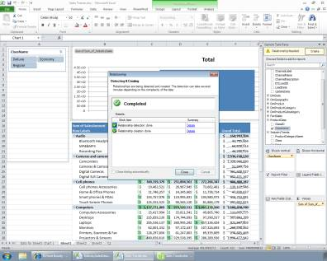  Click Here | - Click Close.
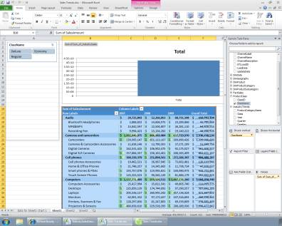  Click Here | - Expand FactSales. | We see the same thing when we add the Contoso Sales numbers. A new relationship is created.
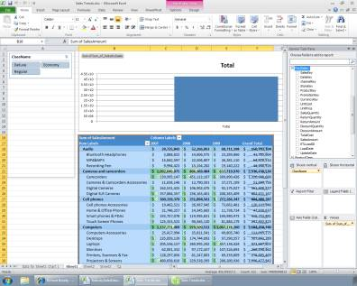  Click Here | - Select SalesAmount.
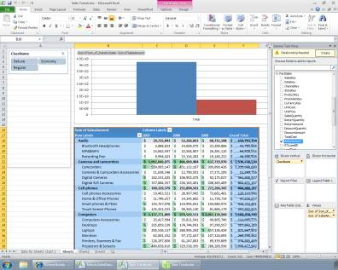  Click Here | - Click the Create button.
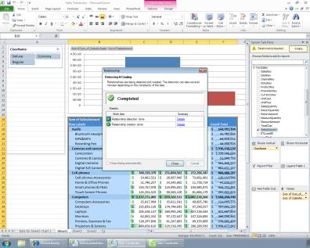  Click Here | - Click Close.
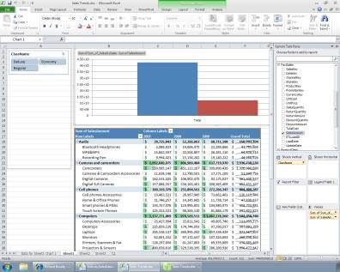  Click Here | - Collapse FactSales.
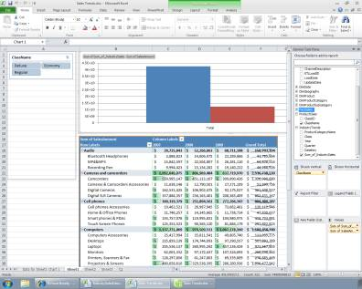  Click Here | - Expand DimDate. | Let’s add the Year value to the chart to see a 3-year view.
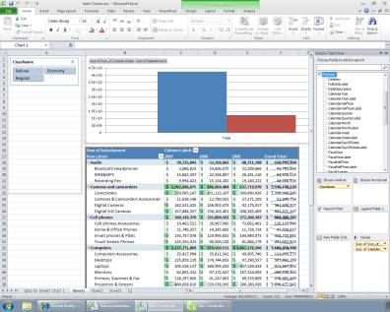  Click Here | - Click on CalendarYear.
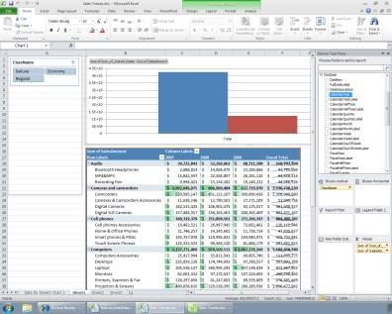  Click Here | - Click on Axis Fields.
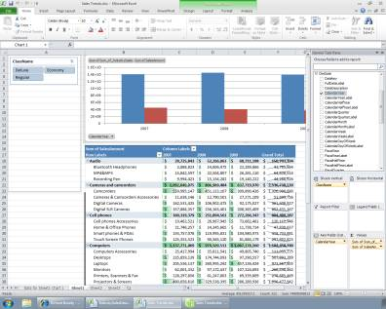  Click Here | - Collapse DimDate.

Publish Workbook | Click Instructions | Presenter Script
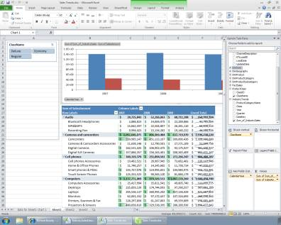  Click Here | - Switch to the File tab. | This worksheet is now a fully interactive Business Intelligence analysis tool that can be shared with other people. These users can easily sort and filter the data with just a web browser using SharePoint. Richard, a typical analyst, was able to use his familiar environment within Excel to pull together this unique view of the data.
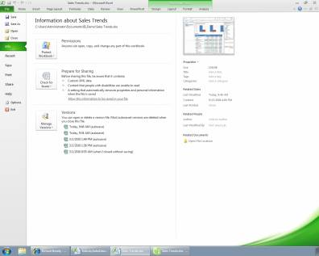  Click Here | - Click on Share. | To share the analysis with other employees, Richard can post this over the web into Microsoft SharePoint Server. It’s as simple as doing a “Save As” function.
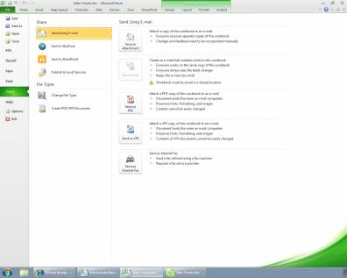  Click Here | - Click on Save to SharePoint.
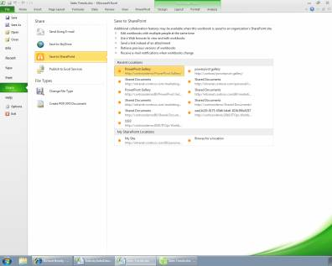  Click Here | - In the Recent Locations, click on PowerPivot Gallery.
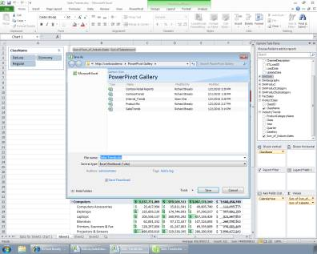  Click Here | - Click in the File Name field.
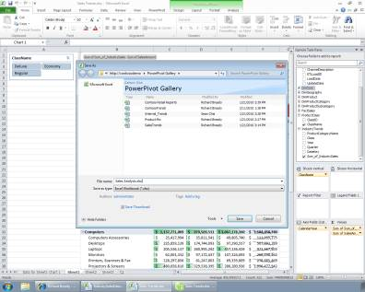  Click Here | - Click Save.

PowerPivot Galley | Click Instructions | Presenter Script
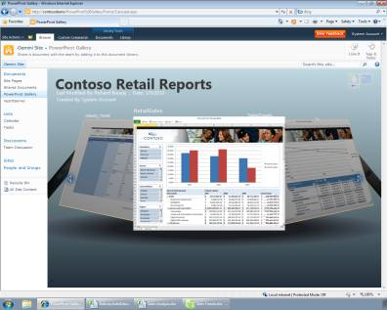  Click Here | - Click the right arrow. | Once published to SharePoint, any end user can see the analysis over the web. They can browse for the file through the new carousel view which allows users to interactively visualize thumbnails of the analysis they want to see.
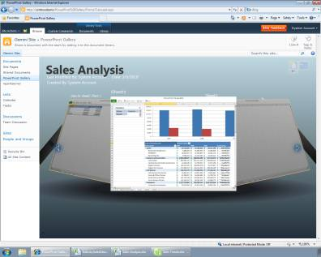  Click Here | - Click on the workbook preview image. | After finding the newly-published Industry Trends workbook, we can now open this from within our web browser
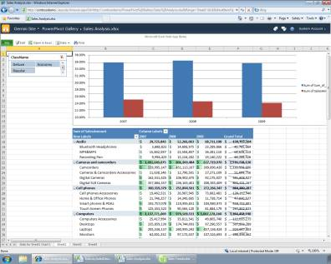  Click Here | - In the ClassName slicer, click on Economy. | After opening this file, users can interact with it, and select slicers to filter the data.
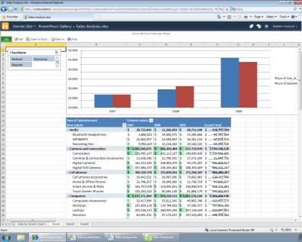  Click Here | - Open the Favorites menu. | With the analysis secured in the SharePoint environment, IT can now manage, administer and apply the appropriate permissions to the Excel file.
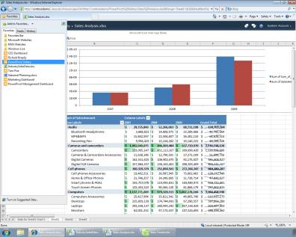  Click Here | - Select PowerPivot Management Dashboard. | You may have noticed that the PowerPivot workbook that Richard created earlier was just one of several such workbooks that have been created by users at Contoso. The job of managing these self-service BI solutions falls to Contoso’s IT administrators.

Mgmt. Dashboard | Click Instructions | Presenter Script
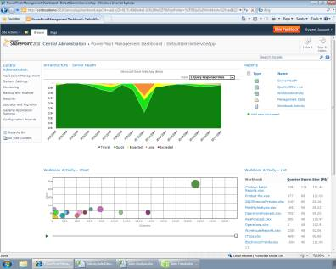  Click Here | - Open the View menu. | In the management console for SharePoint Server 2010, IT can monitor the performance of PowerPivot applications. In this case, you can see a spike here in the middle of Query Response Times indicating something may need to be done with the allocation of resources
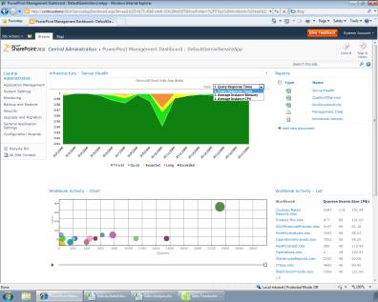  Click Here | - Select Average Instance CPU. | You also can manage and monitor other things like Average Instance CPU.
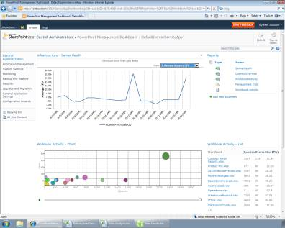  Click Here | - Click the Play button. | In the management console, you can also see a time-series visualization that shows workbook activity over time. We actually can play the timeline to see changes in how certain workbooks are being used and how many users are accessing them.
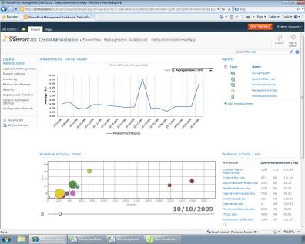
Click Here
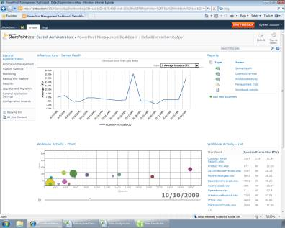
Click Here
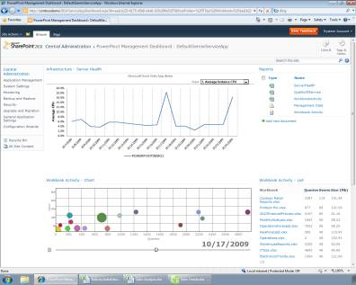
Click Here
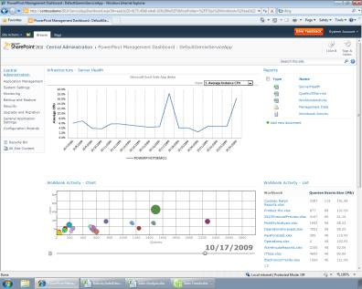  Click Here |  | This visualization is showing us that a particular workbook may need extra attention in terms of resourcing.
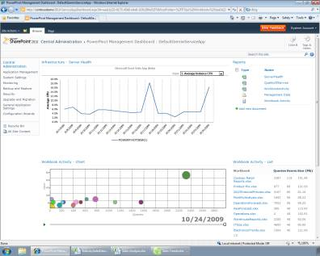  Click Here |  | Within SharePoint, this PowerPivot Management Dashboard allows IT to manage Excel workbooks in a central place. The Dashboard tracks what workbooks are being stored in the system, what resources they require, and how many users are using them. Armed with this information, IT can make informed decisions about how to allocate resources to support the needs of the business.

Conclusion | Click Instructions | Presenter Script
Click Here |  | As you’ve seen in this demonstration, Microsoft empowers users to work with large amounts of information within the familiar Excel environment. Users can easily organize data from multiple sources and perform deeper kinds of analyses that can be shared throughout the organization in a managed IT environment.  For more information on Microsoft Business Intelligence solutions, contact your Microsoft Representative.

