Enterprise Applications – Chapter 8 Study Guide
The following alphabetical list identifies the key terms discussed in this chapter. The page number for each key term is provided.

Analytical CRM, 291 | Operational CRM, 290
Bullwhip effect, 278
Churn rate, 291 | Pull-based model, 283
Cross-selling, 287 | Push-based model, 283
Demand planning, 279 | Supply chain, 276
Enterprise software, 274 | Supply chain planning system, 279
Just-in-time strategy, 278 | Touch point, 285

There has been a rapid increase in ERP systems due to the following factors:
A. Globalization
B. Market maturity in developed countries
C. Advances in information and communication technology
Some firms write their own enterprise software from scratch, but this can be time consuming and costly. Since many firms have similar procedures for accounting, finance, inventory management, and human resource functions, it often makes sense to buy a software package (a software product offered commercially by a third party) to support some of these functions. So-called enterprise resource planning (ERP) software packages serve precisely this purpose. In the way that Microsoft can sell you a suite of desktop software programs that work together, many companies sell ERP software that coordinates and integrates many of the functions of a business. The leading ERP vendors include the firm’s SAP and Oracle, although there are many firms that sell ERP software. A company doesn’t have to install all of the modules of an ERP suite, but it might add functions over time—for example, to plug in an accounting program that is able to read data from the firm’s previously installed inventory management system. And although a bit more of a challenge to integrate, a firm can also mix and match components, linking software the firm has written with modules purchased from different enterprise software vendors.

ERP in Action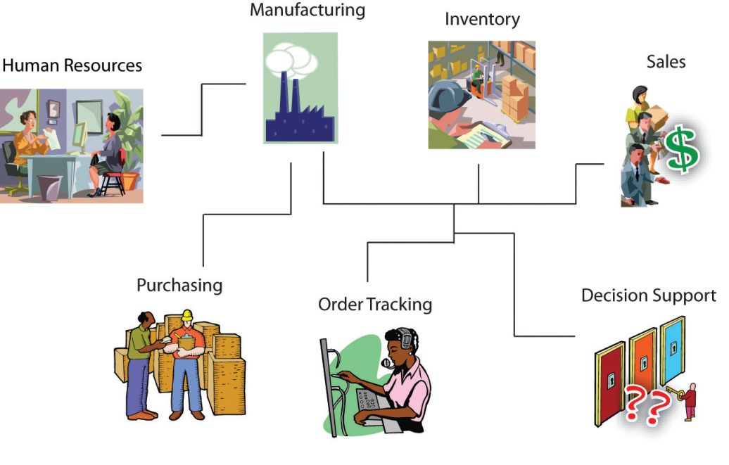
An ERP system with multiple modules installed can touch many functions of the business:
- Sales—A sales rep from Vermont-based SnowboardCo. takes an order for five thousand boards from a French sporting goods chain. The system can verify credit history, apply discounts, calculate price (in euros), and print the order in French.
- Inventory—While the sales rep is on the phone with his French customer, the system immediately checks product availability, signaling that one thousand boards are ready to be shipped from the firm’s Burlington warehouse, the other four thousand need to be manufactured and can be delivered in two weeks from the firm’s manufacturing facility in Guangzhou.
- Manufacturing—When the customer confirms the order, the system notifies the Guangzhou factory to ramp up production for the model ordered.
- Human Resources—High demand across this week’s orders triggers a notice to the Guangzhou hiring manager, notifying her that the firm’s products are a hit and that the flood of orders coming in globally mean her factory will have to hire five more workers to keep up.
- Purchasing—The system keeps track of raw material inventories, too. New orders trigger an automatic order with SnowboardCo.’s suppliers, so that raw materials are on hand to meet demand.
- Order Tracking—The French customer can log in to track her SnowboardCo. order. The system shows her other products that are available, using this as an opportunity to cross-sell additional products.
- Decision Support—Management sees the firm’s European business is booming and plans a marketing blitz for the continent, targeting board models and styles that seem to sell better for the Alps crowd than in the U.S. market.
Other categories of enterprise software that managers are likely to encounter include the following:
- customer relationship management (CRM) systems used to support customer-related sales and marketing activities
- supply chain management (SCM) systems that can help a firm manage aspects of its value chain, from the flow of raw materials into the firm through delivery of finished products and services at the point-of-consumption
- business intelligence (BI) systems, which use data created by other systems to provide reporting and analysis for organizational decision making
Major ERP vendors are now providing products that extend into these and other categories of enterprise application software, as well.
Most enterprise software works in conjunction with a database management system (DBMS), sometimes referred to as a “database system.” The database system stores and retrieves the data that an application creates and uses. Most enterprise software works in conjunction with a database management system (DBMS), sometimes referred to as a “database system.” The database system stores and retrieves the data that an application creates and uses.
Firms that don’t have common database systems with consistent formats across their enterprise often struggle to efficiently manage their value chain. Common procedures and data formats created by packaged ERP systems and other categories of enterprise software also make it easier for firms to use software to coordinate programs between organizations. This coordination can lead to even more value chain efficiencies. Sell a product? Deduct it from your inventory. When inventory levels get too low, have your computer systems send a message to your supplier’s systems so that they can automatically build and ship replacement product to your firm. In many cases these messages are sent without any human interaction, reducing time and errors. And common database systems also facilitate the use of BI systems that provide critical operational and competitive knowledge and empower decision making.

Questions
- How do supply chain management systems coordinate planning, production, and logistics with suppliers?

Define a supply chain and identify each of its components.
A supply chain is similar to a spider’s web. It includes all of the internal functions of an organization, along with suppliers, distributors, retailers, and customers. They are all intertwined and rely on information from each other to effectively meet the business’s objectives.
Exactly what are all the activities involved in getting a product from conception to delivery. It may be helpful to break the supply chain into three distinct groups:
- Upstream: suppliers that deal directly with a manufacturer and their suppliers
- Downstream: distributors and those that deliver products to customers
- Internally: the employees that transform materials, components, and services into the actual products
Think of a mountain stream that starts very small, flows downhill, gathers more water as it combines with other streams, feeds into a river that continues to flow and eventually meets up with other rivers, and on into the ocean. The mountain stream is analogous to suppliers, the river represents manufacturers, and the ocean can be compared to customers.
A supply chain is defined as a network of organizations and business processes for procuring materials, transforming raw materials into intermediate and finished products, and distributing the finished products to customers. It links suppliers, manufacturing plants, distribution centers, retail outlets, and customers to supply goods and services from source through consumption. Supply chain management is the integration of supplier, distributor, and customer logistics requirements into one cohesive process.

Explain how supply chain management systems help reduce the bullwhip effect and how they provide value for a business.
The bullwhip effect occurs when information about the demand for a product gets distorted as it passes from one entity to the next across the supply chain. It can also result from “gaming,” as purchasers present manufacturers or suppliers with a false picture of consumer demand. It can be dealt with by reducing uncertainties about demand and supply when all of the supply chains have accurate and up-to-date information.
Define and compare supply chain planning systems and supply chain execution systems.
Supply chain planning systems enable the firm to generate demand forecasts for a product and to develop sourcing and manufacturing plans for that product. They help companies make better operating decisions such as determining how much of a specific product to manufacture in a given time period; establishing inventory levels for raw materials, intermediate products, and finished goods; determining where to store finished goods; and identifying the transportation mode to use for product delivery. One of the most important functions is demand planning, which determines how much product a business needs to make to satisfy all of its customers’ demands. These functions are referred to as order planning, advanced scheduling, demand planning, distribution planning, and transportation planning.
Supply chain execution systems manage the flow of products through distribution centers and warehouses to ensure that products are delivered to the right locations in the most efficient manner. They track the physical status of goods, the management of materials, warehouse and transportation operations, and financial information involving all parties. These functions are referred to as order commitments, final production, replenishment, distribution management, and reverse distribution.
Describe the challenges of global supply chains and how Internet technology can help companies manage them better.
Firms use intranets to improve coordination among their internal supply chain processes, and they can use extranets to coordinate supply chain processes shared with their business partners. Using intranets and extranets, all members of the supply chain can instantly communicate with each other, using up-to-date information to adjust purchasing, logistics, manufacturing, packaging, and schedules. A manager can use a Web interface to tap into suppliers’ systems to determine whether inventory and production capabilities match demand for the firm’s products. Business partners can use Web-based supply chain management tools to collaborate online with suppliers and customers. Sales representatives can access suppliers’ production schedules and logistics information to monitor customers’ order status. The Internet has introduced new ways of managing warehousing, shipping, and packaging based on access to supply chain information that can give companies an edge in delivering goods and services at a reasonable cost.
Distinguish between a push-based and pull-based model of supply chain management and explain how contemporary supply chain management systems facilitate a pull-based model.

In a push-based model, production master schedules are based on forecasts or best guesses of demand for products, and products are “pushed” to customers. In a pull-based model, actual customer orders or purchases trigger events in the supply chain.
In contemporary supply chain management systems, the Internet and Internet technology make it possible to move from sequential supply chains, where information and materials flow sequentially from company to company, to concurrent supply chains, where information flows in many directions simultaneously among members of a supply chain network. Members of the network immediately adjust to changes in schedules or orders.

- How do customer relationship management systems help firms achieve customer intimacy?
The goals of customer relationship management systems are to optimize:
- revenue
- profitability
- customer satisfaction, and
- customer retention.

Define customer relationship management and explain why customer relationships are so important today.
Customer relationship management is a business and technology discipline that uses information systems to coordinate all of the business processes surrounding the firm’s interaction with its customers in sales, marketing, and service.
Importance of customer relationships: Globalization of business, the Internet, and electronic commerce have put more power in the hands of customers. Companies are realizing that their only enduring competitive strength may be their relationships with their customers. Some say that the basis of competition has switched from who sells the most products and services to who “owns” the customer, and that customer relationships represent the firm’s most valuable asset.

Describe the tools and capabilities of customer relationship management software for sales, marketing, and customer service.

Customer relationship management systems typically provide software and online tools for sales, customer service, and marketing. Capabilities include the following:

Sales:
- Sales force automation modules in CRM systems help sales staff increase their productivity by focusing sales efforts on the most profitable customers, those who are good candidates for sales and services.
- Provide sales prospect and contact information, product information, product configuration capabilities, and sales quote generation capabilities.
- Enable sales, marketing, and delivery departments to easily share customer and prospect information.
- Increase salespeople’s efficiency in reducing the cost per sale as well as the cost of acquiring new customers and retaining old ones.
- Includes capabilities for sales, forecasting, territory management, and team selling.
- Supports direct-marketing campaigns by providing capabilities for capturing prospect and customer data, for providing product and service information, for qualifying leads for targeted marketing, and for scheduling and tracking direct-marketing mailings or e-mail.

Customer Service:
- Provide information and tools to make call centers, help desks, and customer support staff more efficient.
- Includes capabilities for assigning and managing customer service requests.
- May also include Web-based self-service capabilities.

Marketing:
- Supports direct-marketing campaigns by providing capabilities for capturing prospects and customer data, for providing product and service information for qualifying leads for targeted marketing, and for scheduling and tracking direct-marketing mailings or e-mail.
- Includes tools for analyzing marketing and customer data. Identifies profitable and unprofitable customers, designs products and services to satisfy specific customer needs and interests, and identifies opportunities for cross-selling, up-selling, and bundling.

Distinguish between operational and analytical CRM.

Operational CRM includes customer-facing applications such as tools for sales force automation, call center and customer service support, and marketing automation.
Analytical CRM includes applications that analyze customer data generated by operational CRM applications to provide information for improving business performance management. Applications are based on data warehouses that consolidate data from operational CRM systems and customer touch points. The database serves online analytical processing, data mining, and other data analysis techniques. Provides information related to customer lifetime values.
- What are the challenges posed by enterprise applications?
Very Important note: In order to achieve maximum benefit from an enterprise software package, a business must change the way it works to match the software’s business processes.

List and describe the challenges posed by enterprise applications.

Enterprise applications are very difficult to implement successfully. They require extensive organizational change, expensive new software investments, and careful assessment of how these systems will enhance organizational performance. Enterprise applications require both deep-seated technological changes and fundamental changes in business operations. Employees must accept new job functions and responsibilities. They must learn new work activities and understand how data they enter into the system can affect other parts of the company. Enterprise applications introduce switching costs that make it very expensive to switch vendors. Multiple organizations will share information and business processes. Management vision and foresight are required to take a firm- and industry-wide view of problems and to find solutions that realize strategic value from the investment.
Explain how these challenges can be addressed.
Enterprise applications create new interconnections among myriad business processes and data flows inside the firm (and in the case of supply chain management systems, between the firm and its external supply chain partners). Employees require training to prepare for new procedures and roles. Attention to data management is essential. Management must understand the impact that implementing enterprise applications will have on every facet of the business. Executives must not underestimate the time and costs of implementation, not just on the organization but also on customers, suppliers, and business partners.

