Fundraising Lab 2
Visualizing Fundraising

This workbook is intended to introduce you to calculations in Tableau using a fictional university fundraising data set.

This data set was generated randomly using multiple sources, including http://www.generatedata.com/, popular movie characters, typical university faculty names and random number generators. This data set was created specifically for purposes of visualizing using Tableau.

Directions
Before you proceed, read the two dashboards included in this workbook: Creating Calculated Fields and Creating Parameters

You need to be familiar with creating these two Tableau components to complete the exercises. Note you can always come back to these dashboards for reference when you get to the steps that require creating calculated fields or parameters.

Directions for each exercise are contained in a caption. If the caption is long, you can click on the caption area and scroll down to see the rest of the instructions. You can also hide the caption to increase your workspace by click on the Caption title dropdown and selecting Hide Card. If you wish to show the caption again, you can bring it back by clicking on the Worksheet menu > Show Caption

Data Set
The fundraising data set uses a JOIN to combine two worksheets - Funds and Pledges - from one source Excel workbook. The column common between the two worksheets, Fund ID, was used as the linking field.

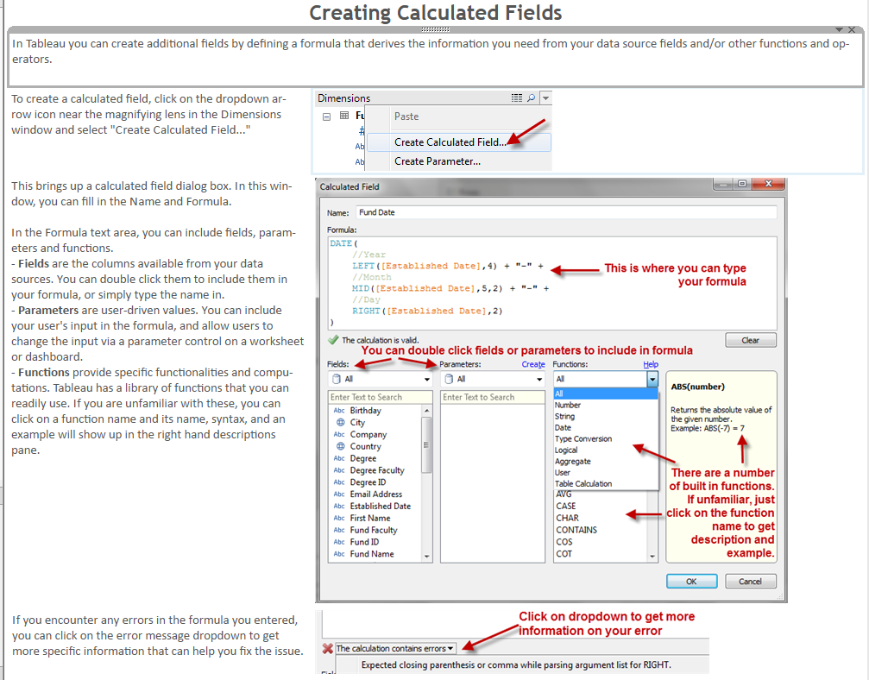
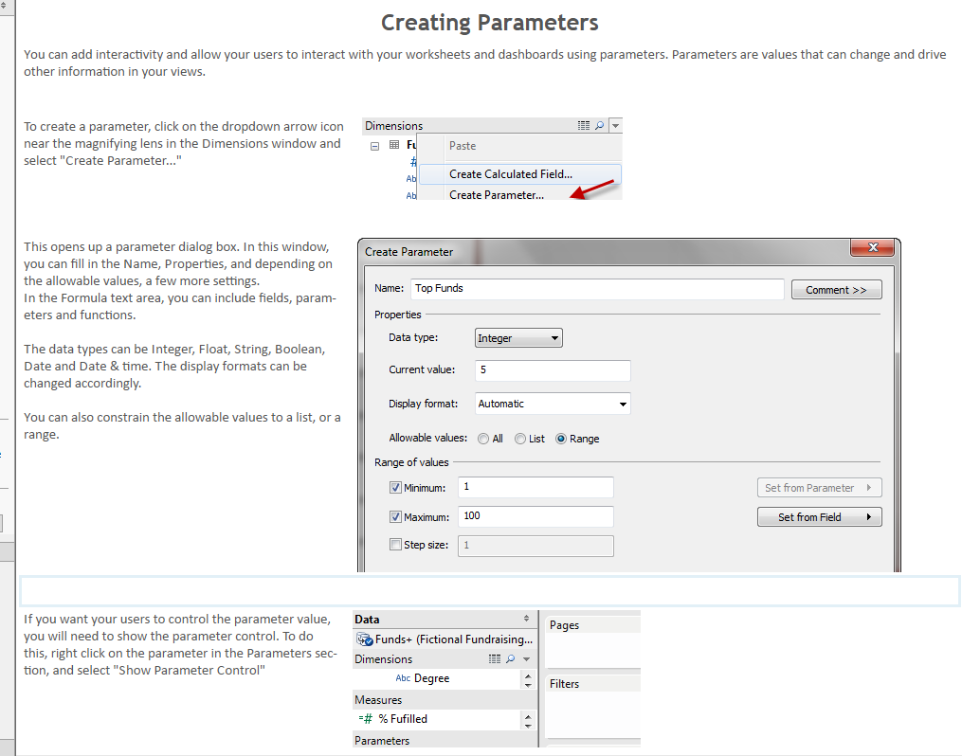
Which degrees donate the most to the university?

Our university receives donations periodically from a variety of individuals. Our university's advancement officer is curious whether people with specific degrees pledge more money to the university than others, and how large the average donation from each degree is.

1. In the Dimensions window, change the data types for Pledge Amount, Received Amount, and Writeoff Amount from String (icon Abc) to Number (icon #)
To do this, right click on each of these amount dimensions, select Change Data Type > Number
2. Drag these amount fields (Pledge Amount, Received Amount and Writeoff Amount) from the Dimensions window to the Measures window
3. Create a calculated field called Average Pledge Amount. In the formula, type:
SUM([Pledge Amount])/SUM([Number of Records])
Click OK when done. This field will appear under Measures
4. Drag Degree to Rows.
5. Drag Average Pledge Amount to Columns
6. Drag Number of Records to the Color shelf (This will help us see which degrees have more overall donations, in addition to the average pledge amount)
7. Edit the color legend by clicking on the top right side of the legend border
Choose the Red Blue Diverging color palette
Click OK when done
How are our funds performing?

The University raises money for different fund types. You want to show how these are performing through time. Fund Type information is included in the Fund Name field, and needs to be extracted.

1. Drag Pledge Date dimension to the Columns shelf. This automatically picks discrete YEAR(Pledge Date). Blue pills represent discrete elements, whereas green represent continuous ones
2. Drag Pledge Amount measure to the Rows shelf
3. Check the different types of fund currently embedded inside the Fund Name field. To see the current values of the Fund Name field, right click on Fund Name and select Describe > Load
For example, Muggle Studies - Scholarship is the name of the fund, and the fund type is Scholarship
Looking at the current data, there are three (3) types of funds in this data set - Scholarship, Bursary and Prize
Close the window when you're done checking the values
4. Extract the Fund Type information by creating a calculated field called Fund Type.
- In the Formula, type:
IF CONTAINS([Fund Name], "Scholarship")
THEN "Scholarship"
ELSEIF CONTAINS([Fund Name], "Bursary")
THEN "Bursary"
ELSE "Prize"
END
Click OK when done. Note this will show up in the Dimensions window
5. Drag the new Fund Type calculated measure field (icon has an equal sign) to the Color shelf

Who are our major gift donors?

Donors who give more than $100,000 are considered by the University as major gift donors. You want to identify them and invite them to an event you and your colleagues are preparing as a thank you.

1. Create a calculated field called Major Gift Donor?
- In the Formula, type:
IIF(
SUM([Pledge Amount]) >= 100000,
//if condition is true
"Major Gift Donor",
//otherwise
"Regular Donor"
)
Click OK when done. Note this will show up in the Measures window
2. Double click on the following fields: Student ID, Last Name, First Name and Pledge Amount
This produces a text table
3. Click on the Descending bars icon on the toolbar (right beside the paper clip)
4. Drag the new Major Gift Donor? calculated measure field (icon has an equal sign) to the Color Shelf
Are faculties meeting their goals?

Donations to university go to funds that belong to specific faculties. Donations go in as pledges. These pledges are fulfilled when money pledged has been received, meaning pledge has been fulfilled. Faculties need to track if they are meeting their fulfillment goals.

1. Create a calculated field called % Fulfilled. Use the following formula:
SUM([Received Amount])/SUM([Pledge Amount])
Click OK when done. Note this will show up in the Measures window.
2. Right click on this new % Fulfilled calculated field and select Default Properties > Number Format > Percentage. Choose zero (0) decimal places
3. Create a parameter called Fulfillment % Goal
Data Type: Float
Current Value: 0.9
Display format: Percentage, no decimal places
Allowable values: Range
Minimum: 0.1
Maximum: 1
Step size: 0.05
Click OK when done. Note this will show up in the Parameters window
4. Right click on Fulfillment % Goal parameter and select "Show Parameter Control". This displays as another card called Fulfillment % Goal, with a slider that can change the goal value. Make sure this is set at 90%
5. Create another calculated field called Met Goal. Use the following formula
[% Fulfilled] >= [Fulfillment % Goal]
Click OK when done. Note this will show up in the Measures window as a boolean (T/F)
6. Drag Fund Faculty dimension to the Rows shelf
7. Change the mark type in the Marks card to Shape
8. Drag the calculated measure field Met Goal to Shape
9. Change the shapes by clicking on the top right corner of the shape legend (with title AGG(Met Goal)) and choose Edit Shape
In the Select Shape Palette, choose KPI
In the Select Data Item, highlight True, and choose the green check icon from the palette
In the Select Data Item, highlight False, and choose the red x icon from the palette
Click OK when done
10. Try to change the Fulfillment % Goal in your parameter control. Slide the value back to 80%, and then slide it to 100% and see what happens to your view

What are the top performing funds?

You want to give your fundraisers a way to visualize the top performing funds. You don't know how many funds they want to see, so you want to include a way for them to control how many top funds will show.

1. Drag the Fund Name dimension to the Rows shelf
2. Drag the calculated Fund Type dimension to the Rows shelf, to the right of Fund Name
3. Drag the Pledge Amount measure to the Columns shelf
4. Drag Received Amount to Color shelf
5. Click on the Fund Name pill on the Rows shelf and perform a descending sort.
6. Create a calculated field called Rank using the INDEX() function, which creates a sequential row number. Use the following formula:
INDEX()
Click OK when done. Note this will show up in the Measures window.
7. Create a parameter called Top Funds
Data Type: Integer
Current Value: 5
Display format: Automatic
Allowable values: All
Click OK when done. Note this will show up in the Parameters window
8. Right click on Top Funds parameter and select "Show Parameter Control". This displays as another card called Top Funds, with a text field that you can type in
9. Create another calculated field called In Top Funds. Use the following formula:
[Rank] <= [Top Funds]
Click OK when done. Note this will show up in the Measures window
10. Drag In Top Funds calculated measure field to the Filters shelf. In the Select from list window, check True. Click OK when done
11. Try to change the Top Funds in your parameter control value from 5 to 10 and see what happens to your view

