Tableau Lab Introduction – Music Sales
Which genre sells the most?

To help determine next year's budget, you are asked to create a visualization to determine which genre sells the most to our customers in Europe and Asia.

1. Drag the Genre dimension to Rows.
2. Drag the Quantity measure to Columns. Notice this will automatically aggregate quantity using SUM.
3. Drag the Genre dimension to Color. Remember that you have to use color with caution, but in our case, we will use this color to relate to another worksheet we'll build in the next exercises.
4. Click on the Descending bars icon on the toolbar (right beside the paper clip).
5. Click on the "Abc" icon on the toolbar to turn on labels, located between the paper clip icon and the presentation icon.
6. Drag the Region dimension to the Filters shelf. Choose Europe and Asia.
7. Right click the Region pill in the Filters shelf to show the dropdown.
Choose Apply to Worksheets > All Using This Data Source.
8. Right click the Region pill in the Filters shelf to show the dropdown.
Select "Show Quick Filter".
Notice this will display another card that has all the Region values with checkboxes right beside them. Your users can use this to interact with this worksheet.
9. Right click on the bar of the top selling genre, and choose Annotate > Mark.

Type the following in the Annotation editor. For anything in angled bracket, use the "Insert" dropdown menu to select the actual fields.

Top Selling Genre: < Genre>
Quantity Sold: < SUM(Quantity)>

Click OK when you are done

9. Adjust the location of the mark annotation so it's visible in the view.

Which artists sell the most?

Now that you know the most popular genres in Europe and Asia, you are asked to determine which artists sell the most. You are also asked to show if the artists produced tracks only on one genre, or if they have music across multiple genres.

1. Drag the Artist dimension to Rows.
2. Drag the Quantity measure to Columns. Notice this will automatically aggregate quantity using SUM.
3. Drag the Genre dimension to the Color shelf. Notice this places a Genre pill in the Marks shelf with a color icon right beside it.
4. Drag the Quantity measure to the Label shelf. Notice this places a Quantity pill in the Marks shelf with an "Abc" icon right beside it.
5. Click on the SUM(Quantity) pill in the Marks shelf to show the dropdown and choose Format.
In the Default section, click on the Numbers dropdown.
Choose Number (Standard).
Click OK when done.
6. Click on the right side of the Artist pill in the Rows shelf. This will show the dropdown. Choose Filter.
In the Filters window, choose the Top tab (4th tab).
Choose By Field: Top 20 by Quantity Sum.
Click OK when done.

How do our region sales compare to each other?

We are then asked to assess which regions in Europe and Asia sell the most records, but we quickly find that we aren't able to answer this information given the fields already defined in our data set.

1. Click on the dropdown icon beside the magnifying lens in the Dimensions window and select "Create Calculated Field".
Name your calculated field Sales.
In the Formula, use the following. Note you can also double click the field names from the Fields pane.
[Quantity] * [UnitPrice]

Click OK when done. This new Sales field will show up under Measures, and will have an icon that starts with an equal (=) sign.
2. Drag the Sales calculated field from Measures to the Size shelf. Notice this places a Sales pill in the Marks shelf with circle icon right beside it.
3. Drag Region dimension to the Color shelf. Notice this places a Region pill in the Marks shelf with color icon right beside it.
4. Drag Country dimension to the Detail shelf. Notice this places a Country pill in the Marks shelf with no icon right beside it.
5. Click on the space beside the Country dimension you just added to the Detail shelf and select the color icon.
6. Right click the Country dimension you added to the Detail shelf and select Sort.
In Sort order, choose Descending.
In Sort by, choose Field: Quantity and Aggregation: Sum.
Click OK when done.
7. Drag the Country dimension to the Label shelf (beside the Size shelf in the Marks card).
8. Drag the Sales calculated field from Measures to the Label shelf.
9. Click on the Sales pill in the Marks shelf to show the dropdown, and choose Quick Table Calculation > Percent of Total
What does our geographic sales distribution look like?

You want to expand sales to more countries. To do this, you need to know first how our sales looks like in the countries we are currently catering.

1. Double click the Country dimension pill. This creates a geospatial map in the view. You should also notice that latitude and longitude are automatically placed in the rows and columns shelves respectively.
2. In the Marks shelf, change the type from Automatic to Filled Map.
3. Drag the Sales measure to Color. This adds a SUM(Sales) pill in the Marks card with a color icon beside it.
4. Drag the Sales measure again to Label. This adds a SUM(Sales) pill in the Marks card with an "Abc123" icon beside it.
5. Click the SUM(Sales) pill in the Marks card to show the dropdown. Choose Format.
Under the Default group, choose Currency (Custom), with zero (0) decimal places. Keep the thousands separator checked.
6. Drag the Country dimension to Label.
7. Click on the Label shelf to open the Label editor. Format the label so that Country is
- placed above Sales
- a slightly bigger font than Sales
- is Bold
8. Edit the color legend by clicking on the top right side of the legend border.
Choose the Red Green Diverging color palette.
Click OK when done.

How does the sales trend of Rock tracks compare against Alternative and Heavy Metal tracks?

One of your market researchers needs to find out the sales trend of Rock, Alternative and Heavy Metal tracks. You offered to help her out.

1. Right click drag InvoiceDate dimension to the Columns shelf. A right click drag opens a menu as soon as the field is placed on the shelf.
Choose the continuous (green) MONTH(InvoiceDate) from the dropdown. This has a green calendar icon beside it.
Continuous (green) fields produce axes, which is what we want. Discrete (blue) fields produce headers.
3. Drag the Sales measure to the Rows shelf. This produces a line graph for you.
4. Drag the Genre dimension to Color to keep the color theme consistent with other worksheets.
5. We have too much information on our view to be able to answer our original question. Drag the Genre dimension to Filters, and choose Rock, Alternative and Punk, and Heavy Metal.
6. Go to the Analysis menu and select Trend Lines > Show Trend Lines.

Dashboarding Instructions P1

Now it's time to put all your worksheets together into a single dashboard. You have freedom to design the dashboard and add components as you see fit. Below is an example dashboard that you can use as a starting point. The "Music Sales Dashboard" is set up as a blank dashboard for you to be able to work with. Once you are finished with your dashboard, upload it to Tableau Public (instructions are on "Dashboarding Instructions P2").

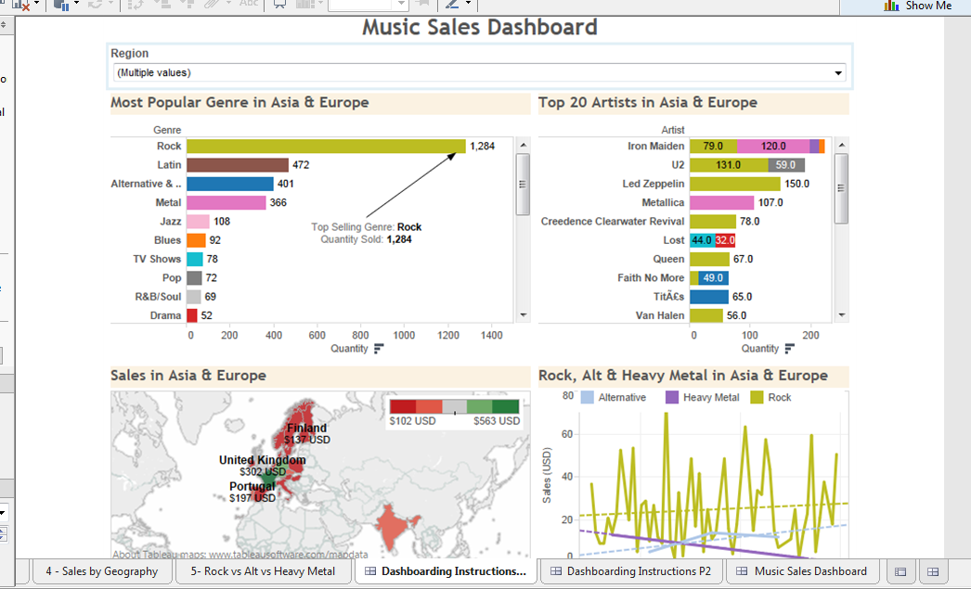
Dashboarding Instructions P2
Dashboarding

To create a more cohesive view, you can bring multiple worksheets into a dashboard.

For this dashboarding exercise, you have the freedom to arrange the worksheets and add additional components such as images, text, blank spaces as you see fit. You can also add interactivity so that the people who are using your dashboard can explore the data and get insights without having to re-design the worksheets.

Here are some items to consider:

Additional Instructions
Make your dashboard and its interactivity components as easy to understand as possible by adding additional instructions. You can do this by adding "text" components in your dashboard

Floating Dashboard Elements
You can add dashboard items such as worksheets as floating elements. These elements are useful for overlaying other parts of visualizations, allowing you to be efficient with your use of space. To make an element floating, click on an element's top right border arrow to reveal a dropdown menu, and select "Floating". Alternatively, you can hold shift and drag an element to make it floating.

Global Filters / Quick Filters
You can make any of the local filters you created at the worksheet level visible at the dashboard level. While in the dashboard, click on that worksheet's dropdown menu and select "Quick Filters". Filters are most often optimally placed near the worksheet or worksheets they filter to make it as easy for your audience to understand as possible.

A quick filter in a dashboard can apply to one worksheet, specific worksheets, or all worksheets that use the same data source. To set this up, click on that quick filter's dropdown menu and choose "Apply to Worksheets". Choose which level you want this filter applied to.

Worksheet Title
You can enhance your dashboard is to change the title of each worksheet so it reflects the values selected in the global filter.

You can right click on the worksheet Title > Edit Title. You can set an appropriate title that incorporates the field used in the global filter, for example:

Most Popular Genre in <Region>

Sharing your dashboard

When you are ready, you can share your worksheets and dashboard several ways:

1. By uploading your workbook to Tableau Server (if it's available to you in your organization), or uploading it to Tableau Public (see below for instructions).
2. By sending a packaged workbook (.twbx) to someone who has access to Tableau Reader, or Tableau Desktop.
3. By exporting the worksheets and dashboards as image, or printing these as PDF.

Tableau Public

To upload to Tableau Public, you must first create a Tableau Public account at https://public.tableausoftware.com. This is separate from your regular Tableau account.

When ready, you can go to the Server menu and select Tableau Public > Save to Web.

