Available Chart Types

Column charts
Data that is arranged in columns or rows on a worksheet can be plotted in a column chart. Column charts are useful for showing data changes over a period of time or for illustrating comparisons among items.
In column charts, categories are typically organized along the horizontal axis and values along the vertical axis.
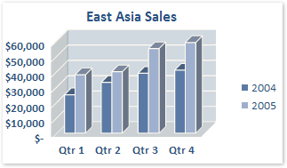
Column charts have the following chart subtypes:
- Clustered column and clustered column in 3-D Clustered column charts compare values across categories. A clustered column chart displays values in 2-D vertical rectangles. A clustered column in 3-D chart displays the data by using a 3-D perspective only. A third value axis (depth axis) is not used.
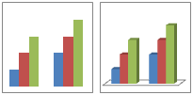
You can use a clustered column chart type when you have categories that represent:
- Ranges of values (for example, item counts).
- Specific scale arrangements (for example, a Likert scale with entries, such as strongly agree, agree, neutral, disagree, strongly disagree).
- Names that are not in any specific order (for example, item names, geographic names, or the names of people).
- Stacked column and stacked column in 3-D Stacked column charts show the relationship of individual items to the whole, comparing the contribution of each value to a total across categories. A stacked column chart displays values in 2-D vertical stacked rectangles. A 3-D stacked column chart displays the data by using a 3-D perspective only. A third value axis (depth axis) is not used.
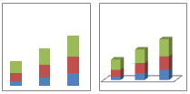
You can use a stacked column chart when you have multiple data series and when you want to emphasize the total.
- 100% stacked column and 100% stacked column in 3-D 100% stacked column charts and 100% stacked column in 3-D charts compare the percentage that each value contributes to a total across categories. A 100% stacked column chart displays values in 2-D vertical 100% stacked rectangles. A 3-D 100% stacked column chart displays the data by using a 3-D perspective only. A third value axis (depth axis) is not used.
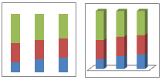
You can use a 100% stacked column chart when you have three or more data series and you want to emphasize the contributions to the whole, especially if the total is the same for each category.
- 3-D column 3-D column charts use three axes that you can modify (a horizontal axis, a vertical axis, and a depth axis), and they compare data points (data points: Individual values plotted in a chart and represented by bars, columns, lines, pie or doughnut slices, dots, and various other shapes called data markers. Data markers of the same color constitute a data series.) along the horizontal and the depth axes.
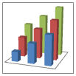
You can use a 3-D column chart when you want to compare data across the categories and across the series equally, because this chart type shows categories along both the horizontal axis and the depth axis, whereas the vertical axis displays the values.
- Cylinder, cone, and pyramid Cylinder, cone, and pyramid charts are available in the same clustered, stacked, 100% stacked, and 3-D chart types that are provided for rectangular column charts, and they show and compare data the same way. The only difference is that these chart types display cylinder, cone, and pyramid shapes instead of rectangles.
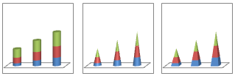
Tip To create a column chart, see Present your data in a column chart.

Line charts
Data that is arranged in columns or rows on a worksheet can be plotted in a line chart. Line charts can display continuous data over time, set against a common scale, and are therefore ideal for showing trends in data at equal intervals. In a line chart, category data is distributed evenly along the horizontal axis, and all value data is distributed evenly along the vertical axis.
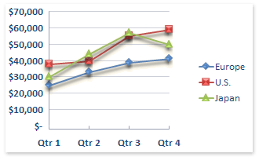
You should use a line chart if your category labels are text, and are representing evenly spaced values such as months, quarters, or fiscal years. This is especially true if there are multiple series—for one series, you should consider using a category chart. You should also use a line chart if you have several evenly spaced numeric labels, especially years. If you have more than ten numeric labels, use a scatter chart instead.
Line charts have the following chart subtypes:
- Line and line with markers Displayed with markers to indicate individual data values, or without, line charts are useful to show trends over time or ordered categories, especially when there are many data points and the order in which they are presented is important. If there are many categories or the values are approximate, use a line chart without markers.
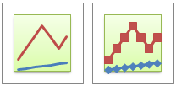
- Stacked line and stacked line with markers Displayed with markers to indicate individual data values, or without, stacked line charts can be used to show the trend of the contribution of each value over time or ordered categories, but because it is not easy to see that the lines are stacked, consider using a different line chart type or a stacked area chart instead.
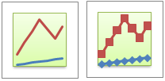
- 100% stacked line and 100% stacked line with markers Displayed with markers to indicate individual data values, or without, 100% stacked line charts are useful to show the trend of the percentage each value contributes over time or ordered categories. If there are many categories or the values are approximate, use a 100% stacked line chart without markers.
Tip For a better presentation of this type of data, consider using a 100% stacked area chart instead.
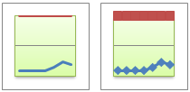
- 3-D line 3-D line charts show each row or column of data as a 3-D ribbon. A 3-D line chart has horizontal, vertical, and depth axes that you can modify.
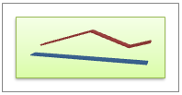
Tip To create a line chart, see Present your data in a scatter chart or a line chart.

Pie charts
Data that is arranged in one column or row only on a worksheet can be plotted in a pie chart. Pie charts show the size of items in one data series (data series: Related data points that are plotted in a chart. Each data series in a chart has a unique color or pattern and is represented in the chart legend. You can plot one or more data series in a chart. Pie charts have only one data series.), proportional to the sum of the items. The data points (data points: Individual values plotted in a chart and represented by bars, columns, lines, pie or doughnut slices, dots, and various other shapes called data markers. Data markers of the same color constitute a data series.) in a pie chart are displayed as a percentage of the whole pie.
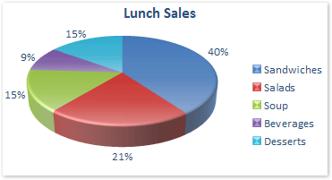
Consider using a pie chart when:
- You only have one data series that you want to plot.
- None of the values that you want to plot are negative.
- Almost none of the values that you want to plot are zero values.
- You do not have more than seven categories.
- The categories represent parts of the whole pie.
Pie charts have the following chart subtypes:
- Pie and pie in 3-D Pie charts display the contribution of each value to a total in a 2-D or 3-D format. You can pull out slices of a pie chart manually to emphasize the slices.
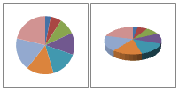
- Pie of pie and bar of pie Pie of pie or bar of pie charts display pie charts with user-defined values that are extracted from the main pie chart and combined into a secondary pie chart or into a stacked bar chart. These chart types are useful when you want to make small slices in the main pie chart easier to distinguish.
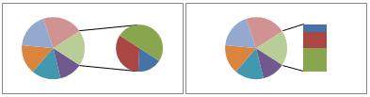
- Exploded pie and exploded pie in 3-D Exploded pie charts display the contribution of each value to a total while emphasizing individual values. Exploded pie charts can be displayed in 3-D format. You can change the pie explosion setting for all slices and individual slices, but you cannot move the slices of an exploded pie manually. If you want to pull out the slices manually, consider using a pie or pie in 3-D chart instead.
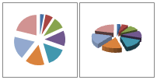
Tip To create a pie chart, see Present your data in a pie chart.

Bar charts
Data that is arranged in columns or rows on a worksheet can be plotted in a bar chart. Bar charts illustrate comparisons among individual items.
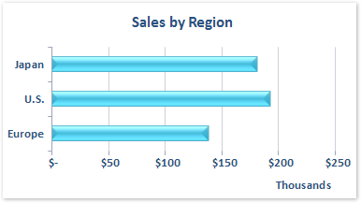
Consider using a bar chart when:
- The axis labels are long.
- The values that are shown are durations.
Bar charts have the following chart subtypes:
- Clustered bar and clustered bar in 3-D Clustered bar charts compare values across categories. In a clustered bar chart, the categories are typically organized along the vertical axis, and the values along the horizontal axis. A clustered bar in 3-D chart displays the horizontal rectangles in 3-D format; it does not display the data on three axes.
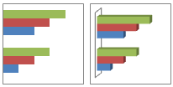
- Stacked bar and stacked bar in 3-D Stacked bar charts show the relationship of individual items to the whole. A stacked bar in 3-D chart displays the horizontal rectangles in 3-D format; it does not display the data on three axes.
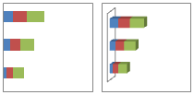
- 100% stacked bar and 100% stacked bar in 3-D This type of chart compares the percentage that each value contributes to a total across categories. A 100% stacked bar in 3-D chart displays the horizontal rectangles in 3-D format; it does not display the data on three axes.
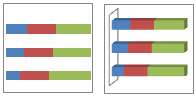
- Horizontal cylinder, cone, and pyramid These charts are available in the same clustered, stacked, and 100% stacked chart types that are provided for rectangular bar charts. They show and compare data the same way. The only difference is that these chart types display cylinder, cone, and pyramid shapes instead of horizontal rectangles.
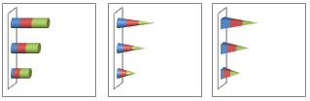
Tip To create a bar chart, see Present your data in a bar chart.

Area charts
Data that is arranged in columns or rows on a worksheet can be plotted in an area chart. Area charts emphasize the magnitude of change over time, and can be used to draw attention to the total value across a trend. For example, data that represents profit over time can be plotted in an area chart to emphasize the total profit.
By displaying the sum of the plotted values, an area chart also shows the relationship of parts to a whole.
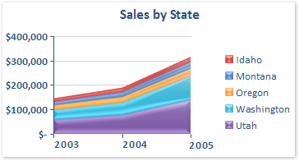
Area charts have the following chart subtypes:
- 2-D area and 3-D area Whether they are shown in 2-D or in 3-D, area charts display the trend of values over time or other category data.3-D area charts use three axes (horizontal, vertical, and depth) that you can modify. As a rule, you should consider using a line chart instead of a nonstacked area chart, because data from one series can be obscured by data from another series.
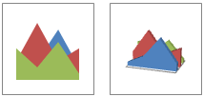
- Stacked area and stacked area in 3-D Stacked area charts display the trend of the contribution of each value over time or other category data. A stacked area chart in 3-D is displayed in the same way but uses a 3-D perspective. A 3-D perspective is not a true 3-D chart — a third value axis (depth axis) is not used.
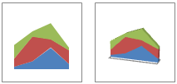
- 100% stacked area and 100% stacked area in 3-D 100% stacked area charts display the trend of the percentage that each value contributes over time or other category data. A 100% stacked area chart in 3-D is displayed in the same way but uses a 3-D perspective. A 3-D perspective is not a true 3-D chart — a third value axis (depth axis) is not used.
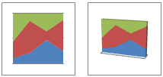
Tip To create an area chart, see Present your data in an area chart.

XY (scatter) charts
Data that is arranged in columns and rows on a worksheet can be plotted in an xy (scatter) chart. Scatter charts show the relationships among the numeric values in several data series, or plots two groups of numbers as one series of xy coordinates.
A scatter chart has two value axes, showing one set of numeric data along the horizontal axis (x-axis) and another along the vertical axis (y-axis). It combines these values into single data points and displays them in irregular intervals, or clusters. Scatter charts are typically used for displaying and comparing numeric values, such as scientific, statistical, and engineering data.
Consider using a scatter chart when:
- You want to change the scale of the horizontal axis.
- You want to make that axis a logarithmic scale.
- Values for horizontal axis are not evenly spaced.
- There are many data points on the horizontal axis.
- You want to effectively display worksheet data that includes pairs or grouped sets of values and adjust the independent scales of a scatter chart to reveal more information about the grouped values.
- You want to show similarities between large sets of data instead of differences between data points.
- You want to compare many data points without regard to time—the more data that you include in a scatter chart, the better the comparisons that you can make.
To arrange data on a worksheet for a scatter chart, you should place the x values in one row or column, and then enter the corresponding y values in the adjacent rows or columns.
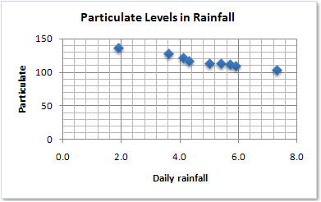
Scatter charts have the following chart subtypes:
- Scatter with only markers This type of chart compares pairs of values. Use a scatter chart with data markers (data marker: A bar, area, dot, slice, or other symbol in a chart that represents a single data point or value that originates from a worksheet cell. Related data markers in a chart constitute a data series.) but without lines when you use many data points and connecting lines would make the data more difficult to read. You can also use this chart type when you do not have to show connectivity of the data points.
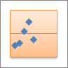
- Scatter with smooth lines and scatter with smooth lines and markers This type of chart displays a smooth curve that connects the data points. Smooth lines can be displayed with or without markers. Use a smooth line without markers if there are many data points.
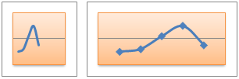
- Scatter with straight lines and scatter with straight lines and markers This type of chart displays straight connecting lines between data points. Straight lines can be displayed with or without markers.
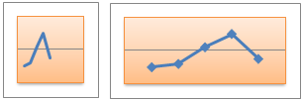
Tip To create a scatter chart, see Present your data in a scatter chart or a line chart.

Stock charts
Data that is arranged in columns or rows in a specific order on a worksheet can be plotted in a stock chart. As its name implies, a stock chart is most often used to illustrate the fluctuation of stock prices. However, this chart may also be used for scientific data. For example, you could use a stock chart to indicate the fluctuation of daily or annual temperatures. You must organize your data in the correct order to create stock charts.
The way stock chart data is organized in the worksheet is very important. For example, to create a simple high-low-close stock chart, you should arrange your data with High, Low, and Close entered as column headings, in that order.
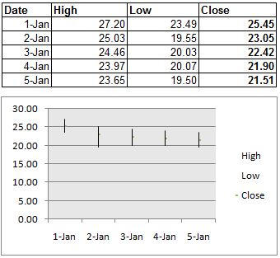
Stock charts have the following chart sub-types:
- High-low-close The high-low-close stock chart is often used to illustrate stock prices. It requires three series of values in the following order: high, low, and then close.
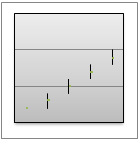
- Open-high-low-close This type of stock chart requires four series of values in the correct order (open, high, low, and then close).
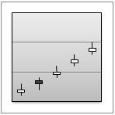
- Volume-high-low-close This type of stock chart requires four series of values in the correct order (volume, high, low, and then close). It measures volume by using two value axes: one for the columns that measure volume, and the other for the stock prices.
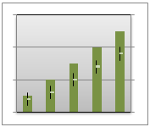
- Volume-open-high-low-close This type of stock chart requires five series of values in the correct order (volume, open, high, low, and then close).
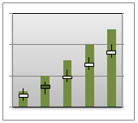
Tip To create a stock chart, see Present your data in a stock chart.

Surface charts
Data that is arranged in columns or rows on a worksheet can be plotted in a surface chart. A surface chart is useful when you want to find optimum combinations between two sets of data. As in a topographic map, colors and patterns indicate areas that are in the same range of values.
You can use a surface chart when both categories and data series are numeric values.
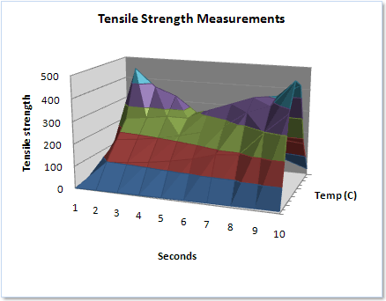
Surface charts have the following chart subtypes:
- 3-D surface 3-D surface charts show trends in values across two dimensions in a continuous curve. Color bands in a surface chart do not represent the data series; they represent the distinction between the values. This chart shows a 3-D view of the data, which can be imagined as a rubber sheet stretched over a 3-D column chart. It is typically used to show relationships between large amounts of data that may otherwise be difficult to see.
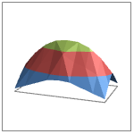
- Wireframe 3-D surface When displayed without color on the surface, a 3-D surface chart is called a wireframe 3-D surface chart. This chart shows only the lines. A 3-D surface chart that is displayed without color bands on any surface is called a wireframe 3-D surface chart. This chart shows only the lines.
Note A wireframe 3-D surface chart is not easy to read, but this chart type is useful for faster plotting of large data sets.
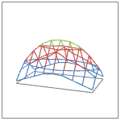
- Contour Contour charts are surface charts viewed from above, similar to 2-D topographic maps. In a contour chart, color bands represent specific ranges of values. The lines in a contour chart connect interpolated points of equal value.
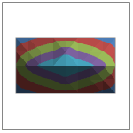
- Wireframe contour Wireframe contour charts are also surface charts viewed from above. Without color bands on the surface, a wireframe chart shows only the lines.
Note Wireframe contour charts are not easy to read. You may want to use a 3-D surface chart instead.
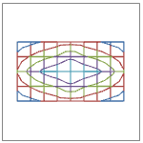
Tip To create a surface chart, see Present your data in a surface chart.

Doughnut charts
Data that is arranged in columns or rows only on a worksheet can be plotted in a doughnut chart. Like a pie chart, a doughnut chart shows the relationship of parts to a whole, but it can contain more than one data series (data series: Related data points that are plotted in a chart. Each data series in a chart has a unique color or pattern and is represented in the chart legend. You can plot one or more data series in a chart. Pie charts have only one data series.).
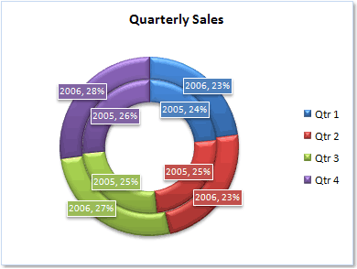
Note Doughnut charts are not easy to read. You may want to use a stacked column or stacked bar chart instead.
Doughnut charts have the following chart subtypes:
- Doughnut Doughnut charts display data in rings, where each ring represents a data series. If percentages are displayed in data labels, each ring will total 100%.
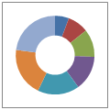
- Exploded Doughnut Much like exploded pie charts, exploded doughnut charts display the contribution of each value to a total while emphasizing individual values, but they can contain more than one data series.
Tip To create a doughnut chart, see Present your data in a doughnut chart.

Bubble charts
Data that is arranged in columns on a worksheet so that x values are listed in the first column and corresponding y values and bubble size values are listed in adjacent columns, can be plotted in a bubble chart.
For example, you would organize your data as shown in the following example.
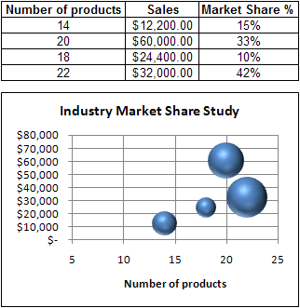
Bubble charts have the following chart subtypes:
- Bubble or bubble with 3-D effect Both bubble chart types compare sets of three values instead of two. The third value determines the size of the bubble marker. You can choose to display bubbles in 2-D format or with a 3-D effect.
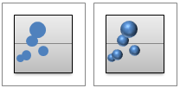
Tip To create a bubble chart, see Present your data in a bubble chart.

Radar charts
Data that is arranged in columns or rows on a worksheet can be plotted in a radar chart. Radar charts compare the aggregate values of several data series (data series: Related data points that are plotted in a chart. Each data series in a chart has a unique color or pattern and is represented in the chart legend. You can plot one or more data series in a chart. Pie charts have only one data series.).
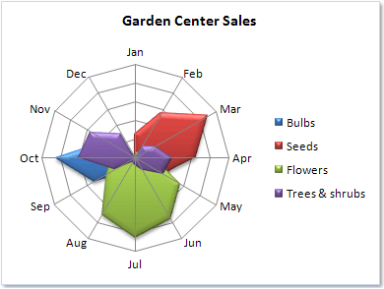
Radar charts have the following chart subtypes:
- Radar and radar with markers With or without markers for individual data points, radar charts display changes in values relative to a center point.
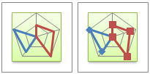
- Filled radar In a filled radar chart, the area covered by a data series is filled with a color.
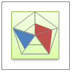
Tip To create a radar chart, see Present your data in a radar chart.

Other types of charts that you can create in Excel
If you do not see the chart type that you want to create on the list of available chart types, there may be another way to create it in Excel.
For example, you can create the following charts:
- Gantt charts and floating column charts You can use a chart type to simulate these types of charts. For example, you can use a bar chart to simulate a Gantt chart, or you can use a column chart to simulate a floating column chart that depicts minimum and maximum values. For more information, see Present your data in a Gantt chart in Excel and Present your data in a column chart.
- Combination charts To emphasize different types of information in a chart, you can combine two or more chart types in that chart. For example, you can combine a column chart with a line chart for an instant visual effect that might make the chart easier to understand. For more information, see Present your data in a combination chart.
- Organization charts You can insert an SmartArt graphic to create an organization chart, flow chart, or hierarchy chart. For more information, see Create an organization chart.
- Histogram and pareto charts To create a histogram or pareto (sorted histogram) chart in Excel, you can use the Data Analysis Tools that become available after you load the Analysis ToolPak, an Excel add-in program that is available when you install Microsoft Office or Excel. For more information, see Present your data in a histogram.

See Also
- Change the chart type of an existing chart
- Create a chart
- Create an organization chart
- Creating a box plot
- Creating a comparative histogram
- Creating a thermometer chart
- Creating a timeline
- View More

