Buzz-Off
Buzz-Off Insect Repellent

John McKay manufactures and distributes a bug repellent called Buzz-Off, and wants to find the best pricing strategy, and what the implications are for his production decisions
. Buzz-Off is marketed in 100 ml. bottles, and the current retail price is $3.95/bottle. Following the usual industry practice, John receives 50% of the selling price as his gross revenue ($1.975 /bottle at the current price). At the current price, he sells 50,000 bottles of Buzz-Off per year.

To help John think about the relationship between price and sales volume, you ask:
"How much would the retail price have to drop for sales of Buzz-Off to double?"
After some reflection, suppose that John says that sales would double if the retail price dropped by 20% (to $3.16/bottle).

The manufacture of Buzz-Off involves variable costs for bottles, raw material, labor, and packaging. John’s variable costs are $0.90 per bottle.

John has fixed costs of operating, including rent, equipment amortization, marketing, and office and bookkeeping services, and other overheads. These administrative costs, which are independent of the volume of Buzz-Off sold, amount to $18,500 per year.

How much Buzz-Off should John make, and what price should he charge?
Steps in the Problem Definition

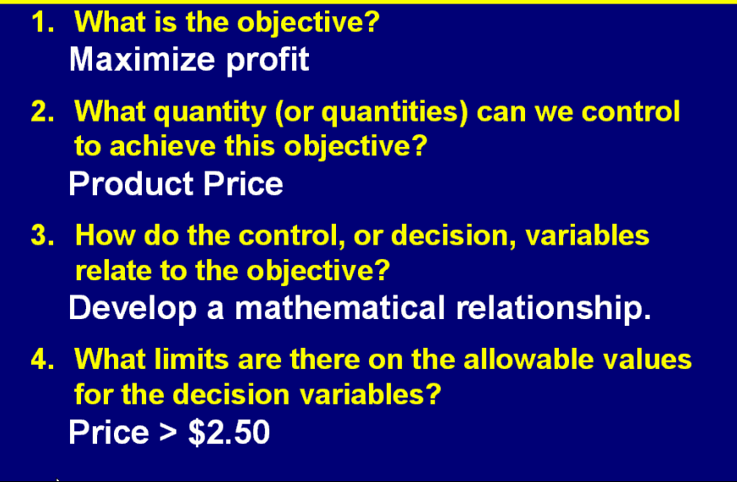

Finding the Demand Curve
This information comes from price history

