# Excel Built-In Functions Lab

1. The Excel file name **marks.xls** contains the following final grades for a class of 25 students, including the student number and sex of each student.
   1. Use the AVERAGE and STDEV built-in functions to find the class average and standard deviation.
   2. Use an IF function to create a column with only the grades for the Male students who have a grade of 80 or better entered; for the female students, enter a blank. (Remember, use double quote marks to check if a cell contains a label, like “M”, and note that you can specify that a blank label is to be entered by two double quote marks with nothing in between, like this “”.)
   3. Create a student lookup cell, so that you can enter the student number in a particular cell, and automatically find the student’s grade in an adjacent cell, using the VLOOKUP function. Your spreadsheet should look like this (where an example has been entered for clarity):



2. Suppose your company wants to choose one of either Project A or Project B, and the forecasted cash flows of each are summarized in the following table (projects.xls). Calculate the Net Present Value (using the built-in NPV function) at a 10% discount rate of each, and also the Internal Rate of Return (using the built-in IRR function) of each. Which would you suggest that the company choose?

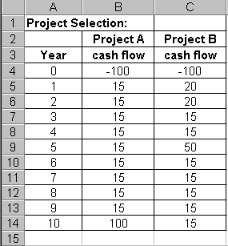

**Definitions:**

The *Net Present Value* is the sum of the present plus future cash flows, with each future cash flow expressed in current dollars by discounting it back to the present at the specified interest rate (called the discount rate). For example, if the discount rate is *i*%, the present value at a of a future sum of money *$F* to be received *n* years from now is given by



The *Internal Rate of Return* is the discount rate that yields an Net Present Value of $0.

**Demo Using ABC.xlsx**



    
    
    

    
    
    

    
    
    

