Histograms
People often say that a picture is worth a thousand words. The ability to summarize a large data set is important. The three tools used most often to summarize data in Microsoft Excel are histograms, descriptive statistics, and PivotTables.
A histogram is a commonly used tool to summarize data. Essentially, a histogram tells you how many observations (another term for data points) fall in various ranges of values. For example, a histogram created from monthly Cisco stock returns might show how many monthly returns Cisco had from 0 percent through 10 percent, 11 percent through 20 percent, and so on. The ranges in which you group data are referred to as bin ranges.
Data Range | Frequency
0-10 | 1
10-20 | 3
20-30 | 6
30-40 | 4
40-50 | 2
Note: Changing the size of the bin changes the appearance of the graph and the conclusions you may draw from it
Example
A teacher grades the tests and creates bins of width 10 points: . . . , 30-39, 40-49, 50-59, 60-69, 70-79, . . . . The number of test scores in each data bin is recorded and plotted as a bar graph.
Data  Student Grade  Bullwinkle 84  Rocky 91  Bugs 75  Daffy 68  Wylie 98  Mickey 78  Minnie 77  Lucy 86  Linus 94  Asterix 64  Obelix 59  Donald 54  Sam 89  Taz 76 | Professor Chang's Physics class has just taken a test. In order to come up with meaningful grades, Professor Chang will make a histogram to represent the distribution of grades and find a reasonable central value.  The critical question is that of bin size. Clearly, a bin size of 100 makes no sense as it puts all the data in one bin, giving us no information. At the same time, a bin size of 1 or less makes no sense as the bins would be so small as to look pretty much like a simple list of results. We already have that!  Let's try a few bin sizes:  - bin width of 20  - bin width of 3  - bin width of 10  This makes it sound like 10 is the best width. Actually, we don't know that. First of all, 8 or 12 might be better. Secondly, narrower or wider bins might give us the look at the data that we need in a particular case.

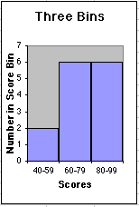 | 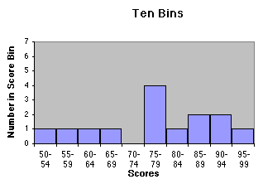 | 