Relational Database Exercise and Demo

Table Name | Primary Key | Foreign Keys | Other Attributes
Inventory | Item Number |  | Cost (standard or list)  Description  Quantity on Hand  Price (standard or list)
Sales | Invoice number | Customer number | Date of sale  Terms
Sales-Inventory | Item number  Invoice number | Item number | Quantity sold  Price (actual sales price)
Customer | Customer number |  | Customer name  Shipping address  Billing address  Credit Limit  Account Balance

- Query
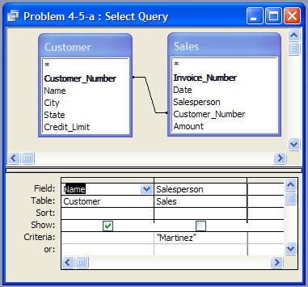 | 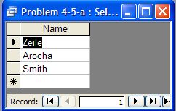  Query Result

- Query
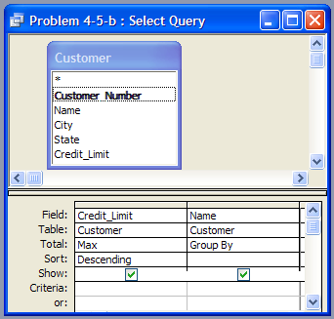 | 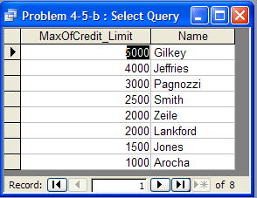  Query Result
c. Query
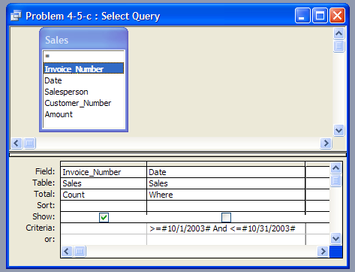 | 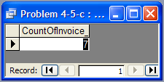  Query Result

- Query
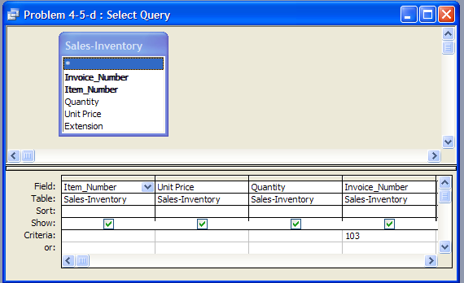
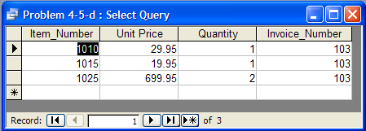Query Result
 | 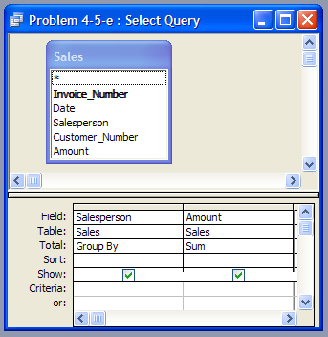 | 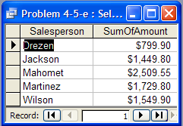  - Result Query
- Query
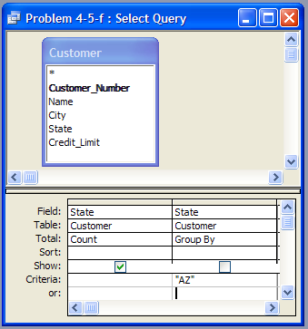 | 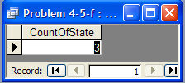  Query Result
- Query
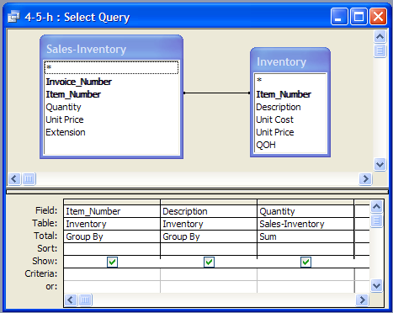 | 